 **ISO/IEC JTC 1/SC 29/WG 7 N0215**

**ISO/IEC JTC 1/SC 29/WG 7  
MPEG 3D Graphics Coding   
Convenorship: AFNOR (France)**

**Document type:** Output Document

**Title:** Insert Document

**Status:** Approved

**Date of document:** 2021-12-29

**Source:** ISO/IEC JTC 1/SC 29/WG 7

**Expected action:** None

**Action due date:** None

**No. of pages:** 151 (with cover page)

**Email of Convenor:** marius.preda @ imt . fr

**Committee URL:** [https://isotc.iso.org/livelink/livelink/open/jtc1sc29wg7](https://isotc.iso.org/livelink/livelink/open/jtc1sc29wg3)

**INTERNATIONAL ORGANIZATION FOR STANDARDIZATION**

**ORGANISATION INTERNATIONALE DE NORMALISATION**

**ISO/IEC JTC 1/SC 29/WG 7 MPEG 3D Graphics Coding**

**ISO/IEC JTC 1/SC 29/WG 7 N** **0215**

**October 2021, Virtual**

|  |  |
| --- | --- |
| **Title** | **G-PCC codec description** |
| **Source** | **WG 7, MPEG 3D Graphics Coding** |
| **Status** | **Approved** |
| **Serial Number** | **20983** |

# G-PCC codec description v12

# Abstract

ISO/IEC MPEG (JTC 1/SC 29/WG 11) is studying the potential need for standardization of point cloud coding technology with a compression capability that significantly exceeds that of the current approaches and will target to create the standard. The group is working together on this exploration activity in a collaborative effort known as the 3 Dimensional Graphics Team (3DG) to evaluate compression technology designs proposed by their experts in this area.

This document provides a detailed description of the point cloud compression G-PCC (Geometry based Point Cloud Compression). It describes the coding features that are under coordinated test model (TMC13) study by 3DG as potential point cloud coding technology. G-PCC addresses the compression of point clouds in both Category 1 (static point clouds) and Category 3 (dynamically acquired point clouds).

Ed. Notes

v1:

* m42238: Neighbour-dependent entropy coding of occupancy patterns
* m42239: Inference of a mode using point location direct coding
* m42689: Sibling neighbour-dependent entropy coding
* m43591: Look ahead cube for efficient neighbours information retrieval
* m43592: Binarization of occupancy information
* m43600: Intra mode for geometry coding
* m43649: alternative entropy codecs
* m43665: Adaptive predictor selection for attributes coding
* m43780: Binarization of transform coefficients
* m43781: Efficient implementation of the Lifting Scheme
* m44750: A new binary entropy coder with update for geometry coding

v2:

* m44752: falsely occupied neighbours
* m44753: adjacent child neighbours
* m44899: a simplified version of the adaptive prediction scheme
* m44940: binary-tree based LoD generation
* m45811: An overview of OBUF and neighbour usage for geometry coding
* m45867: tile and slice partition
* m42538: recolouring

v3:

* m44486, m46209: fixed-point RAHT
* m46148: further reduction of neighbour configurations
* m46149: an improvement of advanced neighbours
* m46150: the reduction of states related to advanced neighbours in OBUF
* m47398: geometry slice header reduction in slice partition
* m46107: Reference structure modification on attribute predicting transform
* m44990: Fixed-point implementation of lifting and predicting transform
* m46188: regular sampling based LoD generation (remove binary LoD)
* m47399: slice based QP delta
* m47401, m47507: QP table
* m46108: attribute residual coding
* m45019: adaptive quantization scheme for RAHT

v4:

* m48892: slice partitioning order, limit the number of points per slice
* m49121: constrain slice partitions to trisoup node size
* m47834: add support for per-layer luma/chroma qp offsets
* m47827: Bypass coding of bypass bins
* m47352: Spatial scalability support
* m48918: LUT-based quantization
* m49407: Distance-weighted color transfer
* m47378: Upsampled transform domain prediction in RAHT

v5:

* m51064 Clarification and Modification of CD syntax and semantics
* m51063: Region-wise attribute quantization control
* m50924: Geometry quantization
* m50927: Slice based geometry quantization
* m51160: Inter-channel Prediction for Near lossless Coding
* m50741: LoD generation for spatial scalability
* m50773: Neighbor’s weight modification on lifting and predicting scheme
* m50008: Planar coding mode
* m50921: Implicit QTBT partition
* m50009: Duplicated points in IDCM
* m51010: Improved implementation of the Prediction and Lifting schemes
* m51092: Possible reduction of attribute coding time for cat3-fused dataset

v6:

* m50642: Angular coding mode
* m52279: Triangle soup decoding
* m51408: LoD generation modification on scalable lifting coding
* m50765: Adaptive predictor selection for reflectance
* m50743: Improved LoD generation for spatial scalability
* m52337: Uniform square partitioning
* m52341: Region-wise attribute quantization control for RAHT
* m52343: Harmonization of angular coding mode and implicit QTBT
* m51374: Early termination for transform domain prediction of RAHT
* m50930: Parallel Octree Coding
* m52400: Harmonization in Geometry Quantization
* m52514: Chunked entropy streams
* m52524: A method to compute dist2 values for LoD attribute coding
* m52719: Improved encoding for inter-channel residual prediction

v7:

* m52951: Division-free RAHT coding
* m52956: Decoupling planar and IDCM in angular mode
* m51596: Azimuthal coding mode
* m52345: Planar mode buffer optimization
* m52986: By-passing coefficient sign coding on attribute
* m52995: Increasing internal precision of inter-depth prediction of RAHT
* m52996: Optimization of RAHT coefficients by the attribute encoder
* m51011: L1 for nearest-neighbour search
* m52331: improved LoD generation for spatial scalability
* m52327: improved geometry occupancy intra prediciton
* m53337: symbol-grouping based coding of attribute transform coefficients
* m52315: geometry reconstruction for spatial scalability
* m52314: nearest neighbour search for spatial scalability
* m52823: weight derivation for spatial scalability
* m53385: bypassed bit coding and chunks modification
* m52522: Integer step sizes for in-tree geometry quantisation
* m52523: Quantisation of IDCM nodes
* m53338, m53390: Explicit signalling of QtBt
* m51012, m53391: Predictive geometry coding
* m53392: Integration of refining slices on existing partitioning methods
* m53421: Neighbour context accessing in QTBT
* m53442: Rate-distortion optimization for prediction mode selection
* m53538: Predictive tree encoding modifications
* m53541: Scale and offset of Attribute in SPS
* m53542: Entropy Continuation flag for Low Latency Coding
* m52392: skip Morton sorting process for low delay attribute coding
* m53619: Division-free Implementation of the Lifting/Prediction scheme
* m53633: Encoder improvements for inter-component residual prediction
* m53650: Non-normative scaling and SPS bounding box
* m53679: A raw attribute coder
* m53693: Context reduction and context derivation simplification for angular mode

v8:

* m53332: Adaptive axis coding order detemination
* m54264: Modify IDCM implicit conditions and introduce non-ordered two-point IDCM
* m54265: Attributes coefficients entropy coding and Run-Length coding
* m54265: Dyadic RAHT
* m54590: Determination on nearest neighbour search for spatial scalability
* m54592: Modification on azimuthal sorting for predictive geometry tree coder
* m54599: Spatial scalability with predicting Transform
* m54607: RAHT upsampled prediction improvement
* m54616: Signaling the number of points at each depth for spatial scalability
* m54622: Coordinate conversion for attribute coding
* m54651: Tile paritioning modification
* m54652: Entropy continuation restriction
* m54659: Entropy continuation for attribute
* m54628: Intra LoD prediction restriction
* m54655: Chroma residual prediction for Lifting transform
* m54668: attribute LoD construction and neighbour search improvement
* m54671: Angular mode for predictive geometry coding
* m54697: Fine granularity quantization step size control
* m54698: On attribute QP derivation
* m54699: On frame index coding
* m54703: Reordered attribute residual coding
* m54707: Fast laser search method

v9:

* m54951: Filter-based attribute prediction
* m55035: A Progressive Quantization for LoD-based 3D PCCs
* m55314: Simplificaiton on coding plane position flag
* m55344: Octree-based LOD generation
* m55364: Joint coding of predictor index and residual
* m55365: Last component residual prediction for Lifting transform
* m55373: Extension on inter-component residual prediction
* m55376: Zero Predictor improvement on predictive geometry coding
* m55387: On in-tree quantization and angular mode
* m55491: The amount of IDCM control
* m55495: Carriage of user data

v10:

* m55859: A Progressive Quantization for LoD-based attribute Predicting Transform coding

v11:

* m56740: Re-ordering for geometry predictive tree coding
* m56810: Reflectance scaling using attribute parameters

v12:

* m57355: Modification on attribute coding with coordinate conversion

# Overview

Figure 1 provides an overview of the G-PCC encoder and decoder. The modules shown are logical, and do not necessarily correspond one-to-one to implemented code in the TMC13 software.

In both the encoder and decoder, point cloud positions are coded first. Attribute coding depends on the decoded geometry.

In Figure 1, the green modules are options typically used for Category 1 data. Orange modules are options typically used for Category 3 data. All the other modules are common between Categories 1 and 3.

For Category 3 data, the compressed geometry is typically represented as an octree from the root all the way down to a leaf level of individual voxels. For Category 1 data, the compressed geometry is typically represented by a pruned octree (i.e., an octree from the root down to a leaf level of blocks larger than voxels) plus a model that approximates the surface within each leaf of the pruned octree. In this way, both Category 1 and 3 data share the octree coding mechanism, while Category 1 data may in addition approximate the voxels within each leaf with a surface model. The surface model used is a triangulation comprising 1-10 triangles per block, resulting in a triangle soup. The Category 1 geometry codec is therefore known as the Trisoup geometry codec, while the Category 3 geometry codec is known as the Octree geometry codec.

There are 3 attribute coding methods in G-PCC: Region Adaptive Hierarchical Transform (RAHT) coding, interpolation-based hierarchical nearest-neighbour prediction (Predicting Transform), and interpolation-based hierarchical nearest-neighbour prediction with an update/lifting step (Lifting Transform). RAHT and Lifting are typically used for Category 1 data, while Predicting is typically used for Category 3 data. However, either method may be used for any data, and, just like with the geometry codecs in G-PCC, the user has the option to choose which of the 3 attribute codecs they would like to use.

In the remainder of this document, Section 3 describes the algorithmic details of the geometry and attribute coding methods in G-PCC. Relevant references for this document are provided in Section 4.

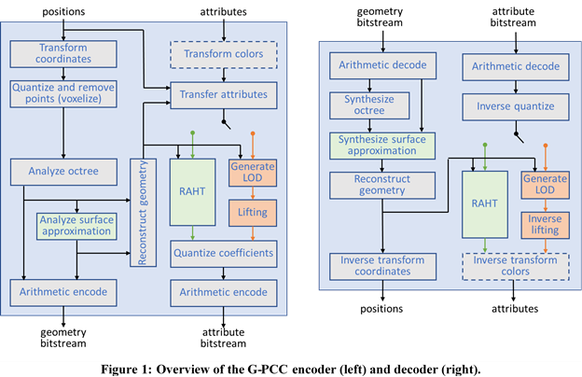

Figure 1: Overview of the G-PCC encoder (left) and decoder (right)

# Codec Descriptions

This section is organized as follows. Section 3.1 describes the pre- and post-processing of point clouds that may be common to Category 1 and Category 3 data in G-PCC. Section 3.2 describes the details of the Octree method for geometry encoding/decoding, while Section 3.3 describes the Trisoup geometry encoding/decoding. Section 3.4 describes Predictive geometry coding and Section 3.5 describes Geometry quantization. Section 3.6 describes the geometry entropy coding method for geometry. Section 3.7 details the attributes transfer (recolouring) module that is used to transfer attributes to point cloud geometry that has been compressed and then reconstructed (decompressed) at the encoder, prior to attribute encoding. Section 3.8 then describes the Predicting method for attribute coding, Section 3.9 describes the Lifting method, and Section 3.10 describes the Region Adaptive Hierarchical Transform (RAHT). Section 3.11 describes Attribute Quantization and Section 3.12 describes the entropy coding for attribute. Section 3.13 describes attribute coding with coordinate conversion and Section 3.14 describes a raw attribute coder. Section 3.15 describes tools for functionality.

## Pre- and post-processing

A point cloud is a collection of points with positions , , where is the number of points in the point cloud, and optional attributes , , where is the number of attributes for each point. The geometry of the point cloud comprises the point positions only. The attributes of the point cloud comprise the point attributes only. In this Test Model, the only attributes supported are a colour triple and/or a reflectance (or else no attributes). The geometry and the attributes of a point cloud are often expressed in application-specific spaces. The Test Model provides pre-processing and post-processing to convert between these application-specific spaces and finite-resolution internal spaces, where the point clouds are compressed.

### Coordinate transform and inverse

Original application-specific point positions are generally represented by floating point numbers and need not have any structure, lying in an original (or world) coordinate system denoted , .

Internal (or frame) coordinates , are obtained from original coordinates by the coordinate transformation

where . The parameters and are such that the point positions lie in a bounding cube for some non-negative integer parameter .

Point positions in the internal coordinate system that have been compressed and decompressed are denoted , where is the number of points in the decoded point cloud. may not be the same as .

Decoded point positions in the original coordinate system are obtained from decoded point positions in the internal coordinate system by the coordinate transformation

This can alternatively be expressed by the following homogeneous transformation from internal to original coordinates:

If the Trisoup geometry codec is used, is specified by the triSoupIntToOrigScale parameter, while is [0, 0, 0], and is specified by the triSoupDepth parameter. Components of points outside the bounding cube are clipped to the range if necessary.

If the Octree geometry codec is used, is specified by the positionQuantizationScale parameter, while is determined by and is determined by

such that is the smallest bounding cube with side an integer power of two that contains the point positions in internal coordinates. See Appendix A for definitions of Ceil, Log2, and Max.

### Colour transform and inverse

Attribute quantization of colour components is agnostic to the colour space of the components, since the components are processed independently. However, the TM supports conversion from RGB to YCbCr and back again (ITU Rec.709), if desired.

### Point quantization and duplicate point removal (voxelization)

Point positions are represented internally as non-negative -bit integers before being compressed. To obtain these integers, the point positions in the internal coordinate system are rounded. Let be a point position in the internal coordinate system. Then its representation as a non-negative -bit integer is

where is the function that rounds the components of a vector to the nearest integer. See Appendix A for details.

After such quantization, there may be multiple points with the same position, called duplicate points. The duplicate points removal process is optional. If enabled, it removes points with the same quantized coordinates. In order to detect duplicates, the STL set data structure is leveraged.

Multiple points with the same quantized position and different attributes will be merged in a single point. The attributes associated with the single point will be computed by the attributes transfer module described in Section 3.7

The process of position quantization, duplicate point removal, and assignment of attributes to the remaining points is called voxelization. In other words, voxelization is the process of grouping points together into voxels. The set of voxels are the unit cubes for integer values of , , and between 0 and . Specifically, the locations of all the points within a voxel are quantized to the voxel centre, and the attributes of all the points within the voxel are combined (e.g., averaged) and assigned to the voxel. A voxel is said to be occupied if it contains any point of the point cloud.

## Octree geometry encoding/decoding

If the Octree geometry codec is used, then the geometry encoding proceeds as follows. First, a cubical axis-aligned bounding box B is defined by the two extreme points and .

An octree structure is then built by recursively subdividing B. At each stage, a cube is subdivided into 8 sub-cubes. An 8-bit code, named an occupancy code, is then generated by associating a 1-bit value with each sub-cube in order to indicate whether it contains points (i.e., full and has value 1) or not (i.e., empty and has value 0). Only full sub-cubes with a size greater than 1 (i.e., non-voxels) are further subdivided. Since points may be duplicated, multiple points may be mapped to the same sub-cube of size 1 (i.e., the same voxel). In order to handle such a situation, the number of points for each sub-cube of dimension 1 is also arithmetically encoded. The same arithmetic encoder is used to encode all the information put into the bitstream. Currently the implementation from [1] is used.

The decoding process starts by reading from the bitstream the dimensions of the bounding box B. The same octree structure is then built by subdividing B according to the occupancy codes. Each time a sub-cube of dimension 1 is reached, the number of points for that sub-cube is arithmetically decoded and points located at the origin of the sub-cube are generated.

Note: In order to guarantee encoder/decoder synchronization, the point order defined by the decoding process is used during the level of detail generation process.

### Direct coding mode (DCM) [7] [58]

The octree representation, or more generally any tree representation, is efficient at representing points with a spatial correlation because trees tend to factorize the higher order bits of the point coordinates. For an octree, each level of depth refines the coordinates of points within a sub-volume by one bit for each component at a cost of eight bits per refinement. Further compression is obtained by entropy coding the split information, i.e. pattern, associated with each tree node. This further compression is possible because the pattern distribution is not uniform, non-uniformity being another consequence of the correlation.

On the other hand, isolated points P cannot be better coded than directly coding their coordinates without compression, simply because by definition, there are no other points within the volume to correlate with. To do otherwise risks a worst-case penalty of five (=8-3) bits per refinement without taking into account entropy coding or assuming uniform distribution. Directly coding point coordinates in a volume/sub-volume is called Direct Coding Mode (or DCM hereafter).

Furthermore, isolated points “pollute” the distribution of patterns, inducing many patterns with only one occupied child, thus changing the balance of the distribution and penalizing the coding of other patterns.

It would be highly beneficial to get rid of isolated points in octree/tree coding in order to obtain better compression performance in volumes where point correlation exists. Also, complexity would be greatly reduced because a DCM is by essence much simpler than a recursive split of a tree.

A combination of octree coding and the Direct Coding Mode, see Figure 2, is a straightforward attempt.

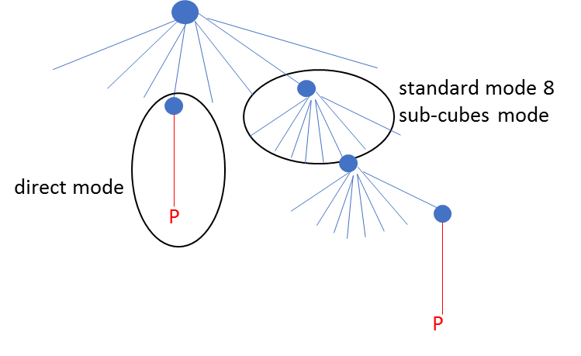

Figure 2: combining tree coding and Direct Coding Mode

Instead of signaling the usage of the DCM for all nodes of the tree is inferred from information coming from the node neighbourhood, leading to what we call Inferred Direct Coding Mode (or IDCM), see Figure 3.

A new eligibility (for DCM) condition is introduced and depends on information coming from the parent node itself or the neighbours of the parent node; this is the inference. If the node is not eligible, then tree coding is applied. If the node is eligible, then:

1. a binary flag is coded to signal if the DCM is applied (flag=1) or not (flag=0) to the node
2. if the flag is equal to 1, then points belonging to the associated volume are directly coded using the DCM. Otherwise (the flag is equal to 0), the tree coding process continues for the current node.

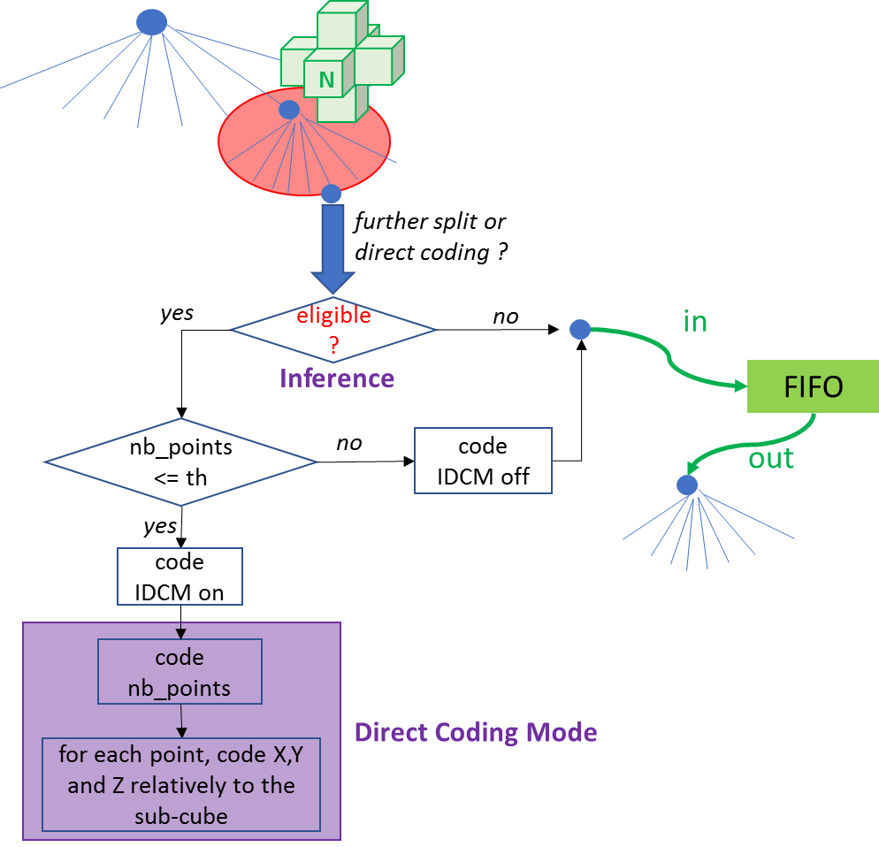

Figure 3: overview of IDCM

If the node is eligible for DCM, then a flag is coded to signal if the DCM is applied or not. This flag may be determined by an encoder based upon the number of points belonging to the volume attached to the node. If this number is less than or equal to a threshold th, then DCM is activated; otherwise it is not. TMC13 software has used the value th=2, i.e. up to two points can be directly coded in a volume. The value th is implicit, but could be a coded parameter at sequence/picture level.

If a DCM is applied, the coding of points is performed as follows

1. the number of points (necessarily at most th points) is coded using a truncated unary binarizer followed by a binary entropy coder. With th=2, there is only on flag signalling if the number of points is either 1 or 2. This flag is entropy coded using a binary arithmetic coder with a dedicated context
2. positions X, Y and Z are coded independently for each point, and relatively to the volume associated with the node. For example, if the volume is a cube of size 2^D, then D bits are needed for each coordinate of each point. These bits are direct pushed into the bitstream (bypass coding).

The criterion for eligibility can take two flavours

1. parent-based-eligibility. There is only one occupied child (=the current node) at parent-node level, AND the grand-parent node has at most two occupied children (= the parent node + possibly one other node).
2. 6N eligibility. There is only one occupied child (=the current node) at parent-node level, AND there is no occupied neighbour N (among the six neighbours sharing a face with the current cube associated with the current node, see Figure 3).

If eligibility condition is not fulfilled, the node is not eligible and the process continues to octree coding as in TMC13.

Concerning 6N eligibility, he breadth first scan order of the octree as performed in TMC13 ensures that the six neighbours N are available when determining the eligibility of the current node.

Additionally, IDCM was extended to handle duplicated points optimally by coding the number of duplicated point instead of coding each of them individually.

#### Intensity values for IDCM implicit conditions [111]

To provide new interesting alternatives for speed versus compression efficiency trade-off, intensity values ranging from 0 to 2 for new IDCM implicit conditions were introduced. The new IDCM implicit conditions allow to increase the number of nodes coded using IDCM and so to speed-up the execution runtime:

* Intensity 0 corresponds to original G-PCC IDCM implicit conditions. It has best compression performances but is the slowest compared to other intensities.
* Intensity 1 relax the implicit conditions so that there is no condition on the number of siblings of the current node and child node, but the six adjacent neighbours of the current node must still be empty. More nodes can then be processed by IDCM.
* Intensity 2 relax even more the implicit condition so that any node containing one or two points can be coded using IDCM. This is the fastest option, but it introduces more coding losses.

With the introduction for LiDAR sequences of azimuthal for angular coding, IDCM coding with azimuthal information was a little bit modified in order to keep its efficiency with the relaxed implicit conditions.

Particularly with intensity 2, bigger nodes may be coded using IDCM. With such bigger nodes, the phi azimuthal angle predictor is not as efficient. So now, each time a new bit is azimuthal-IDCM coded, the phi angle predictor for azimuthal is refined (in same way as it is initialized).

#### Non-ordered two points [111]

In order to improve compression performance of IDCM nodes, it was introduced to profit from the non-ordered characteristic of two points belonging to a same node. This allows for saving one bit per pair of points.

The non-ordered coding of bits of one coordinate of a pair of points is depicted in Figure 4. Applying this coding to two-point DCM nodes provides noticeable gains of compression for DCM intensity set to 2.

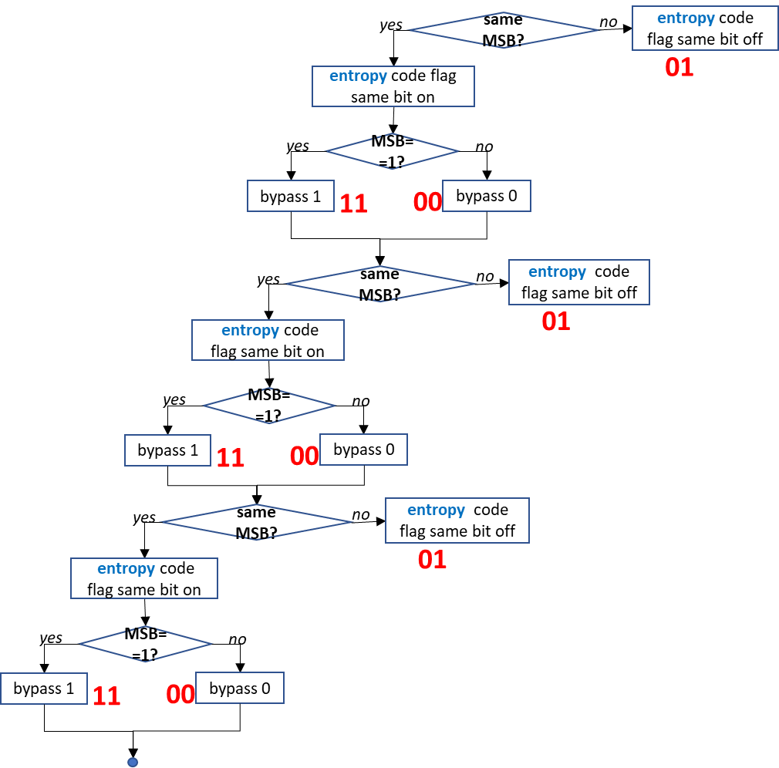

Figure 4: Non-ordred coding of a coordinate of a pair of points

The points are ordered first by coding highest equal bits of X coordinate, then bits of Y coordinate when X coordinates are equal, and finally bits of Z coordinates when box X and Y coordinates are equal. With Angular coding for LiDAR sequences, the Z coordinate is note taken into account in the ordering process (and so is not coded), since Z coordinate bits are more efficiently coded using angular.

With the introduction of Azimuthal coding for LiDAR sequences, it is also needed to change/improve the ordering to keep the benefits of the Azimuthal coding. Azimuthal is used for coding X or Y coordinate depending on the node position, it is then obviously better to take the spatial position of the node into account when performing the point re-ordering so that the coordinate that will be better coded with Azimuthal is not coded using the two points ordering.

Thus we use a flagX, a flagY and a flagZ to indicate if the corresponding coordinates can be coded using the two-point ordering process:

flagX = !angularIDCM || abs(nodeLidarX) > abs(nodeLidarY);

flagY = !angularIDCM || abs(nodeLidarX) <= abs(nodeLidarY);

flagZ = !angularIDCM;

#### The amount of IDCM control [142]

The IDCM mode conditionally permits the coding of direct point positions. Since there would be a large cost associated with coding the mode flag for each tree node, an inference process is used to first determine whether the node is eligible for IDCM. Here, a simpler method to control the amount of IDCM use was introduced.

The variable geom_idcm_eligibility_rate in geometry parameter set controls the rate at which nodes can be eligible for IDCM. When not present, geom_idcm_eligibility_rate is inferred to be 0. The array IdcmEligibilityPattern is derived as follows:

for (i = 0, acc = 0; i < 32; i++) {

acc += geom_idcm_eligibility_rate + 1

idcmEligibilityPattern[i] = acc >= 32

acc &= 0x1f

}

The variable DirectModeFlagPresent indicates whether the current node is eligible for early termination using direct position coding.

DirectModeFlagPresent = NodeIdcmEligible[depth][nodeIdx]

&& Max(EffectiveNodeSizeLog2) > 0

&& idcmEligibilityPattern[nodeIdx % 32]

### Neighbour-Dependent Entropy Context (NEIGHB) [8]

Neighbour-Dependent Entropy Context (NEIGHB) selects the configuration depending on the six neighbours N of the parent node and these 6 neighbours, a neighbour configuration number (NC) is deduced to code occupancy pattern. This number NC is an integer between 0 and 63. The value 0 means that there is no occupied neighbour, and the value 63 means that all neighbours are occupied.

The decision process is to choose directly a distribution, among 64 distributions, from the neighbouring configuration number NC, but with a special handling of the case NC=0 which is further split into two sub-cases:

* If the parent node has only one occupied child node (Number of Occupied child nodes =: NO =1), then the position is directly coded by using 3 bits to code the occupied child node position in XYZ inside the volume associated with the parent node
* Otherwise the 0-th distribution corresponding to NC=0 is used.

In order for the decoder to know if NO=1 or not, an additional flag stating whether or not NO=1 must be coded when NC=0. This flag is also entropy coded using a binary arithmetic coder with a dedicated context.

#### Configuration and geometrical invariance

By construction of the octree, a current cube (in blue on Figure 4) associated with a current node is surrounded by six cubes of the same depth sharing a face with it. As depicted on the figure, weights (1, 2, 4, etc.) are associated with each of the six cubes and a neighbouring configuration NC is determined by summing the weights of occupied cubes among the six cubes. Figure 4 on the right, depicts the example for NC=15.

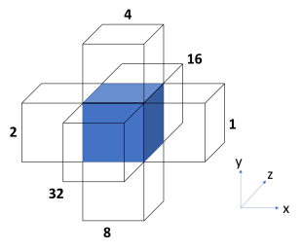 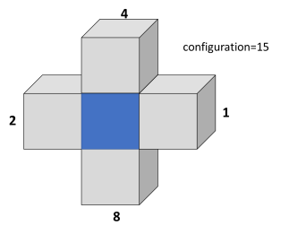

Figure 5: neighbour configuration NC (left) and example for NC=15 (right)

Using a breadth-first scanning order ensures that the occupancy of the six cubes neighbouring the current cube is known before (de)coding the 8-bit occupancy pattern of the current node. Therefore, the set Ɗj={b0...bj-1,NC} of states can be used in OBUF (Optimal Binarization with Update On-the-fly, or OBUF) to code the occupancy bit bj. For example, the size of Ɗ7 is 128*64= 8192 states. This is marginally practical for HW implementation and, more importantly, this leads to the dilution of occupancy statistics into too many states to obtain optimal compression performance.

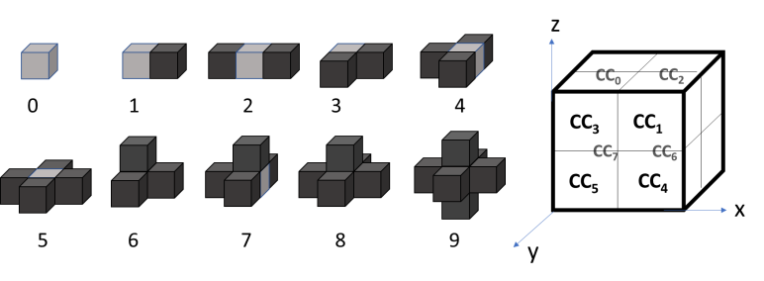

Figure 6: the ten invariant neighbour configurations NC10 (left) and

the scanning order of current child cubes Ci (right)

To solve these issues, the 64 neighbouring configurations NC are reduced to 10 invariant configurations NC10 by using geometry invariance. Assuming local geometry correlation of the point cloud as invariant under 3D isometries (for example by assuming anisotropy of the 3D space), then the neighbouring configuration can be transformed using 90° rotations and symmetries to match uniquely one of the ten configurations shown on Figure 5. The integer NC in [0,63] is thus mapped onto NC10 in [0,9].

As consistency between neighbouring configuration and occupancy pattern must be preserved, the pattern undergoes the same geometrical transform. Next, in the transformed space for both configuration and pattern, the scanning of the child cubes of the current cube is performed in the order shown in Figure 5 (right).

#### Configuration-driven OBUF State reduction

The size of the sets Ɗj of states can be lowered further by using a state reduction process. Using NC10 instead of NC, the size of Ɗ7 has become 128*10=1280 states. However, the future introduction of additional intra (but also potentially inter) prediction tools will unavoidably increase its cardinality. Therefore, the number of states must be further reduced already at this stage in order to anticipate new tools. Further reduction is obtained using anisotropy and screening.

When the neighbourhood is empty (NC10=0), the points belonging to the current cube are isolated. In this case, one can use anisotropy, i.e. there is no privileged direction for occupancy. Consequently, when coding bj, the order of the preceding bits b0 to bj-1 is of no importance. Because we are dealing with binary data, the non-ordered set {b0,…,bj-1} is totally characterized by the sum b0+…+bj-1. Consequently, as shown on Figure 7 on the left branch of the decision tree, the set of states is reduced from {b0...bj-1, NC=0}to {b0+…+bj-1, NC10=0}when the neighbouring NC10 configuration is zero.

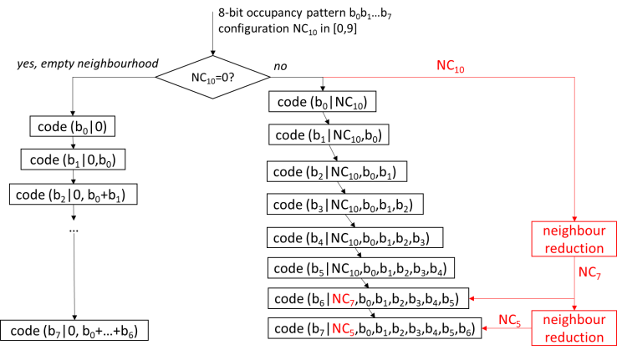

Figure 7: reduced dependency state (bj, N10) driving the entropy coder OBUF

When the neighbourhood is not empty, a state reduction is possible by using screening, a term used in physics when mobile charge carriers damp an electric field, like electrons around a nucleus. To continue with this analogy, we will simply replace the nucleus by a neighbouring volume and electrons by already coded current child volumes as depicted on Figure 8. Occupancy bits of child volumes CC0 to CC3 (blue small cubes) have already been coded, and the occupancy of these child volumes “screens” the occupancy of the neighbouring volume (green cube) located above the current volume. Therefore, when coding the occupancy of the child volume CC4 (red small cube), one can neglect the effect of this neighbouring volume, thus leading to the reduction of configurations NC10 = 6, 7 and 8 to configurations 3, 4, and 5 respectively. Practically, one replaces NC10 by NC7 that takes only seven different values.

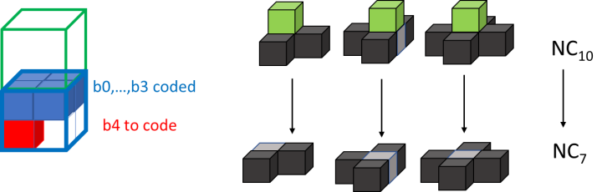

Figure 8: application of screening to reduce the number of configurations from 10 to 7

Figure 9 shows another usage of the screening technique for the last child cube CC7 for which the front and right neighbouring volumes are screened by the seven already coded child cubes CC0 to CC6. Consequently, for coding b7, NC7 can be replaced by NC5 that takes only five different values. Tests have shown that a good trade-off between compression performance and size of the coder mappings is to use NC10 for bits b0 to b5, NC7 for bit b6 and NC5 for bit b7, as shown on Figure 7.

At this stage the sizes of the eight sets Ɗj of states, for j=1,…,7, are 10, 20, 39, 76, 149, 294, 391 and 520 respectively. These are reasonable sizes that can be implemented.

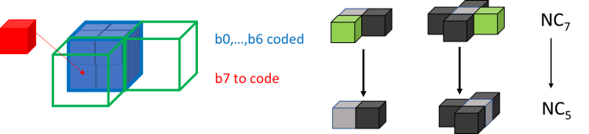

Figure 9: further application of screening to reduce the number of configurations from 7 to 5

#### On further reduction of neighbour configurations (nine neighbour configurations) [27]

Firstly, a minor change in the scan order of the child nodes of the current node must be introduced by swapping bits b5 and b6. This swap is performed to obtain a better screening of b6 from the right.

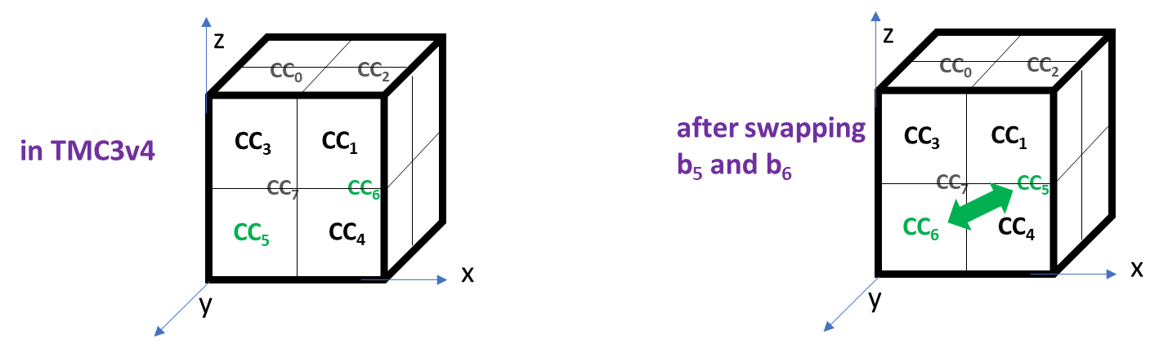

Figure 10: swapping b5 and b6

Secondly, NC10 is reduced to nine neighbour configurations by regrouping NC10=1 and NC10=2 together. Also, a more aggressive reduction is performed down to five configurations for bits b4 and b5, to three configurations for bit b6 and to two configurations for bit b7 as explicated in the figure below.

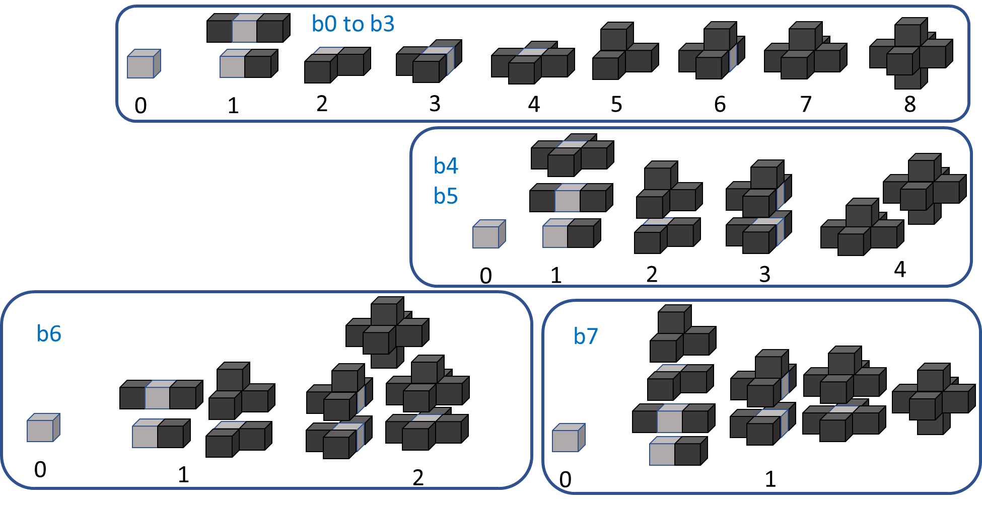

Figure 11: nine neighbour configurations with more aggressive reduction from bit b4

This leads to a significant decrease of the number of states, see table below. The max number of states associated with an occupancy bit has decreased from 520 to 136; the total number of states for all bits has decreased from 1499 to 604.

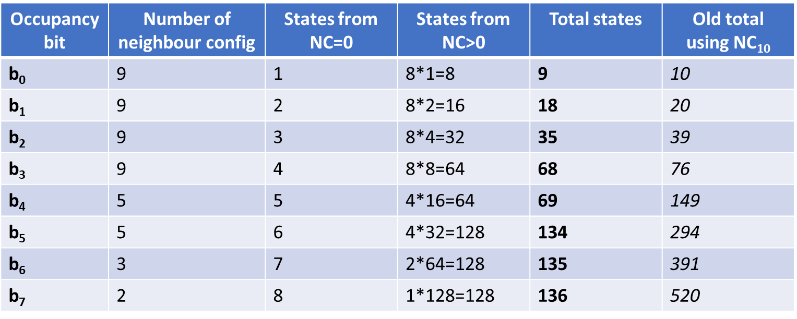

Figure 12: number of states using the proposed nine neighbour configurations

#### On using child nodes of already-coded neighbouring nodes [20][21]

Among the six neighbours sharing a face with a current node, some of them are already coded. Consequently, if they are occupied, their occupancy information is already coded in the bitstream and the occupancy of their child nodes is known by the decoder when processing the decoding of the current node. Therefore, the knowledge of the occupancy of the occupied already-coded neighbours’ child nodes can be used to better code the occupancy information of the current node.

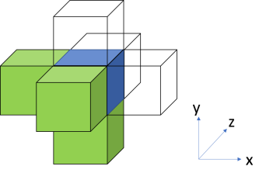 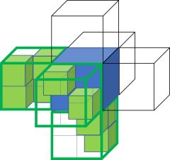

Figure 13: already coded neighbours for a breadth-first scan (left) and children of already-coded occupied neighbours (right)

For example, as shown on Figure 13, when nodes are scanned in breadth-first octree scanning order, in increasing order along the three XYZ axis, there are systematically three neighbouring nodes, sharing a face with the current node, that are already coded. These three nodes are those with lower X, Y and Z coordinates than the current node (Figure 13, left). The child nodes (see Figure 13, right) of the occupied nodes among these three nodes will be used to

* improve the determination of the neighbouring configuration NC10, and
* augment the set Ɗj of states used by OBUF to code the occupancy bits bj of the current node

##### Falsely occupied neighbour

The determination of the neighbouring configuration NC or NC10 as described in section 3.2.2.1 is modified as depicted on Figure 14. Let us consider an occupied already-coded neighbour (red cube on the left of the current node in blue). Instead of systematically taking the neighbour as occupied in the computation of the neighbouring configuration, the occupancy status of this neighbour is determined depending on its child nodes distribution.

If at least one child node is immediately adjacent to the current node, i.e. one of the child’s faces is shared with a face of the current node, then the neighbour is determined as “truly occupied”, thus not changing its status. However, if no child node of the neighbour touches the current node, the neighbour is said to be “falsely occupied”, and its status is set to “non-occupied” in the computation of the neighbouring configuration.

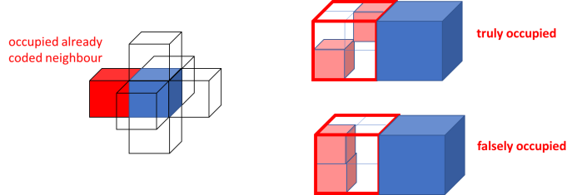

Figure 14: truly and falsely occupied neighbours

##### Occupied child nodes adjacent to a current sub-node

For a given sub-node of a current node, let NT (Number Touching) be the number of all occupied child nodes touching (or directly adjacent to) the sub-node from all already-coded occupied neighbouring nodes of the node. The number NT is computed, before the geometrical transform that reduces the neighbour configurations from 64 to 10. Figure 15 illustrates all possible configurations for a sub-node position adjacent to three already coded neighbour nodes. Depending on the distribution of the touching neighbour child nodes, the NT value is comprised between 0 and 3. As shown in Figure 16, the maximum value for NT is 1 as the sub-node touches only one already-coded neighbour node. One also understands that the top-right-rear sub-node of any node necessarily has NT=0 as this sub-node does not touch any already-coded neighbour.

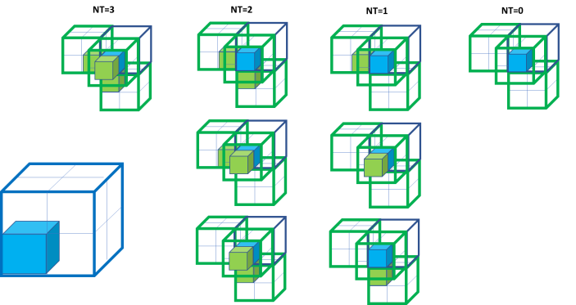

Figure 15: example of values of NT depending on neighbour’s child nodes distribution

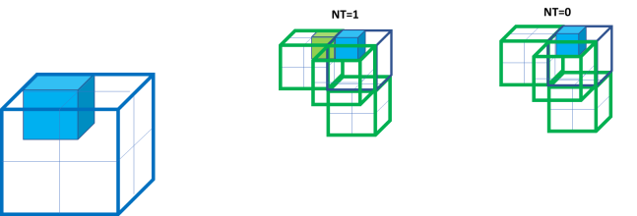

Figure 16: another example of values of NT depending on neighbour’s child nodes distribution

After applying the geometrical transform to reduce the neighbouring configuration, each of the child node CCj (as depicted in Figure 10) inherits a value NT[j] indicating the number of neighbour’s occupied child nodes touching the child node. This value can be used to augment the sets Ɗj of states. It has been observed that the case NT[j]=3 is marginal and does not provide extra information to OBUF compared to NT[j]=2. Therefore, in order to minimize the size of the set of states, the value NT[j] is capped to the value 2 to obtain the new value C[j]. The set of states is then augmented as follows

The sets Ɗj of states are practically small enough as reductions based on anisotropy and screening do still apply. By construction, not all combinations of the neighbouring NC10 configuration and C[j] are possible. For example, when NC10=0 (no occupied neighbours), C[j] value is always zero. In another example, when NC10=1, then C[j] is at most one, and necessarily zero for the four child nodes CCj (j=0,3,5,7) on the left on the Figure 10. All those natural reductions lead to sets of states not bigger than a thousand states in average.

##### On an improvement of advanced neighbours[28]

This method replaces the count C[i] of occupied child nodes of occupied neighbours that are adjacent to the current child node to code (occupancy bit bi) by the following information (see figure below)

* the number of occupied child nodes of occupied neighbours, i.e. essentially the same as C[i]
* the number of missed (=non-occupied) child nodes of occupied neighbours

that are adjacent to the current child node.

Then two quantities are deduced

* C[i] = min(2,occupied)
* M[i] = min(1,missed)

then combined into CM[i] = M[i] + 2*C[i] that can take six valued in [0,5]. A reduction is performed, for i>4, as follows

* Nadv[i] = CM[i] if i<=4
* Nadv[i] = LUT_red[CM[i]] if i>4 where LUT_red = {0,0,1,2,3,3}.

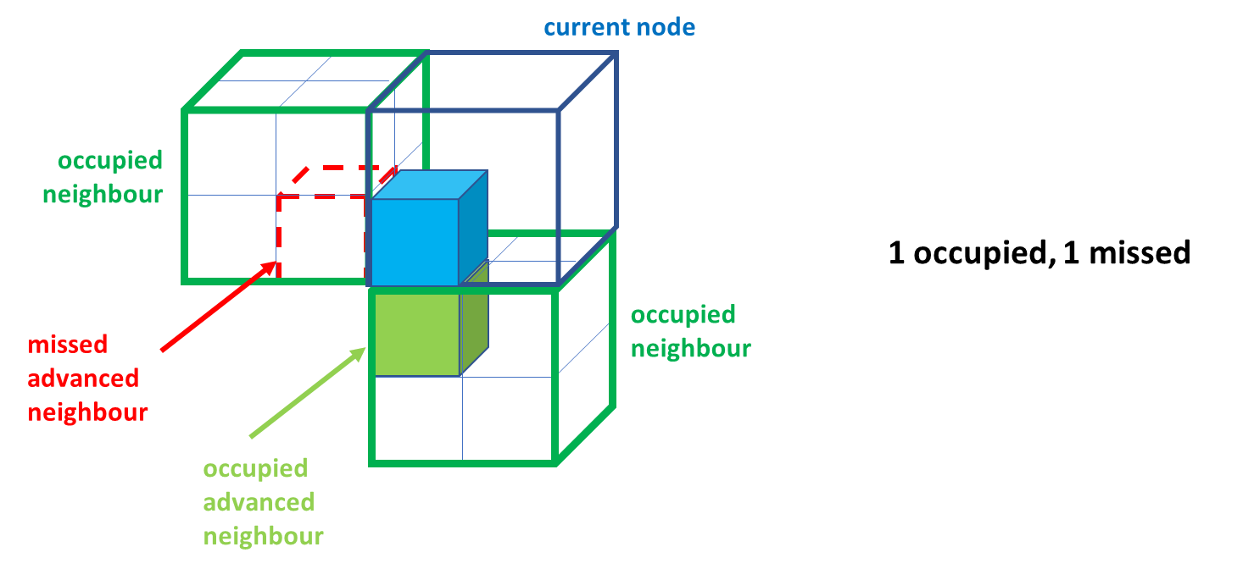

Figure 17: definition of occupied/missed advanced neighbours

##### Incompatibilities between NC9 and new advanced neighbour states Nadv[i][29]

For example, considering the empty configuration NC9 = 0, obviously C[i] must be 0 because there can’t be any occupied advanced neighbour. However, due to “falsely occupied” (see section 3.2.2.4.1), there may be missed advanced neighbours.

Generally speaking, due to “falsely occupied” neighbours, M[i] may be 0 or 1 for any configuration. In the general case, the max value for Nadv[i] depends on

* the position of the child node, i.e. the index i
* the value of the configuration NC

Figures below depict the max possible values for occupied/missed advanced neighbours depending on the index I of the occupancy bit bi and on the neighbour configuration NC.

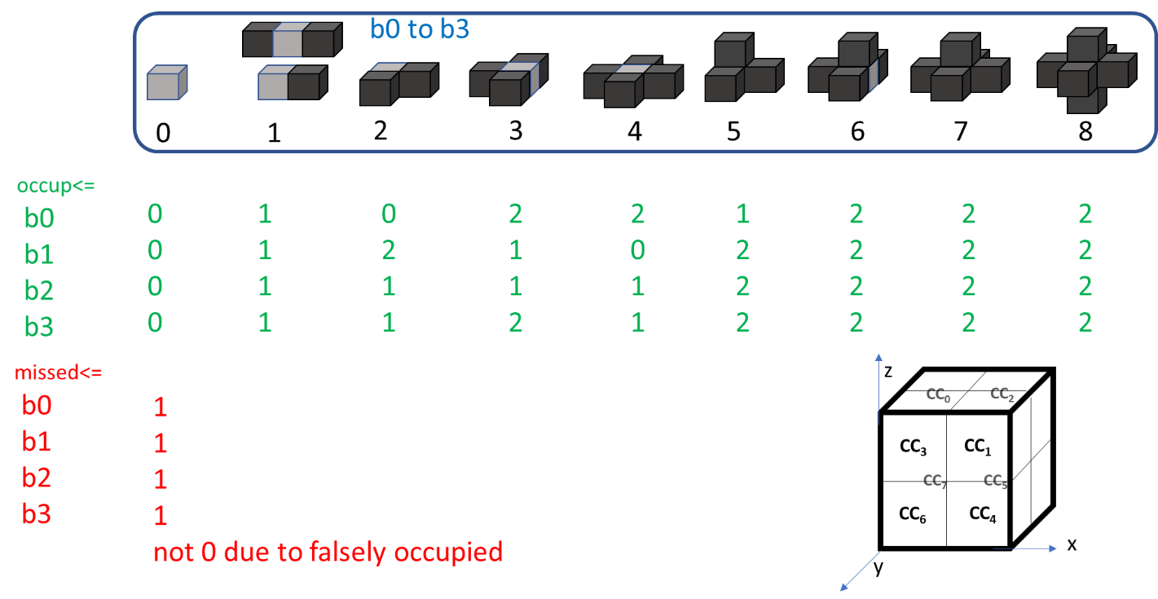

Figure 18: max possible values for occupied/missed advanced neighbour for bits b0 to b3

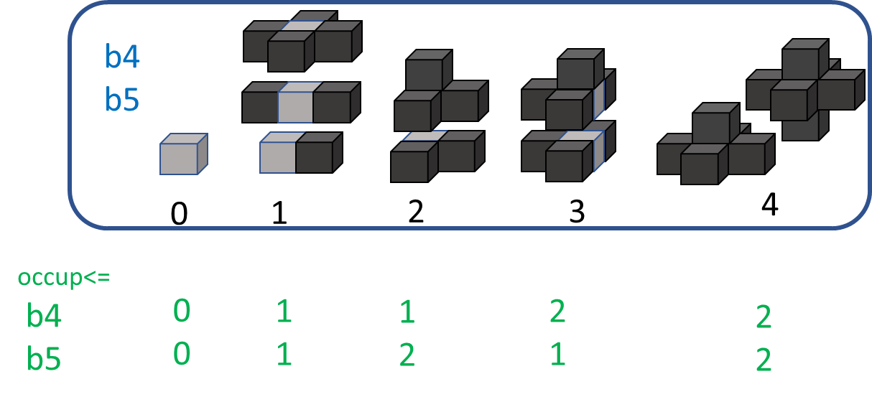

Figure 19: max possible values for occupied/missed advanced neighbour for bits b4 and b5

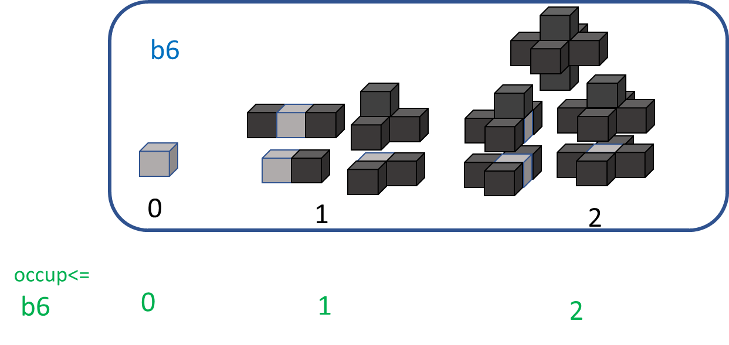

Figure 20: max possible values for occupied/missed advanced neighbour for bit b6

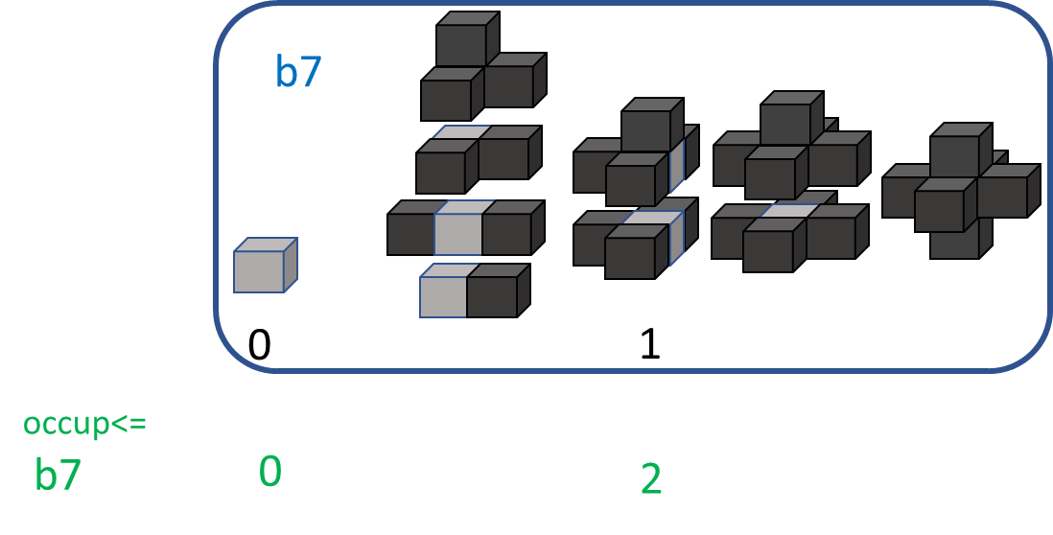

Figure 21: max possible values for occupied/missed advanced neighbour for bit b7

The max value for Nadv[i] is given by

* max Nadv[i] = max missed[i] + 2* max occup[i]

and, in case i>4, then the LUT_red = {0,0,1,2,3,3} is applied to this max. This leads to the below in term of number of states.

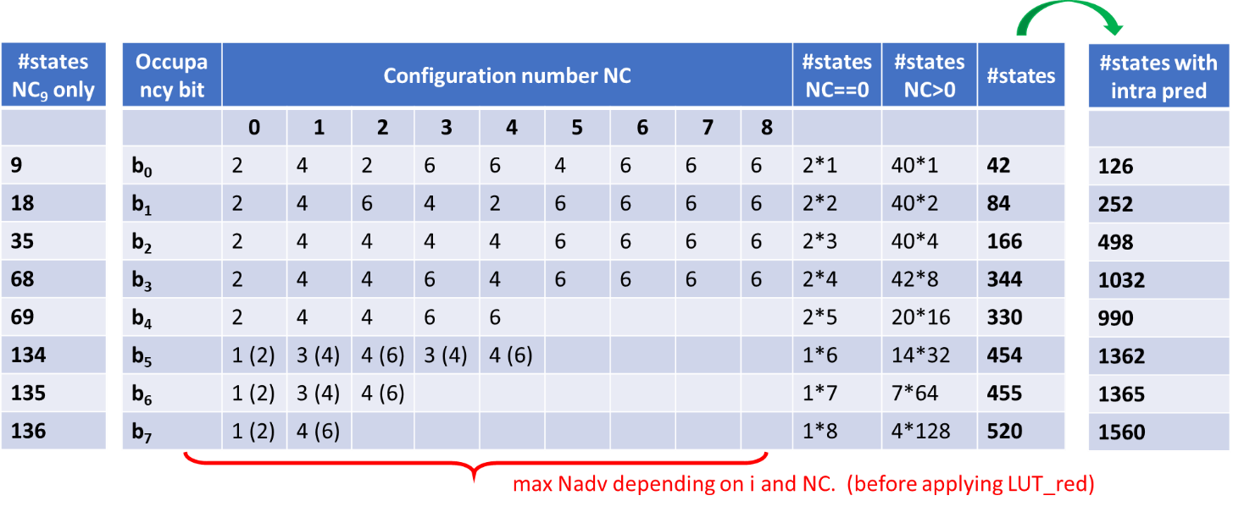

Figure 22: number of states when considering incompatibilities between NC and advanced neighbours

#### Look ahead table [9]

The current octree-based geometry approach exploits an octree-based subdivision of the 3D space in order to efficiently encode regions containing points. At each level of subdivision of the octree, cubes of the same size are subdivided and an occupancy code for each one is encoded.

* + For subdivision level 0, it has single cube of (2C,2C,2C) without any neighbors.
  + For subdivision level 1, it may have up to 8 cubes of dimension (2C-1,2C-1,2C-1) each
  + …
  + For subdivision level L, it may have up to 8L cubes of dimension (2C-L,2C-L,2C-L) each

At each level L, TMC13 defines a set of non-overlapping look-ahead cubes of dimension (2H-C+L,2H-C+L,2H-C+L) each, as described in Figure 23. Note that the look-ahead cube can fit 23xH cubes of size (2C-L,2C-L,2C-L).

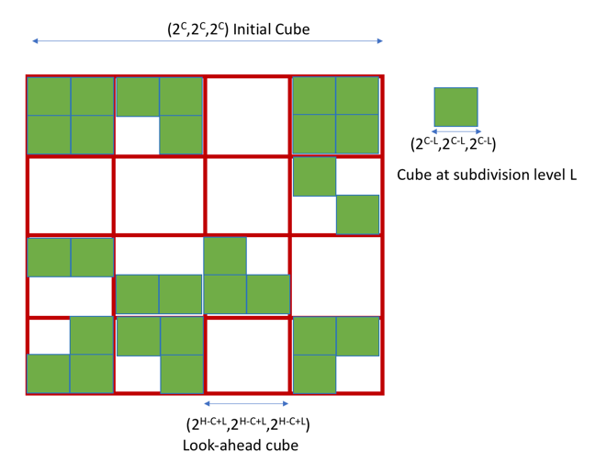

Figure 23: Look-ahead cubes

At each level L, TMC13 encodes the cubes contained in each look-ahead cube without referencing cubes in other look-ahead cubes. This later constraint makes it possible to use a look-up table with a pre-defined (and limited) size to store neighborhood information of the all the cubes within each look-ahead cube. Such a look-up-table-based approach offers the advantage of avoiding the linear search required in [8], at the cost of slightly higher memory usage (i.e., space to store the LUT) and slightly lower compression efficiency.

TMC13 proceeds as follows:

* During the look-ahead phase, the cubes of dimension (2C-L,2C-L,2C-L) in the current look-ahead cube are extracted from the FIFO and a look-up table that describes for each (2C-L,2C-L,2C-L) region of the current look-ahead cube whether it is occupied or empty is filled.
* Once, the look-up table was filled, the encode phase for the extracted cubes begins. Here, the occupancy information for the 6 neighbors is obtained by fetching the information directly from the look up table.
* For cubes on the boundary of the look-ahead cube, the neighbors located outside are assumed to be empty.
* Efficient implementation could be achieved by
  + Storing the occupancy information of each group of 8 neighboring (2C-L,2C-L,2C-L) regions on one byte
  + Store the occupancy bytes in a Z-order to maximize memory cache hits

#### Sibling dependent coding [10]

In TMC13, 10 coding tables are used in arithmetic coding. The switching between the coding tables is controlled by the six neighbours of the current parent node, shown in Figure 24.

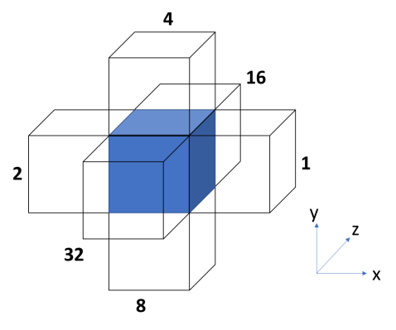

Figure 24: Six neighbours used to decide the switching of the coding table

During encoding/decoding, the neighbour information for the child node is obtained by searching the encoded/decoded nodes. Information of the encoded/decoded node is also updated by the newly encoded/decoded one. In this way, the six-neighbour information of each child node could be fully obtained by the searching and updating. The same process exists in each level of the octree (except for the last one).

Among the 6 neighbours, three of them are easy to be obtained without any searching. They are shown in Figure 25.

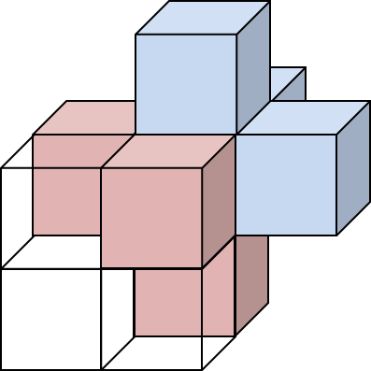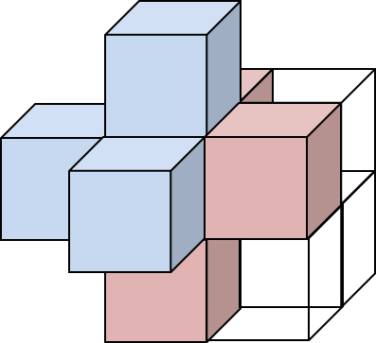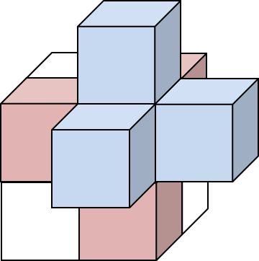

Figure 25: Three of the six neighbours are in the same node in the grand parent point of view. Pink nodes are in the same 2x2x2 node, while the other 3 (blue) are outside of the node.

The occupancy of three children that outside of volume of the current parent node is more difficult to be checked. The searching is needed for these three outside children. The other half of the neighbour information could be obtained by checking the occupancy code of the parent node. The efficiency could be improved if the searching process is skipped, since checking current occupancy code would be simpler than searching in the coded node.

The neighbour information retrieval method only considers the three sibling neighbours in case of the parameter neighbourAvailBoundaryLog2 equal to 0 in TMC13 software. For all the child locations, local neighbours are shown in Figure 26.

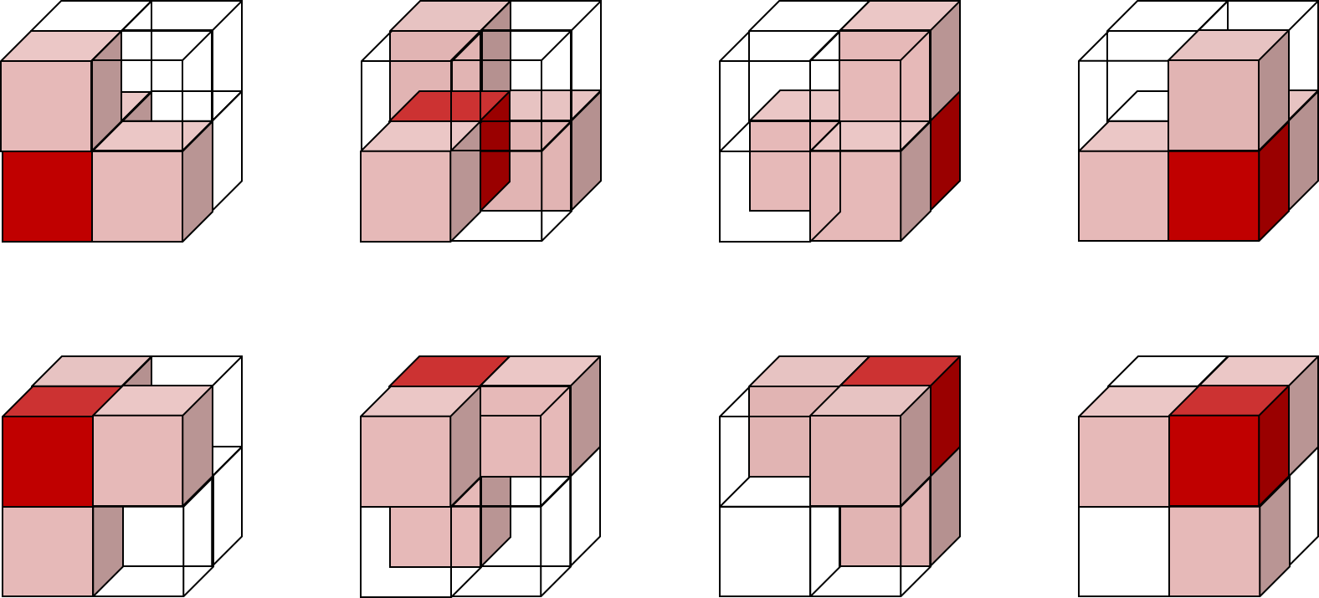

Figure 26: Possible neighbours (pink) in eight cases

In the reduction, the three non-sibling neighbours are considered non-exist. The 64 neighbour configurations are reduced to 6:

* 0 occupied neighbor.
* 1 occupied neighbor, with target node they are horizontal to the x-y plane.
* 1 occupied neighbor, with target node they are vertical to the x-y plane.
* 2 occupied neighbors, with target node they are horizontal to the x-y plane.
* 2 occupied neighbors, with target node they are vertical to the x-y plane.
* 3 occupied neighbors.

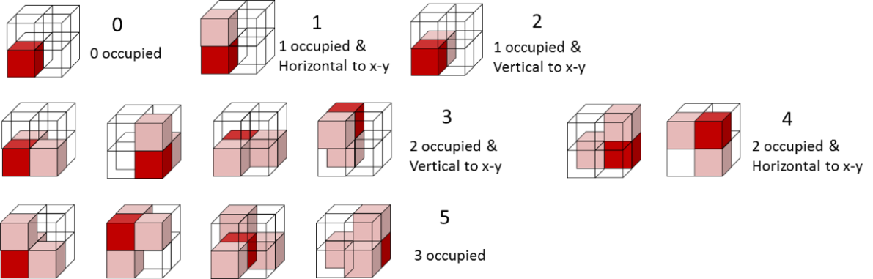

Figure 27: 6 configurations used in selecting coding tables

### Intra prediction [11]

Using the six neighbours of the same depth and sharing a face with a current node does not provide all possible information about the local geometry. Ideally, one would like to use at least the 26 neighbours that share a face, an edge or a vertex with the current node. Obviously, the number of possible patterns of occupancy for the 26 neighbours is by far too high to be directly used in the sets Ɗj of states, even trying complex and tricky direct state reductions. In this section, it is proposed to reduce the 26-neighbour pattern to a ternary information that predicts the value of the occupancy bits bj. This process will be called intra prediction. The practical feasibility of using as many as 26 neighbours has been made possible by a fast and efficient search of neighbours introduced in [23].

#### The occupancy score from the 26 neighbours

Firstly, before applying the geometrical transform that reduces the neighbour configurations from NC to NC10, an occupancy score scorem is computed for each of the eight sub-nodes SNm (m=0,…,7) of a current node by using a weighted sum over the 26 neighbours

where m is the sub-node index, k is a neighbour index, wk,m is the contribution (weight) from neighbour k to sub-node m, and δk is the occupancy status (0 for non-occupied, 1 for occupied) of the neighbour k, as depicted on Figure 28.

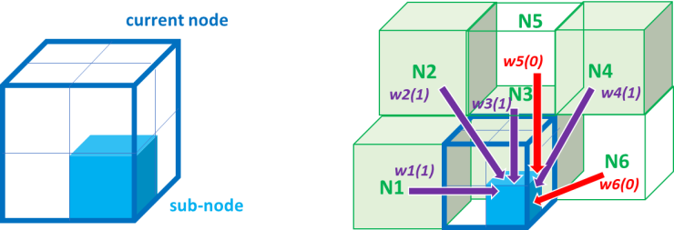

Figure 28: weights between neighbours and sub-nodes of a current node

Using the usual anisotropy argument, the weights are considered as a function W of the Euclidian distance dk,m, between the neighbour k and the sub-node m, and the occupancy status δk.

This function W is found empirically. The distance dk,m can take only eight different values and one gets

where W1 and W2 are two LUTs having eight entries (ordered from the shortest to the longest distance) each and are as follows

W0 = {-1, -6, 12, 20, 14, 28, 22, 12},

W1 = {27, 39, 20, 8, 18, 4, 11, 18}.

The LUTs have been constructed such that a higher score scorem indicates a higher probability of the sub-node SNm to be occupied, and such that the transition between low and high probability of occupancy is the sharpest possible as a function of the score.

#### Score-driven entropy coding

The score can take too many different values to be usable as is in the sets of states. Furthermore, it has been observed that the probability of a sub-node to be occupied depends not only on the score but also on the number No of occupied neighbours among the 26 neighbours.

The score is transformed into a ternary information Predm belonging to the set {“predicted non-occupied”, “predicted occupied”, “not predicted”} of three prediction states by using two thresholds th0(No) and th1(No) that depend on the number No of occupied neighbours. If the score scorem is lower than th0(No), then Predm is set to “predicted non-occupied”; if the score scorem is higher than th1(No), then Predm is set to “predicted occupied”; otherwise the score is between the two thresholds and Predm is set to “not predicted”.

After applying the geometrical transform to reduce the neighbouring configuration from NC to NC10, each of the child node CCj inherits a prediction value Pred[j] and the set of states becomes:

This leads to sizes of the eight sets Ɗj of states multiplied by a factor three because the intra prediction is taken independent on other neighbouring techniques. Basically, this means that the set of states is three copies of the sub-set without prediction, i.e.

The two thresholds are determined empirically for the five cases of occupied neighbours No≤9, No=10, No=11, No=12 and No≥13, and practically obtained from the following two LUTs:

TH0 = {62, 60, 61, 59, 59},

TH1 = {67, 66, 65, 66, 64}.

#### Improved geometry occupancy intra prediction [86]

The improved geometry occupancy intra prediction is introduced to reduce complexity and enhance coding efficiency. This approach counts the number of occupied neighbours, , among the 7 neighbours that share a face, and edge or a vertex with the current sub-node. Figure 29 shows the distribution for each sub-node .

The transformation from occupancy value to a ternary information is dependent on the comparison between and threshold TH0, TH1, where the value of TH0 or TH1 can be taken from 0 to 7.

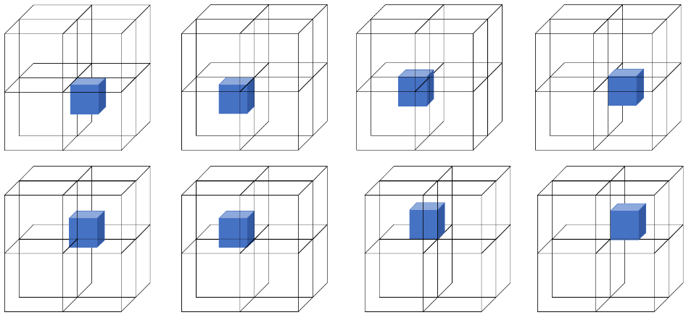

Figure 29: the 7 neighbours that share a face, an edge or a vertex with the current sub-node

The values of TH0 and TH1 are related to the number of occupied neighbours, , among all the 26 neighbours that share a face, and edge or a vertex with the current node, which can take value from 0 to 26.

### Planar coding mode [61]

The planar mode was introduced to code each eligible nodes of the octree more efficiently.

#### Definition of the planar mode

A flag isPlanar is introduced, which indicates whether or not the occupied child nodes belong to a same horizontal plane. If isPlaner is true, then an extra bit planePosition is signaled if this plane is the lower plane or the upper plane.

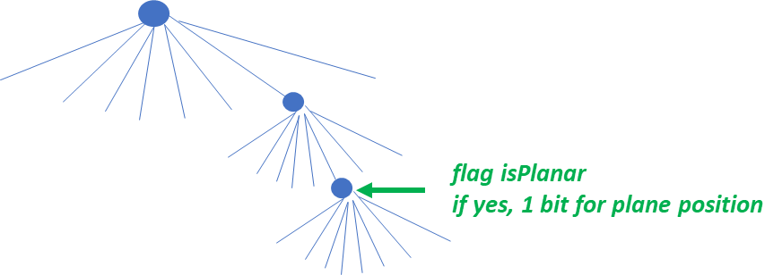

Figure 30: isPanar flag

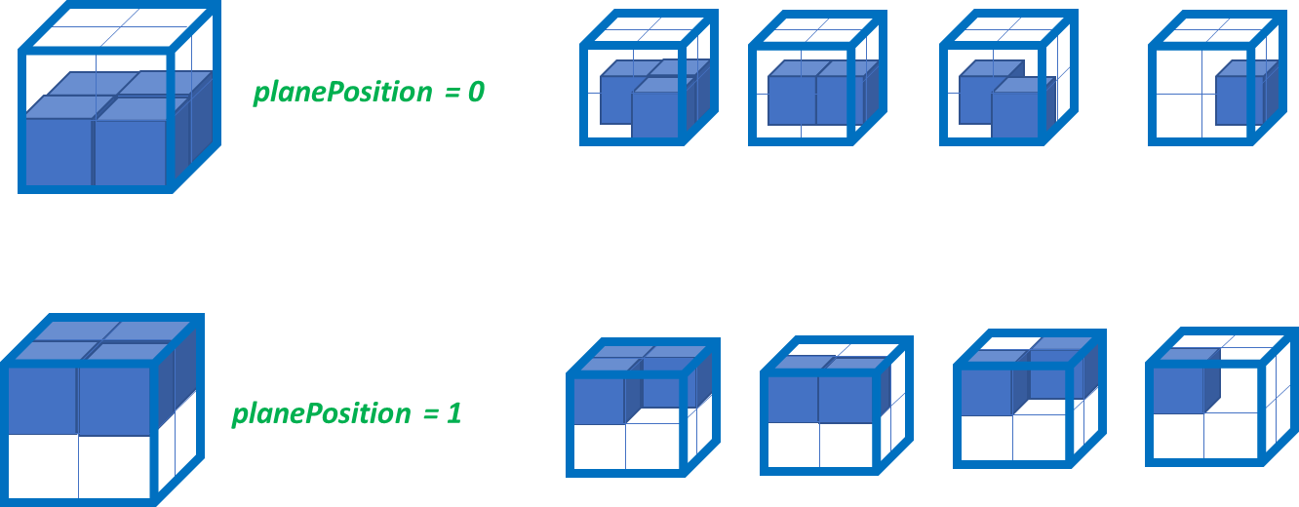

Figure 31: planePosition information

#### Coding of the planar flag of a current node

The planar flag is coded by using a binary arithmetic coder with the 3 contexts based on the axis information.

#### Coding of the plane position of a current node

If the node is planar, the plane position information is coded by using a binary arithmetic coder with 24 (=2x3x2x2) contexts based on the following information,

* The occupancy of the parent vertical neighbour adjacent to the current node
* The distance d from the closest already coded node at same coordinate and depth
  + d is discretize into three values : “near” or “not too far” or “far”
* The plane position (if any) of the closest already coded node at same coordinate and depth
* The vertical coordinate of the current node relative to its parent node

1 specific context in case the closest already coded node at same z and depth is not planar.

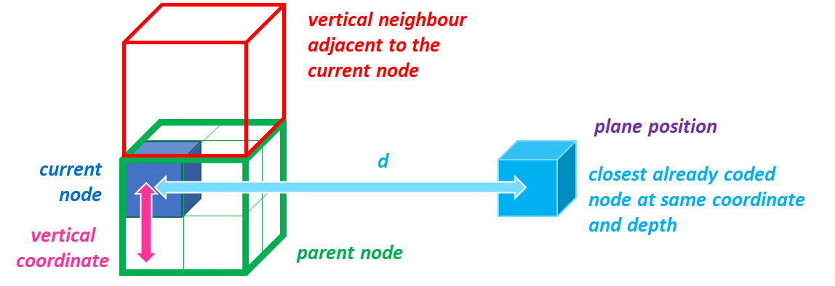

Figure 33: a plane position coding scheme

#### Simplificaiton on coding plane position flag [135]

The simplificaiton on coding plane position flag was introduced as following.

* when the current node is at the low plane of its parent:



(a) (b) (c)

Figure 34: Neighbour occupancy with current node locating at the low plane of its parent (a) low yoz plane (b) low xoz plane (c) low xoy plane

Taking Figure 34 (a) as an example, the red node represents the current node whose *planePosition* flag is to be predicted. The blue nodes are its siblings in the same parent. The green node is the adjacent neighbour of current node. It is thus reasonable to have the following inference:

a．If any of the sub-nodes 4 to 7 of the green node are occupied and all the blue nodes are unoccupied, it is strongly likely that there is a plane in the red node (current node) and the plane position is low.

b．If sub-nodes 4 to 7 of the green node are all unoccupied and any of the blue nodes are occupied, it is strongly likely that there is a plane in the red node (current node) and the plane position is high.

c．If sub-nodes 4 to 7 of the green node are all unoccupied and all the blue nodes are unoccupied, we cannot infer the plane position, and thus it is labelled as unknown.

d．If any of the sub-nodes 4 to 7 of the green node are occupied and any of the blue nodes are occupied, we cannot infer the plane position, and thus it is labelled as unknown.

* when the current node is at the high plane of its parent:



(a) (b) (c)

Figure 35: neighbour occupancy with current node locating at the high plane of its parent (a) high yoz plane (b) high xoz plane (c) high xoy plane

Taking Figure 35 (a) as an example, the red node represents the current node whose *planePosition* flag is to be predicted. The blue node is its sibling in the same parent. The green node is the adjacent neighbour of current node but not in the same parent. It is thus reasonable to have the following inference:

a．If any of the sub-nodes 4 to 7 of the blue node are occupied and the green node is unoccupied, it is strongly likely that there is a plane in the red node (current node) and the plane position is low.

b．If sub-nodes 4 to 7 of the blue node are all unoccupied and the green node is occupied, it is strongly likely that there is a plane in the red node (current node) and the plane position is high.

c．If sub-nodes 4 to 7 of the blue node are all unoccupied and the green node is unoccupied, we cannot infer the plane position, and thus it is labelled as unknown.

d．If any of the sub-nodes 4-7 of the blue node are occupied and the green node is occupied, we cannot infer the plane position, and thus it is labelled as unknown.

Based on the above inferences, the contexts used for coding the *planePosition* flag can be simplified as follows:

1. The *planeposition* of current node predicted by the occupancy information of its neighbors. (three values: predicted as low, high, or unknown)
2. The distance d from the closest already coded node at same coordinate and depth d is discretized into three values: “near” or “far”.
3. The plane position (if any) of the closest already coded node at same coordinate and depth. (low or high)
4. axisIdx (value=0,1, or 2) identifying the axis normal to a plane.

In case the closest already coded node at same coordinate and depth is not planar or non-exists, modification of the context is as follows:

1. The *planeposition* of current node predicted by the occupancy information of neighbors (three values: low, high and unknown).

Compared with previous model, the number of the contexts for coding *planePosition* flag was reduced from 72 to 39 (36 + 3).

#### Determining the closest already coded node at same coordinate

* using a rolling buffer (of length 4)
* for each possible coordinate
  + keep track of the four last already coded nodes at same coordinate
    - stores x or y or z and plane position for the already coded nodes
  + determine the closest node from the buffer using (x,y)
    - swap the closest to front
* the size of the buffer is at most 2^depth

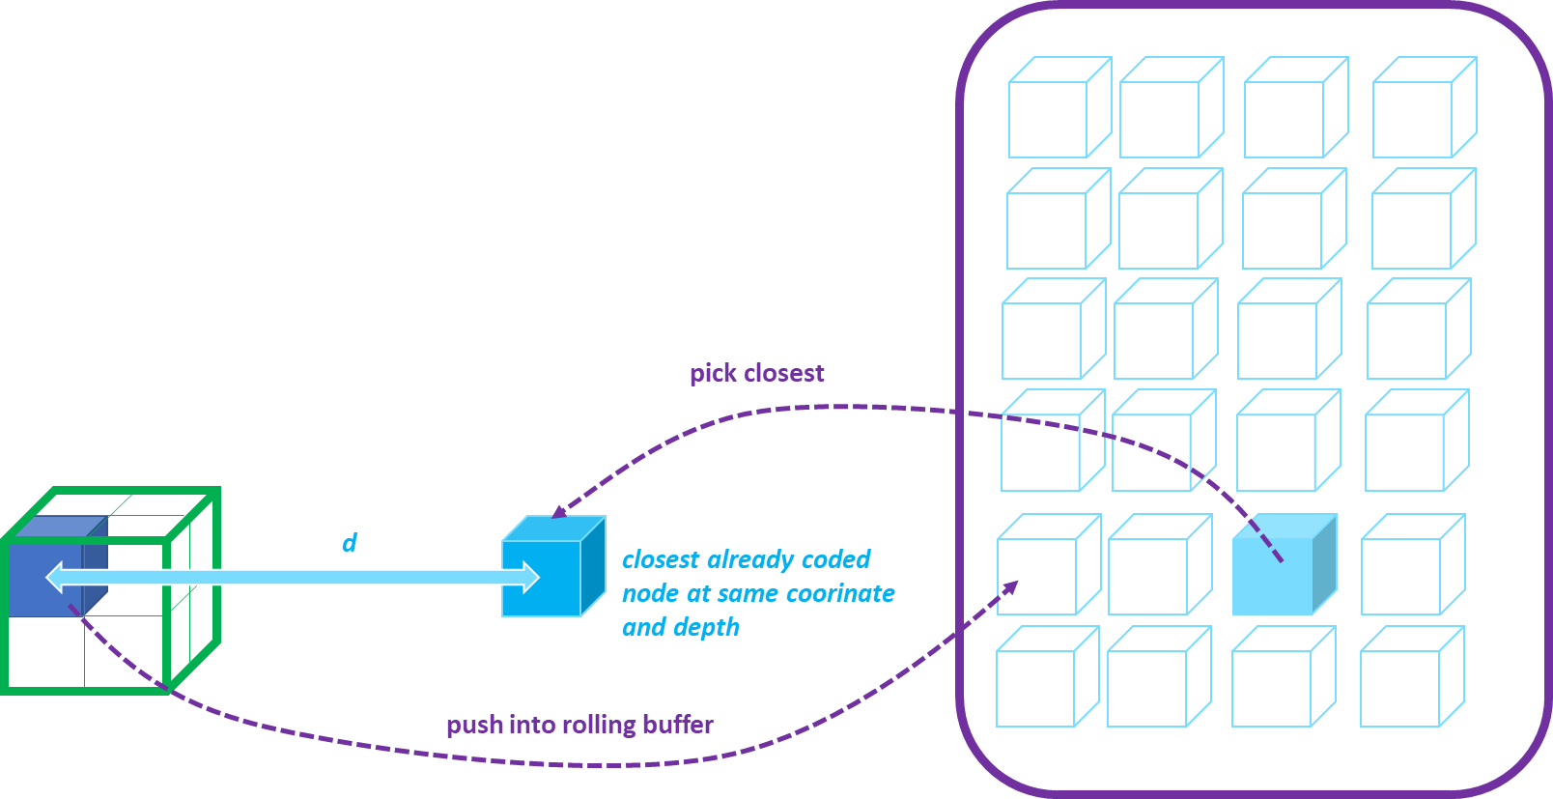

Figure 36: how to determine the closest already coded node with rolling buffer

#### Eligibility of a current node to planar mode

The eligibility criterion is based on tracking the probability of past coded node being planar

* eligible if and only if

p = prob(planar) >= threshold and local_node_density > 3

* typical threshold value is 0.6

Updating the probability prob(planar)

* using a channel model



* with length L=255
* where δ(coded node) is 1 if the coded node is planar and 0 otherwise

Update is performed when

* a node occupancy is (de)coded
* or/and a node planar information is (de)coded

Tracking the local node density

* rolling average of number of occupied siblings

#### Planar mode in three directions

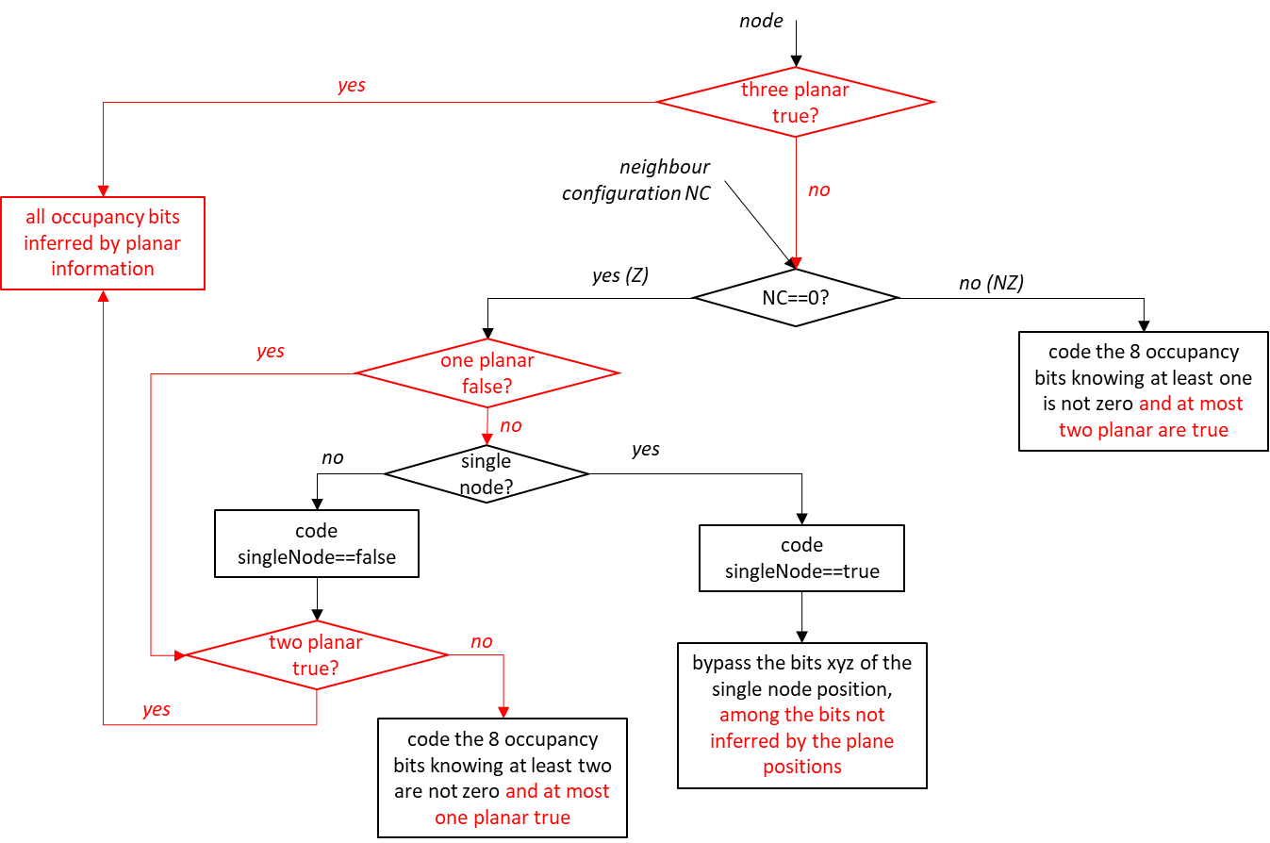

Figure 37: Coding of occupancy bits with three planar modes xyz

#### Eligibility of a current node to xyz-planar mode

The simple juxtaposition of eligibility criteria does not work.

* Sub-optimal because a first activated planar mode masks 4 occupancy bits in the current node, but a second activated planar mode will then only mask 2 bits of the remaining 4, and a third one would mask only 1 bit of the remaining 2

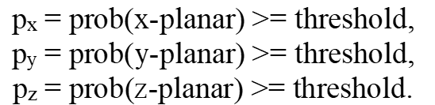

A combined eligibility criterion that preserves symmetry

* does not preclude that one direction is more important than the other two
* definition of “first”, “second” and “third” planar mode is based on the probabilities px, py and pz
* three thresholds th1 < th2 < th3 (typical values 0.6, 0.77, 0.88)

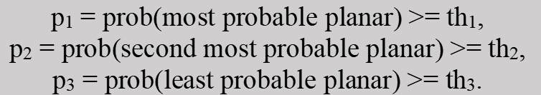

Eligible if local node density >3

#### Planar mode buffer optimization [80]

To further reduce the amount of memory needed by a planar buffer, it is introduced to

1. limit the number of buffer rows per buffer grid,
2. reduce the number of elements per buffer row,
3. reduce the memory needed per buffer element.

##### Limiting the number buffer of rows per buffer grid

Instead of using the *dim* coordinate value to select a buffer row in the planar-*dim* buffer, it is introduced to select a buffer row according to the lowest N-bits of the *dim* coordinate of the coded node. It allows to limit to 2^N the number of buffer rows per buffer grid. Then the buffer grid works like a kind of hash table. But, on the contrary of a hash table, hash collisions are no handled to keep tracking of each *dim* value. Instead; hash collisions are used as a mean to reduce memory: two *dim* values with the same hash value are handled as if they were the same *dim* value. By keeping lowest N-bits of the *dim* coordinate as hash function, nodes with a close *dim* coordinate will not have hash collisions in the table and, so when successively coding nodes in the tree, close nodes in dimension *dim* will not interfere in the buffer content.

The introduced changes are shown in red in Figure 38.

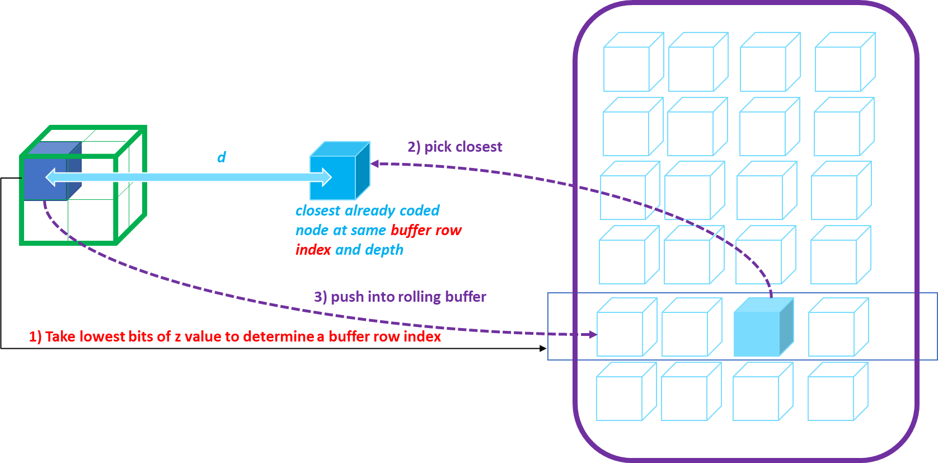

Figure 38: Buffer to determine the closest already coded node at same buffer row index, when limiting the number of buffer rows

The distance to find the closest node is still computed as if the nodes in the buffer row have the same *dim* coordinate. It is then still computed on the two other coordinates only. So, it is not needed to add the *dim* coordinate in the buffer element. Then, it does not introduce additional complexity or memory consumption per buffer element.

The buffer memory reduction depends on the volume dimension, and on the chosen N value.

For a buffer at a tree depth *Ddim*, memory reduction factor is 1/2^(max(0, *Ddim* - N)).

##### Reducing the number of elements per buffer row

Instead of using of using M = 4 elements per buffer row, it is introduced to reduce this number of elements. The maximum memory reduction factor is ¼, when the number of elements per buffer row is reduced to 1. This particular case has the advantage of also removing the closest node search and the reordering of the buffer elements. It is illustrated in Figure 39, and the changes are put in red.

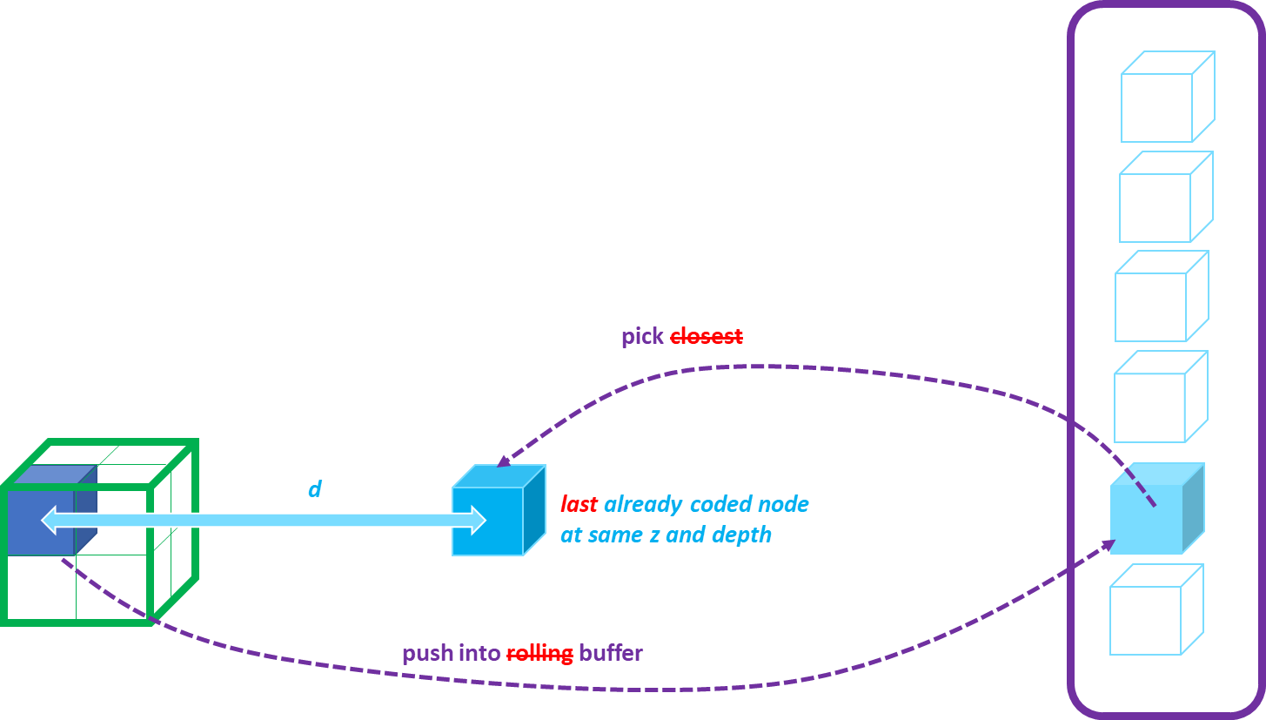

Figure 39: Buffer to determine the closest already coded node at same buffer row index, when limiting the number of elements per buffer rows to 1.

##### Reducing the size per buffer elements

Instead of using two 32-bits integer values to store the two coordinates (*a, b*) other than *dim* coordinate (e.g. x and y for planar-z buffer), it is introduced to store them on a reduced number of bits.

These two (*a, b)* coordinates are used to compute a distance *d* between the coded node and previously coded nodes in a same plane (e.g. with same z-coordinate), using the *L1* norm. The distance *d* is used to find a closest node on the same plane, and the distance *d0* to the closest node is used to determine coding context for planar mode flags. Coding context are determined by categorizing *d0* into three categories: category “near” for *d0* ≤ 2, category “not too far” for 2 < *d0*≤ 16, and category “far” for *d0*> 16.

Even if lowest bit of *a*, and *b* are ignored, the categorization is still the same. It is then possible to remove the lowest bit of *a*, and *b* when storing them without affecting too much the coding efficiency (the only changes is noise related to the reordering of the buffer that can be slightly different, because chosen closest node can be slightly different du to possible distance equality when comparing two distances were a difference of 1 would be obtained if the full precision was kept).

Removing that bit allow for storing on the two 32-bits integer values, both *a* and *b* and the two bits for storing planarity information.

It is also possible to remove some of the highest bits of *a* and *b* without affecting to much the compression efficiency. This is because high distances with the nodes in the buffer will statistically not occur frequently, and so, only relying on lowest bits for context modeling is sufficiently “stable” to provide coding gains (erroneous distances are not so frequent).

It is then introduced to use the following operations to limit the number of bits of *a* and *b* of the current node:

constexpr int  shiftAB = 1

constexpr int maskAB = ((uint64_t(1)<<ABBits)-1)<<shiftAB;

a = (a & maskAB)>>shiftAB;

b = (b &  maskAB)>> shiftAB;

where shiftAB is used to remove lowest bit, and ABBits is the number of bits to be stored in the buffer per coordinate, and as to be fixed as a compromise between memory reduction versus compression efficiency.

One possible way to store a buffer element information is then to use the following structure:

struct GeometryPlanarNeighbor {

  // (a, b) are (x, y) for planar z, (x, z) for planar y and (y, z) for planar x

  unsigned int a:ABBits;

  unsigned int b:ABBits;

  int planeIdx:2; // -2: not used, -1: not planar, 0: plane 0, 1: plane 1

};

Then the distance computation can be performed as

int dist0 = std::abs(a - buffer[idxP].a) + std::abs(b - buffer[idxP].b);

where idxP is the index in the buffer row of the element to be compared to the current node coordinates *a*, *b*.

To compensate for the removed lowest bit the categorization of *d0* for context determination can be adjusted to: category “near” for *d0* ≤ 1, category “not too far” for 1 < *d0*≤ 8, and category “far” for *d0*> 8; or alternatively the computed distance can be multiplied by 2 (or left shifted by one).

For the sake of memory alignment, it is recommended to choose the ABBits value as being one of 3, 7, 15 or 31, so that the total structure size can be stored in 1, 2, 4 or 8 bytes.

### Angular coding mode [63]

The angular mode was introduced to improve planar coding mode. It uses the child node angular distance from laser angles to improve compression of binary occupancy coding through the prediction of the plane position of the planar mode and the prediction of z-coordinate bits in IDCM nodes.

#### Corrected angles per laser beam

The data captured with laser beam includes vertical angle dispersion due to noise, measurement precision and inaccuracy of laser position/origin. So, it is corrected as following.

The vertical angle without correction is calculated as following,

Herein, (, , ) indicates a lidar absolute head position.

The vertical angle with correction relative to a laser position (,) in Figure 40 is calculated as following,

Practically, only is significant for the relative position, so is omitted. Note that the correction does depend on a particular laser L. This corrected laser angles are used in angular coding mode.

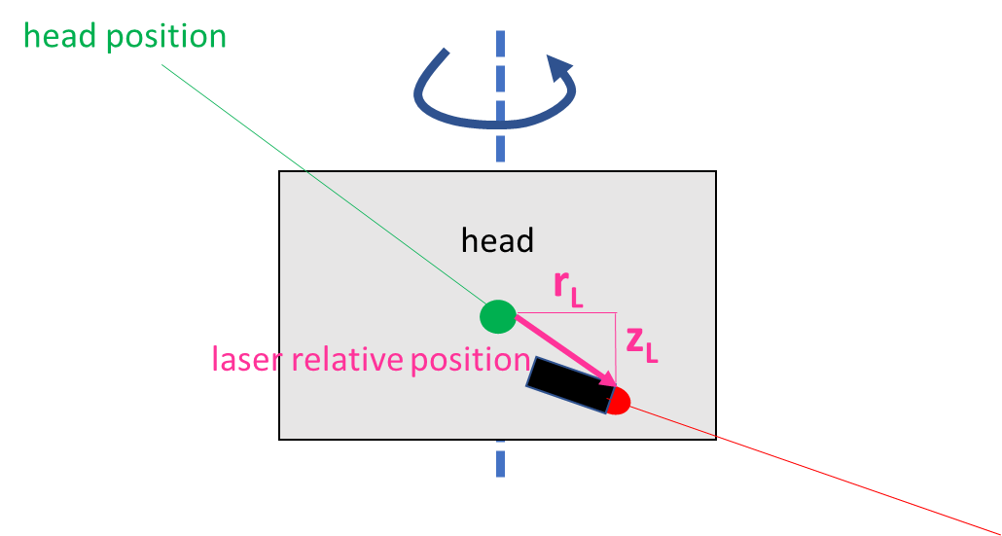

Figure 40: Lidar head position and laser relative position

#### Angular eligibility and determination of the corrected vertical angle

The angular coding mode is applied for nodes where the «angular size» node_size / r is small enough for the eligibility with r relative to the lidar head position (, , ), i.e. if the angular is lower than the smallest angular delta between two laser |tan(θL1) - tan(θL2)|.

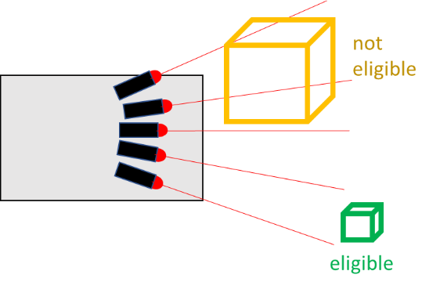

Figure 41: Angular eligibility

Then, if the eligibility condition is true, the corrected vertical angle of a node is calculated. At first, non corrected angle is calculated as following,

Herein, the center (x,y,z) of the node and the lidar head position (, , ) are used. Then, it is determined to which closest laser L the node belongs to this laser L such that | tan(θ) - tan(θL)| is minimum. Finally, the corrected vertical angle is calculated as following,

#### Enhancing planar mode using angular contexts

The angular information enhances the plane position set of contexts. At first, the corrected vertical angles tan(θbottom) and tan(θtop) of the two bottom and top virtual planes are calculated by using the center of the virtual planes.

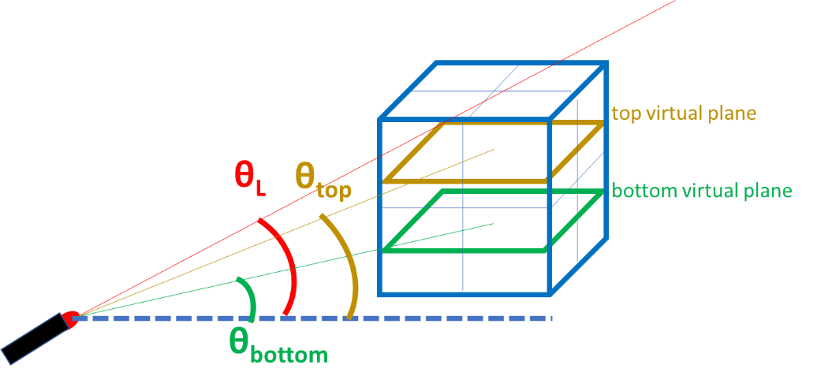

Figure 42: Corrected vertical angles tan(θbottom) and tan(θtop)

Then, an angular context for planePositionZ is selected based on tan(θL), tan(θbottom) and tan(θtop) from 10 angular context values. It depends on

* Which of m =|tan(θL) - tan(θbottom)| and M=|tan(θL) - tan(θtop)| is minimum (2 possible values)
* the quantization of |m-M|*r (over 5 values depending on a constant α)
  + <=0.5*α
  + in ]0.5, 1]*α
  + in ]1, 2]*α
  + in ]2, 4]*α
  + >4*α

#### Enhancing IDCM using angular contexts

IDCM with angular coding mode are introduced to enhance IDCM. In this mode, x,y-coordinate bits are still bypassed while z-coordinate bits are entropy coded using angular contexts. The z-coordinate bit is coded based on a z-interval as following steps (Figure 43, Figure 44),

* Split in two after (de)coding each z-coordinate bit
* Angular prediction of the sub-interval based on angular information
* Angular context to (de)code the bit
* Context determine based on the sub-interval prediction

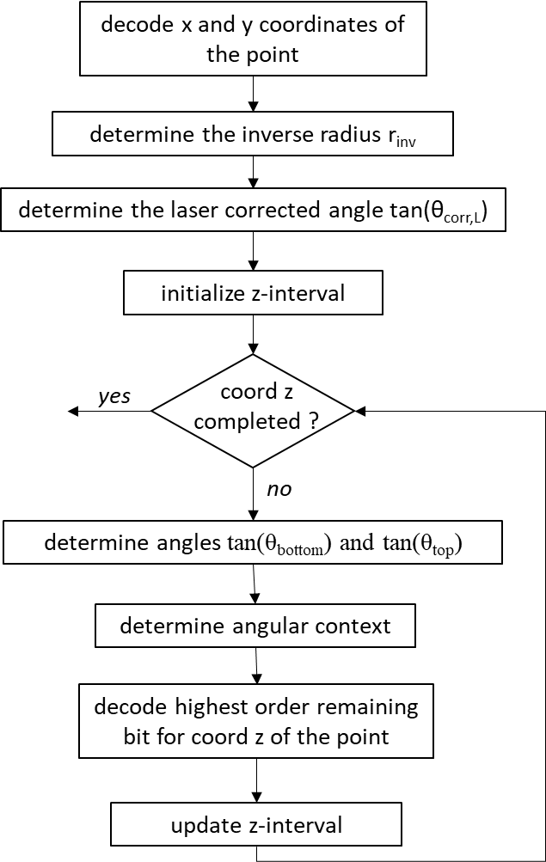

Figure 43: Angular IDCM node

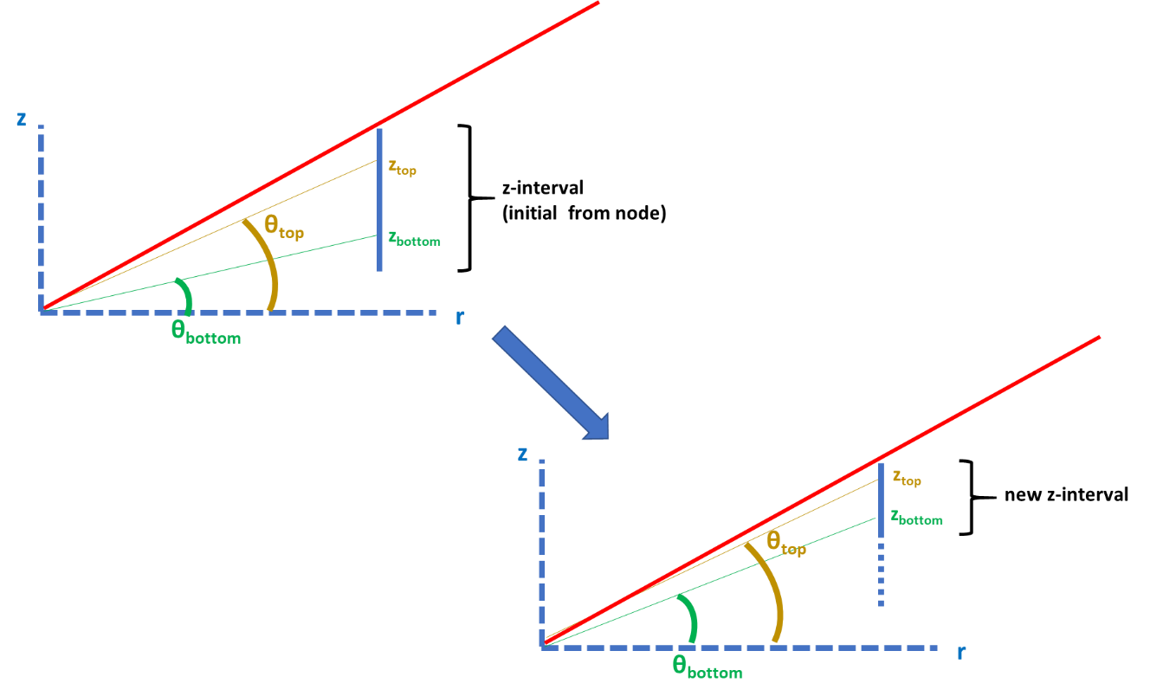

Figure 44: Evolution of the z-interval

#### Context reduction and context derivation simplification for angular mode [109]

It is introduced to use four contexts for coding the planar mode’s vertical plane position in case the angular mode is used. The context index is determined by the laser beam’s position within four intervals. This is illustrated in Figure 45.

|  |
| --- |
|  |

Figure 45: Introduced context index determination for coding the planar mode’s vertical plane position (angular mode) based on laser beam (red) position within intervals separated by yellow lines.

The introduced simplified four-context derivation is specified in Figure 46. The number of conditions is reduced to three, which are highlighted in green. These conditions are simple to implement, because they only check the sign of an integer value.

|  |
| --- |
| …  Firstly, the corrected angular difference relative to the center of the node is determined.  thetaLaserDelta = laser_angle [laserIndex [Child]] - theta32  Hr = laser_correction [laserIndex [Child]] * rInv  thetaLaserDelta += Hr >= 0 ? -(Hr >> 17) : ((-Hr) >> 17)  Then, the angular context is deduced.  zShift = (rInv << ChildNodeSizeZLog2) >> 20  DeltaBottom = thetaLaserDelta + zShift  DeltaTop = thetaLaserDelta - zShift  contextAngular[Child] = thetaLaserDelta >= 0 ? 0 : 1  if (DeltaTop >= 0) contextAngular[Child] += 2  else if (DeltaBottom < 0) contextAngular[Child] += 2  … |

Figure 46: Spec text of introduced simplified four-context derivation for coding planar mode’s vertical plane position (angular mode case).

In the IDCM case, four contexts are determined by the laser beam’s position within similar intervals. This is illustrated in Figure 47.

|  |
| --- |
|  |

Figure 47: Determining context index for coding IDCM’s vertical point position offsets based on laser beam (red) position within intervals indicated by yellow lines (angular mode case).

The introduced simplified four-context derivation is specified in Figure 48. The number of conditions is reduced to three, which are highlighted in green. These conditions are simple to implement, because they only check the sign of an integer value.

|  |
| --- |
| …  A relative laser position thetaLaserDeltaVirtualInterval relative to the middle of the virtual interval is computed by:  zLidar = ((posZlidarPartial[i][j] + halfIntervalSize [j]) << 1) - 1  theta = zLidar*rInv  theta32 = theta >= 0 ? theta >> 15 : -((-theta) >> 15)  thetaLaserDeltaVirtualInterval = ThetaLaser - theta32  Then, the angular context is deduced based on thetaLaserDeltaVirtualInterval.  zShift = ( (rInv << ChildNodeSizeZLog2) >> 18 ) >> j  DeltaBottom = thetaLaserDeltaVirtualInterval + zShift  DeltaTop = thetaLaserDeltaVirtualInterval - zShift  idcmIdxAngular[i][j] = thetaLaserDeltaVirtualInterval >= 0 ? 0 : 1  if (DeltaTop >= 0) idcmIdxAngular[i][j] += 2  Else if (DeltaBottom < 0) idcmIdxAngular[i][j] += 2    … |

Figure 48: Spec text of introduced simplified four-context derivation for coding IDCM vertical point position offsets (angular mode case)

#### On in-tree quantization and angular mode [141]

When quantization is applied to a node position, it was introduced to use the scaled version of the node position (inverse of the quantization operation) and node sizes in the derivation of the context for angular planar and angular IDCM modes. This compares all the node positions in the correct scale space, which is the same space as the LIDAR head position/angular origin.

The changes to the planar mode and IDCM mode context derivations are described below.

**Planar mode context**

In the determination of the context for the planar variable, the scaling operation is applied on the position of the child node absPos, midNode (which denotes half the size of the node) and the childSize (which denotes the size of the node) – the scaled version of these values are used in the context derivation process.

**Determining nodePosition and laser index**

The scaling operation (also referred to as inverse quantization) is initialized with the QP of the node and the quantization mask applicable to the point positions.

Wherever the position of the node w.r.t. to the LIDAR origin is to be estimated, the scaled value of the positions are used. This ensures that the relative position w.r.t. the LIDAR origin is properly estimated, and the laser index, elevation and azimuth are calculated properly. When the node position is updated, by adding a mask value or a node size, the added value is also inverse quantized before addition (or in some cases, the value is added to the unquantized position and then scaled)

**Determining the contexts for angular IDCM**

Similar to the previous section, when the position of the node w.r.t. to the LIDAR head position is compared, the scaled version of the node size and node positions are used.

### Azimuthal coding mode [79]

The azimuthal mode that works similarly to the angular mode was introduced to improve planar coding mode and IDCM nodes coding. It uses azimuthal angle of already coded nodes to improve compression of binary occupancy coding through the prediction of the x or y plane position of the planar mode and the prediction of x or y-coordinate bits in IDCM nodes.

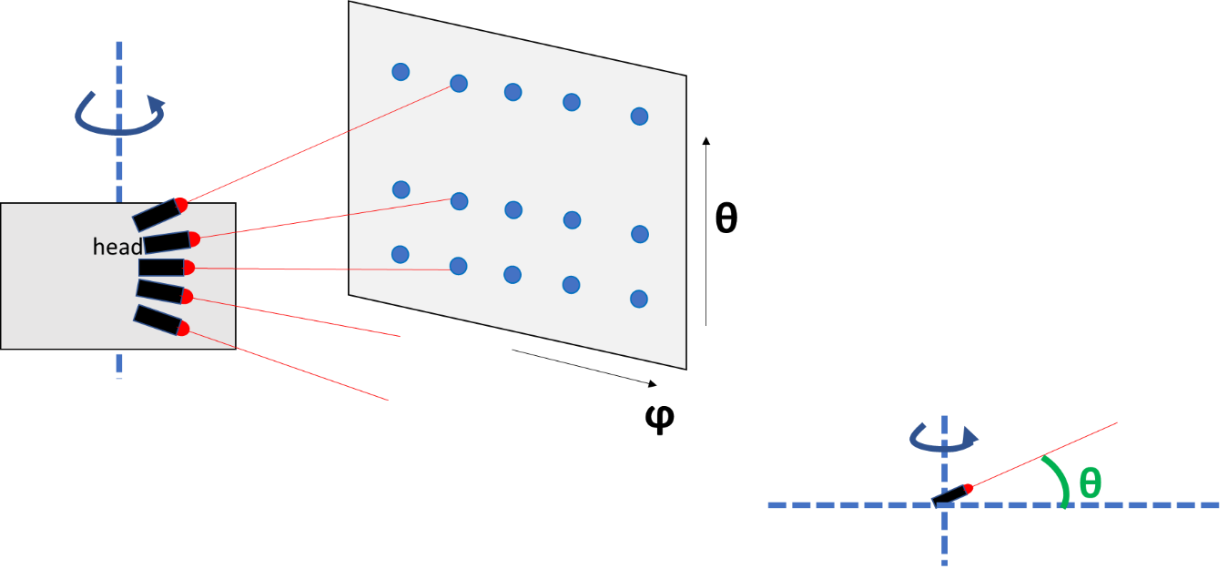

Figure 49: Lidar acquisition by a set of spinning laser beams (theta: angular, phi: azimuthal)

#### Prediction of the azimuthal angle

##### Azimuthal angular eligibility

The azimuthal coding mode is applied for nodes where the «azimuthal angular size» node_size / r is small enough for the eligibility with r relative to the lidar head position (, , ), i.e. if the azimuthal angular is lower than the elementary azimuthal shift .

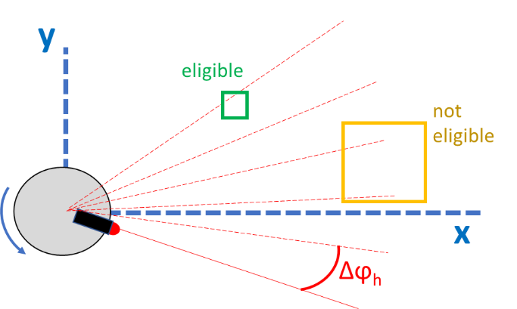

Figure 50: Azimuthal angular eligibility

##### Determining a prediction of the azimuthal angle for a node

The azimuthal angle of an already coded node, which is selected as the “closest” node in the azimuthal plane and probed by the same laser as the current node, is used to calculate predicted azimuthal angle of the current node. The correction of the azimuthal angle to obtain the prediction angle is conducted by a multiple n of the elementary azimuthal shift such as to become the closest possible from the azimuthal angle of the center of the current node.

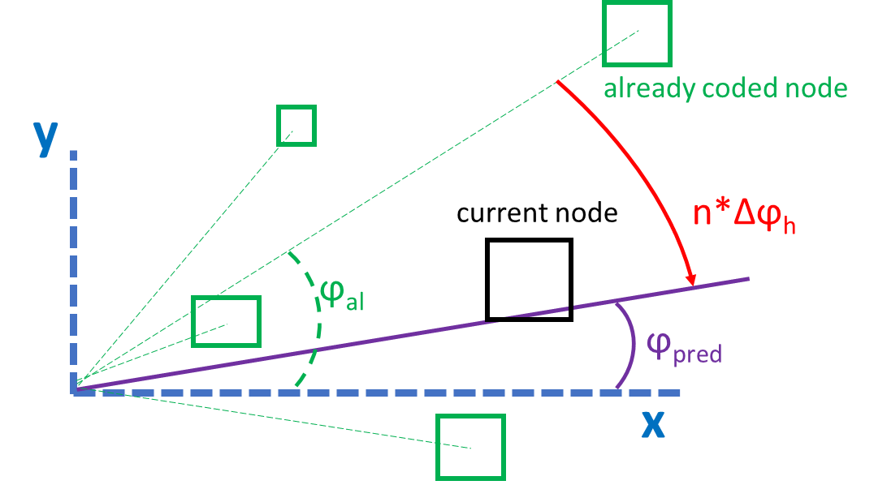

Figure 51: a prediction of the azimuthal angle for a node

#### Enhancing planar mode using azimuthal angular contexts

The azimuthal angular information enhances the plane position set of contexts. At first, the planar direction ( x-planar or y-planar ) predicted by azimuthal angle is selected based on the following conditions,

* depending on the position of the current node
* basically x planar if ||<=||, otherwise y-planar

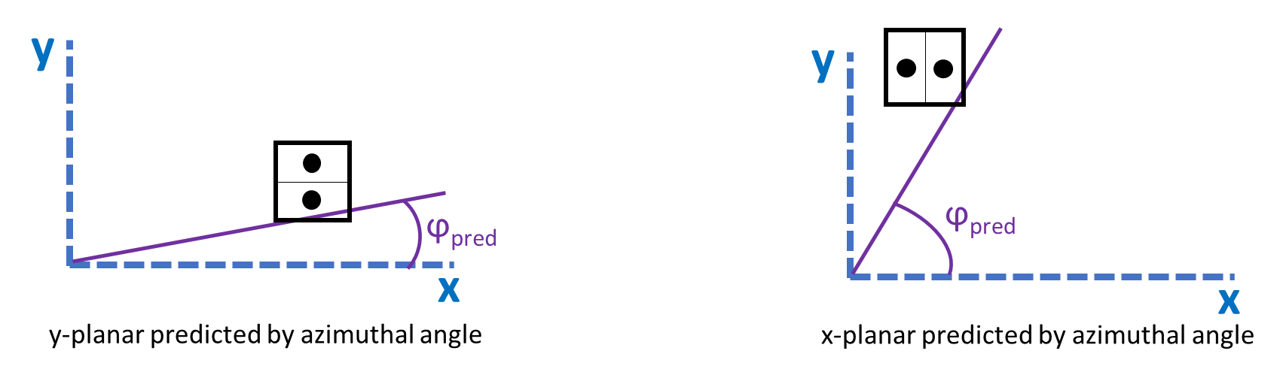

Figure 52: selecting the planar direction predicted by azimuthal angle

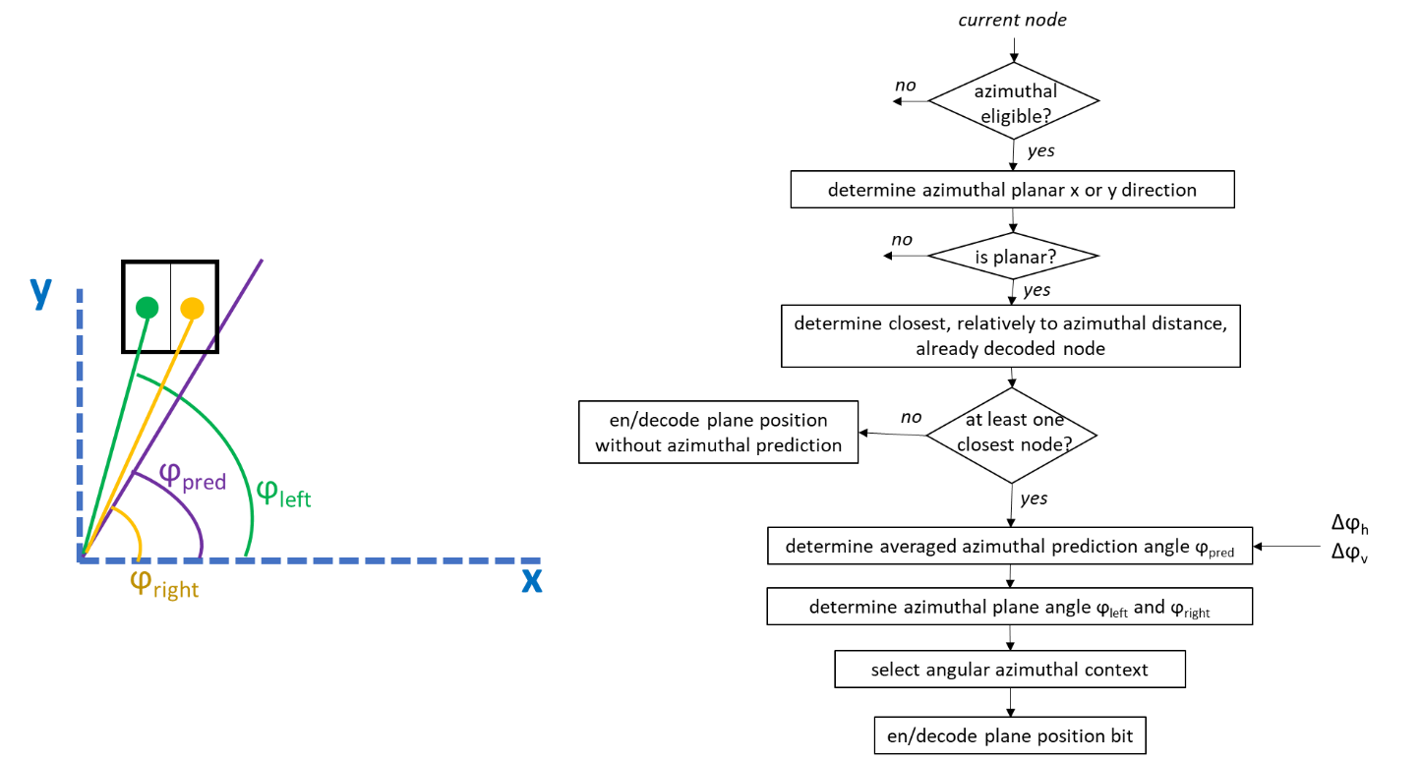

Figure 53: x-planar/y-planar mode with azimuthal contexts

Then, an azimuthal angular context is selected based on , and from 16 angular context values. It depends on

* do ϕpred - ϕleft and ϕpred - ϕright have the same sign (2 possible values)
* which of m =| - | and M=| - | is minimum (2 possible values)
* the quantization of the ratio m1/m2 with m1 = min{m,M} and m2 = max{m,M}  
  over 4 values depending on,
* m2 <= 2m1
* 2m1 < m2 <=4m1
* 4m1 < m2 <=16m1
* 16m1 < m2

#### Enhancing IDCM using azimuthal angular contexts

IDCM with azimuthal angular coding mode are introduced to enhance IDCM. In this mode, x (or y) coordinate bits are still bypassed and y (or x) coordinate bits are entropy coded by using azimuthal angle contexts. z-coordinate bits are entropy coded using angular contexts.

The x (or y) coordinate bit is coded based on a x (or y)-interval as following steps (Figure 54, Figure 55),

* Split in two after (de)coding each x ( or y)-coordinate bit
* Azimuthal angular prediction of the sub-interval based on azimuthal predictor
* Azimuthal context to (de)code the bit
* Context determine based on the sub-interval prediction

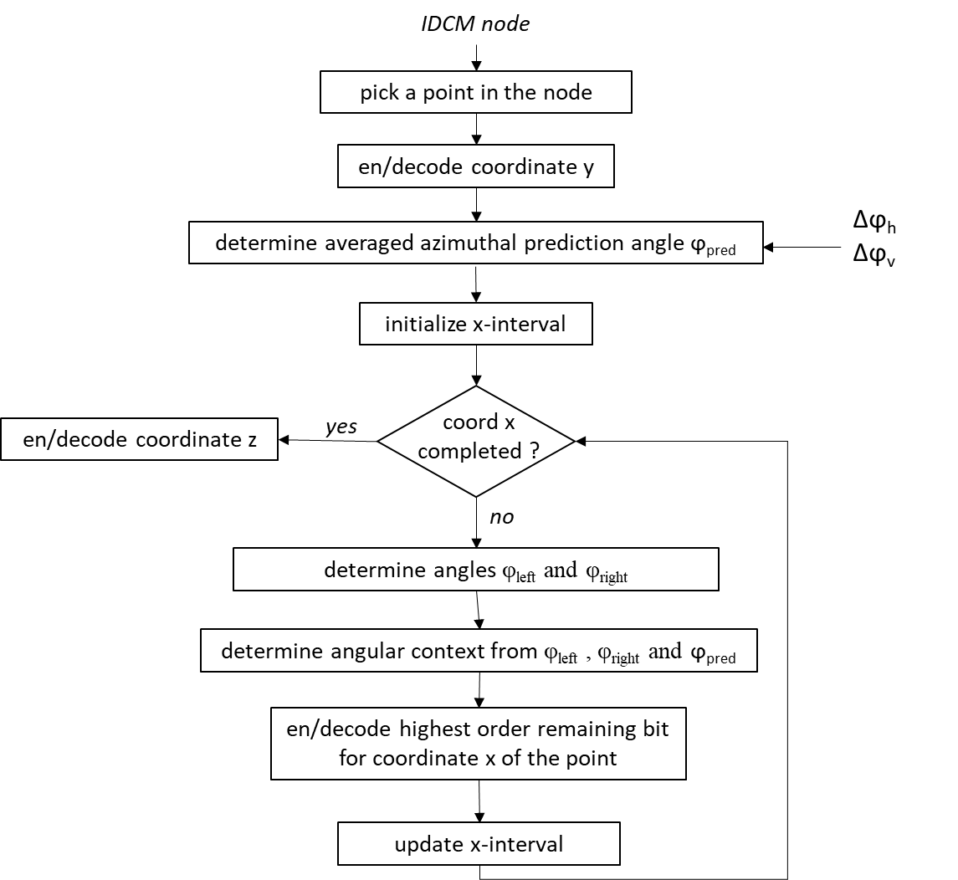

Figure 54: Azimuthal IDCM node

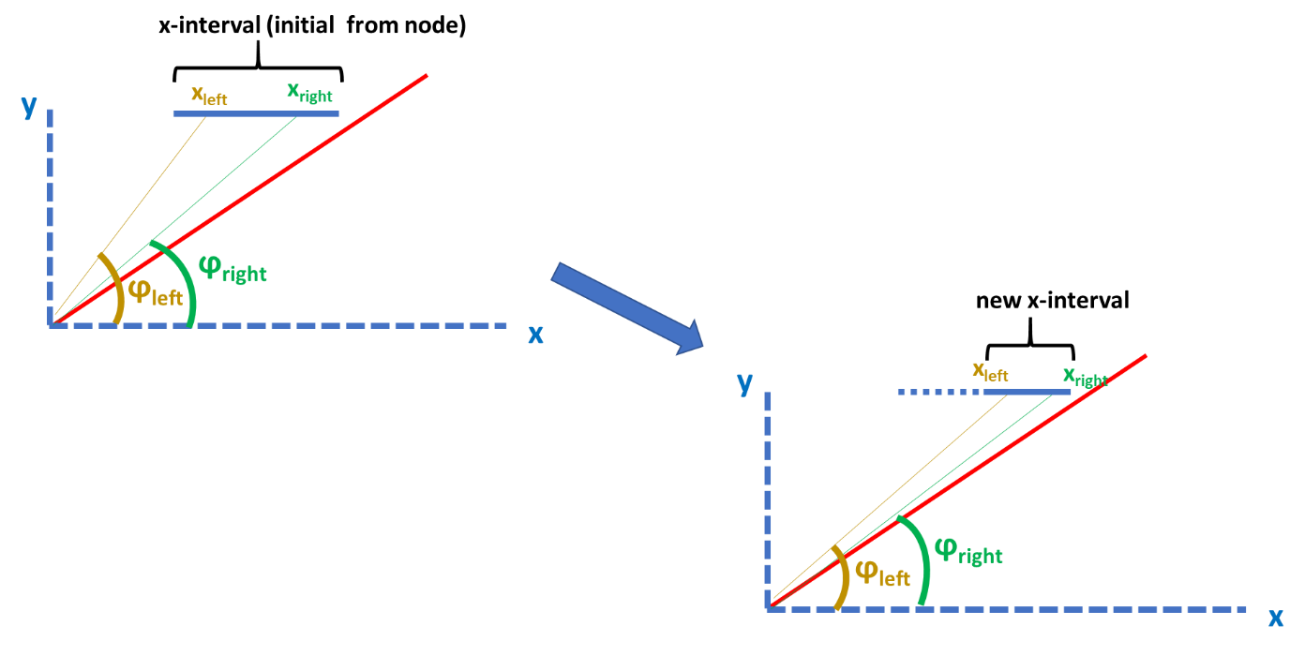

Figure 55: Evolution of the x (or y)-interval

#### Decoupling planar and IDCM in angular mode [78]

The angular coding mode is effective as a prediction tool in both the planar mode and the IDCM mode with the constrain that the angular IDCM uses information (red arrows on Figure 56) provided by the angular planar mode. Consequently, the angular coding mode could be used only when the planar mode was activated.

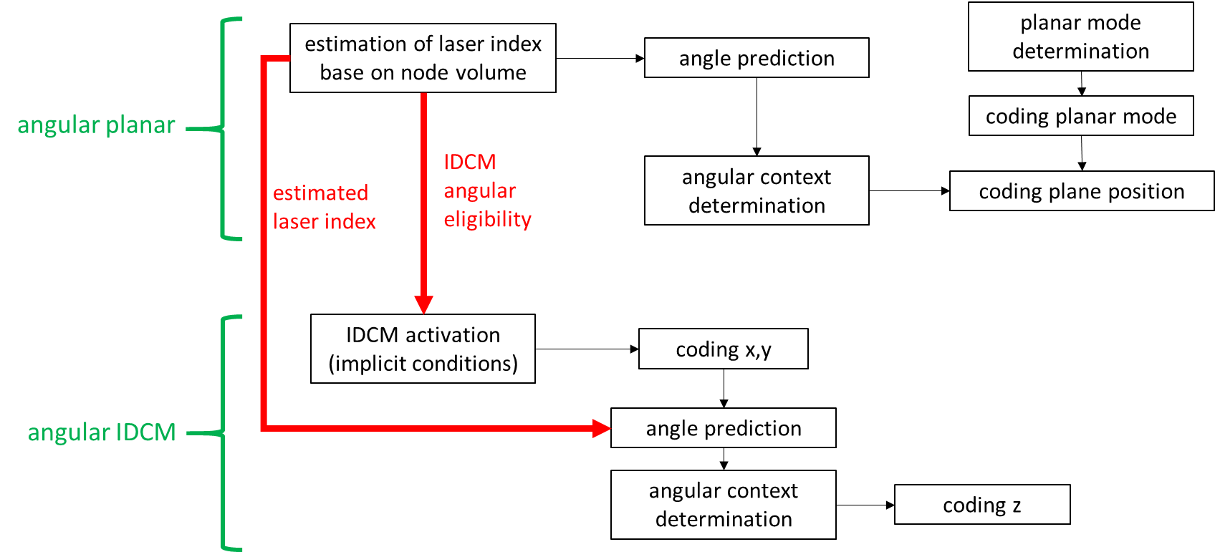

Figure 56: Angular planar and angular IDCM modes as in TMv9

The modification was introduced due to the following several motivations for decoupling the planar mode and the angular mode,

* Estimating the compressions gains arising from angular planar or angular IDCM independently
* Lowering complexity by increasing IDCM usage
  + Angular IDCM eligibility is constraining IDCM usage (=> more complex than when angular not used)
  + Preparing the relaxing of IDCM implicit condition in order to dramatically reduce the complexity

Figure 57 shows the current design which includes the following modifications,

* remove the dependence of IDCM condition on IDCM angular eligibility
* for each IDCM child node
  + estimate laser index exactly as performed in angular planar node
  + based on child node associated volume
* for each point in IDCM child node
  + compute exact laser index for each point (encoder)
  + encode laser index residual = exact – estimated

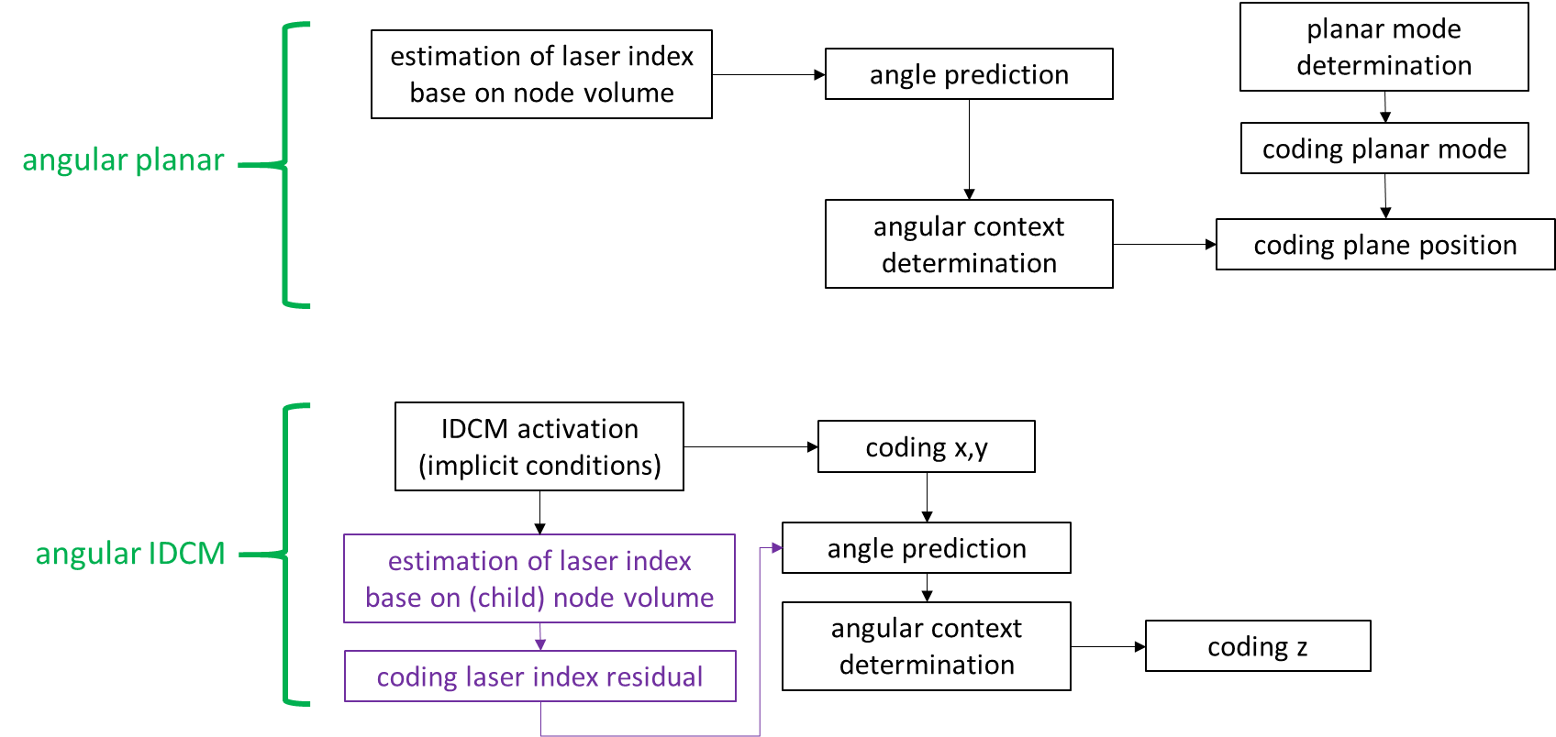

Figure 57: Angular planar and angular IDCM modes

### Implicit QTBT partition [62]

The implicit QTBT partition is a simple approach that enables asymmetric geometry partition, in a way the TMC13 can handle the asymmetric bounding box and kd-tree like partitioning can be enabled at certain conditions. It can achieve significant coding gains on sparse distributed data such as on category 3-frame data. The gain is from the intrinsic characteristics of such kind of data where the 3D points of the scene are distributed along one or two principle directions. In such case, implicit QTBT can achieve the gains naturally because the tree structure would be imbalanced

#### Signaling of implicit QT and BT partitions

First of all, the bounding box B is not restricted to be a cube, instead it can be an arbitrary-size rectangular cuboid to better fit for the shape of the 3D scene or objects. In the implementation, the size of B is represented as a power of two, i.e., . Note that are not assumed to be equal, they are signaled separately in the slice header of the bitstream.

As B may not be a perfect cube, in some cases the node may not be (or unable to be) partitioned along all directions. If a partition is performed on all three directions, it is a typical OT partition. If performed on two directions out of three, it is a QT partition in 3D. If performed on one direction only, it is then a BT partition in 3D. Examples of QT and BT in 3D are shown in Figure 59 and Figure 60, respectively.

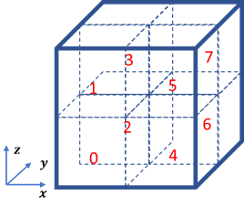

Figure 58: Illustration of an octree-partition in 3D space

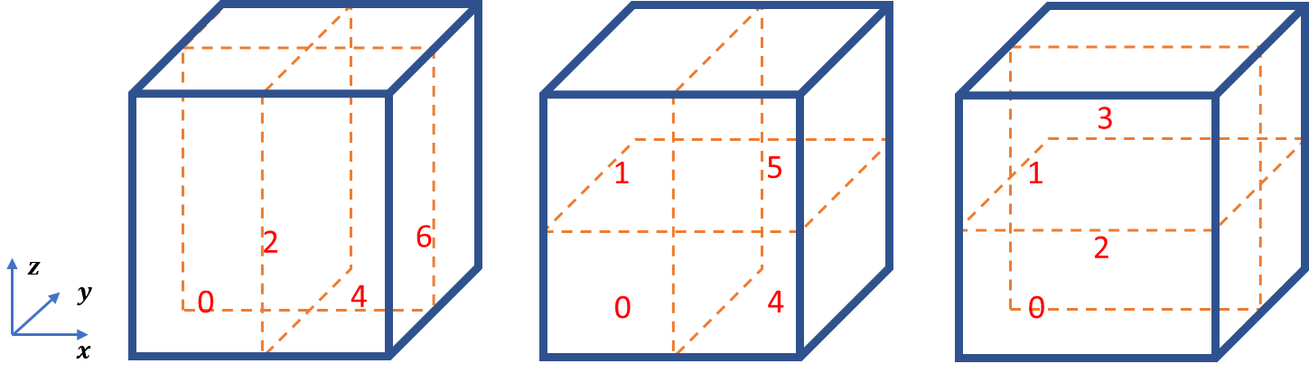

Figure 59: Quad-tree partition of a 3D cube, along x-y, x-z, y-z axes, respectively.

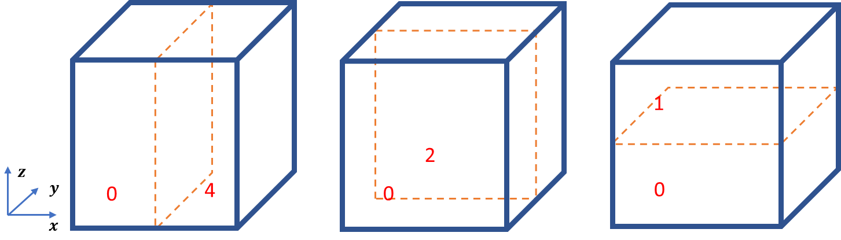

Figure 60: Binary-tree partition of a 3D cube, along x, y, z axis, respectively.

When conditions are met, QT and BT partitions can be performed implicitly. “Implicitly” implies that no additional signaling bits are needed to indicate that a QT or BT partition, instead of an OT partition, is used. Determining the type and direction of the partition is based on the pre-defined conditions. Moreover, bits can be saved from an implicit QT or BT partition compared to an OT partition when signaling the occupancy information of each sub-node. A QT requires four bits, reducing from eight, to represent the occupancy status of four sub-nodes, while a BT only requires two bits.

The encoding of occupancy code of implicit QT and BT partitions can be described as the following examples. First, one can assume that the occupancy code of an OT is encoded in the order as shown in Figure 58. Then, the occupancy code of a QT partition along x-y axes, as shown in the leftmost graph of Figure 59, can be coded by omitting the bits in positions 1, 3, 5, 7, as they can be inferred to be zeros, and only the bits in positions 0, 2, 4, 6 need to be signaled. Similarly, a BT along x axis, as shown in the leftmost graph of Figure 60, only needs to encode occupancy information in positions 0 and 4, and the other six bits can be inferred to be zeros.

In addition, since the implicit partition may lead to sub-nodes with unequal sizes in dimensions, the direct coding mode (DM) should be changed accordingly. For example, if a sub-node with the size of is to be coded in DM mode, the relative positions of each point in the sub-nodes are coded by fixed-length coding with bits, respectively.

#### Conditions for implicit QT and BT partitions

To define the conditions of implicit QT and BT partitions, two parameters are defined, i.e., and . The first parameter defines the maximum times of implicit QT and BT partitions that can be performed before OT partitions. The second parameter defines the minimal size of implicit QT and BT partitions, indicating that implicit QT and BT partitions are allowed only if all dimensions are greater than .

More specifically, the first partitions follow the rules in Table 1, after then it follows the rules in Table 2. If none of the conditions listed in tables are met, an OT partition is performed.

Table 1: Conditions to perform implicit QT or BT partition for the first partitions

|  |  |  |  |
| --- | --- | --- | --- |
|  | **QT along x-y axes** | **QT along x-z axes** | **QT along y-z axes** |
| **Condition** |  |  |  |
|  | **BT along x axis** | **BT along y axis** | **BT along z axis** |
| **Condition** |  |  |  |

Table 2: Conditions to perform implicit QT or BT partition after the first partitions

|  |  |  |  |
| --- | --- | --- | --- |
|  | **QT along x-y axes** | **QT along x-z axes** | **QT along y-z axes** |
| **Condition** |  |  |  |
|  | **BT along x axis** | **BT along y axis** | **BT along z axis** |
| **Condition** |  |  |  |
|  |  |  |

Let B have the size of . Without loss of generality, one can assume that . Following the conditions, at first () depths, implicit BT partitions are performed along z axis and implicit QT partitions are then performed along y-z axes based on Table 1. The size of sub-nodes then becomes , where the value of and depend on the value of . Then, OT partitions are performed times making the remaining sub-nodes have the size of . Next, according to Table 2, implicit BT partitions are performed along z-axis times, and implicit QT partitions are then performed along y-z axes times. The rest nodes are with the size of , therefore OT partitions are performed times to reach the smallest units.

Since the Trisoup scheme in current TMC13 design assumes that all three dimensions have the same size, we set and by default if Trisoup is enabled. In this case, all implicit QT and BT partitions are performed before OT partitions, making sure the sub-notes will have equal sizes in three dimensions before Trisoup is invoked. Therefore, the proposed scheme is compatible with current Trisoup.

#### Neighbour context accessing in QTBT [99]

There was an issue when accessing the child-level neighbours in QTBT partitions. A 2D diagram may be illustrative. As shown in Figure 61, the y-axis is not split while the x-axis is split, therefore only the solid child nodes could be occupied, and the shaded nodes are not only unoccupied but also invalid. The left-hand diagram in Figure 61 shows the issue. In original implementation of storing context information, for the child nodes in current node (solid orange block), its left-neighbour is accessible, but the top-neighbour would be invalid, because the top-neighbours are always zeros. The fix is shown in the right-hand diagram in Figure 61, where the orange block can access its “real” top-neighbours from the same relative position in the top-neighbour block of its parent node. The similar situation where the x-axis is not split is shown in Figure 62. In this case, the left-neighbours of current child node may be invalid, and the “real” left-neighbours are from the same relative position in the left-neighbour block of its parent node.

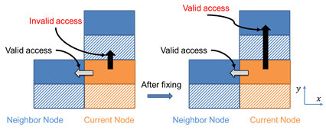

Figure 61: 2D illustration of the issue and the fix method when the y-axis is not split.

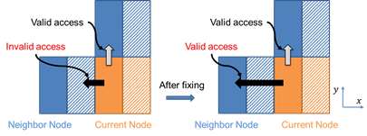

Figure 62: 2D illustration of the issue and the fix method when the x-axis is not split.

### Harmonization of angular coding mode and implicit QTBT [70]

The method to harmonize implicit QTBT with angular coding mode was introduced. This section explains the reason why the harmonization was needed and how to do it.

Cat3-frame LiDAR sequences in CTCs are mostly “flattened”: the bounding boxes are large and mostly square in x, y; and have a smaller z range. When using implicit QTBT on these sequences, the volume is first split in octrees on the first levels, until having a node with a z dimension equal to one. Then quadtree are used to split, x and y, and finally binary tree (but since LiDAR scenes are most often square in x, y, binary tree is more rarely used).

This decomposition implies that z occupancy is coded for wide but flattened nodes, and so that angular mode must deal with that nodes.

Since angular mode is used to code the z plane index of the planar mode, it is only useful when all the occupied child nodes belong to a same z plane. But, the wider the node is, the higher is the probability that more than one laser is crossing the node, and/or a single laser is crossing the two planes. Then, there is higher probability that the node is not planar. And if it is planar, the angular modeling is less accurate. This problem is illustrated by an example in Figure 63. This example is simplified to a 2D case (x, z) for the sake of simplicity. In Figure 63, the node obtained using implicit QTBT is height time larger than tall, two lasers are crossing the same node, and are even crossing the two horizontal planes of the node. There are 2 points acquired by Laser 1 (suppose that they have a different y value for instance), in two different horizontal planes, and thus the node is coded as not planar. For comparison, the same example is presented Figure 64 but without implicit QTBT, and so, nodes are square. Even if there are more nodes for which planar mode will be coded, all the node are planar, and since the nodes are less wide than in Figure 63, the probability to be planar is higher (and the coding cost of planar mode bit may be lower because it is less random), and the angular prediction modeling of the plane index is better (i.e. the entropy of the plane index bit is lower).

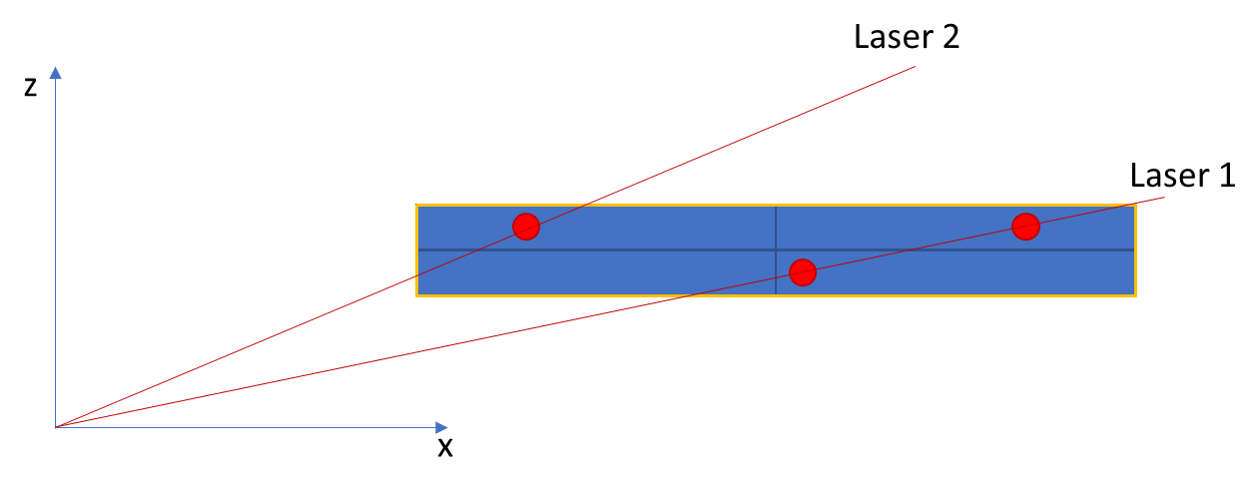

Figure 63: x,z occupancy example with implicit QTBT leading to large but flattened nodes. One node size is orange rectangle, with sub-nodes in blue. Red points are points in the point cloud.

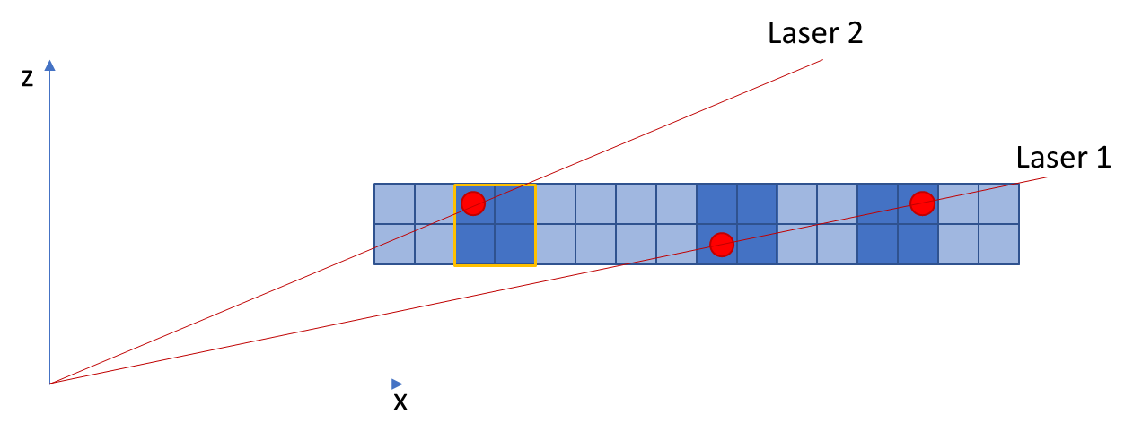

Figure 64: x,z occupancy example without implicit QTBT, and so with cube nodes. One node size is orange rectangle, occupied nodes are in dark blue and non-occupied nodes in light blue. Red points are points in the point cloud.

To further improve the accuracy of the angular modeling, instead of using usual implicit QTBT rules, it is more interesting for angular to modify the implicit tree splitting so that it produces nodes that are taller than wide, especially for the highest point precision levels (i.e. bottom of the tree). Figure 65 provides an example with the same case as illustrated in Figure 63 and Figure 64. In this example the node size is one in width and two in height, and thus, the angular precision is further improved, as the probability that a laser is crossing the two planes of a same node is further reduced.

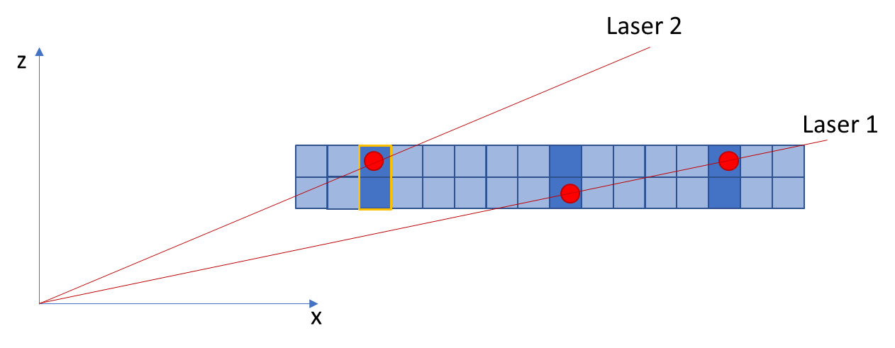

Figure 65: x,z occupancy example with modified implicit QTBT, and so with more vertical nodes at the bottom of the tree. One node size is orange rectangle, occupied nodes are in dark blue and non-occupied nodes in light blue. Red points are points in the point cloud.

Thus, to harmonize implicit QTBT with angular, it has been chosen to tweak the rules of implicit QTBT, splitting when angular mode is enabled as follow:

inline Vec3<int>

implicitQtBtDecision(

  Vec3<int> nodeSizeLog2,

  int maxNumImplicitQtbtBeforeOt,

  int minDepthImplicitQtbt,

  bool angularModeEnabled,

  const GeometryParameterSet& gps

  )

{

  const int maxNodeMinDimLog2ToSplitZ =

    gps.implicit_qtbt_angular_max_node_min_dim_log2_to_split_z;

  const int maxDiffToSplitZ = gps.implicit_qtbt_angular_max_diff_to_split_z;

  int nodeMinDimLog2 =

    std::min({nodeSizeLog2[0], nodeSizeLog2[1], nodeSizeLog2[2]});

  if (maxNumImplicitQtbtBeforeOt || nodeMinDimLog2 == minDepthImplicitQtbt) {

    // implicit qt bt

    int nodeMaxDimLog2 =

      std::max({nodeSizeLog2[0], nodeSizeLog2[1], nodeSizeLog2[2]});

    for (int k = 0; k < 3; k++) {

      if (nodeSizeLog2[k] == nodeMaxDimLog2)

        nodeSizeLog2[k]--;

    }

  } else if ( angularModeEnabled

      && (maxNodeMinDimLog2ToSplitZ + maxDiffToSplitZ > 0) ) {

    // implicit xy qt bt : do not split z

    int nodeXYMaxDimLog2 = std::max({nodeSizeLog2[0], nodeSizeLog2[1]});

    for (int k = 0; k < 2; k++) {

      if (nodeSizeLog2[k] == nodeXYMaxDimLog2)

        nodeSizeLog2[k]--;

    }

    if ( (nodeMinDimLog2 <= maxNodeMinDimLog2ToSplitZ

          && nodeSizeLog2[2] >= nodeXYMaxDimLog2 + maxDiffToSplitZ)

      || (nodeXYMaxDimLog2 >= maxNodeMinDimLog2ToSplitZ + maxDiffToSplitZ

          && nodeSizeLog2[2] >= nodeXYMaxDimLog2) )

      nodeSizeLog2[2]--;

  } else // octree partition

    nodeSizeLog2 = nodeSizeLog2 - 1;

  return nodeSizeLog2;

}

gps.implicit_qtbt_angular_max_node_min_dim_log2_to_split_z is an integer that indicates from which node size we want to have more vertical nodes. It allows not having vertical node too early (i.e. on big node sizes) and reduce the probabilities to have multiple lasers crossing the nodes for a given (big) width.

gps.implicit_qtbt_angular_max_diff_to_split_z is an integer that provides the log2 of the maximum vertical/horizontal ratio we want to obtain.

In the performed tests, these values are derived at encoder by using:

      params.encoder.gps.implicit_qtbt_angular_max_node_min_dim_log2_to_split_z =

        std::max<int>(0, 6 + log2(params.encoder.sps.seq_source_geom_scale_factor));

      params.encoder.gps.implicit_qtbt_angular_max_diff_to_split_z =

        std::max<int>(0, 3 + log2(params.encoder.sps.seq_source_geom_scale_factor));

Thus, for lossless coding, the first one is equal to 6 and the second one is equal to 3.

And for lossy coding we take into account the quantization (geometry scale factor) to scale the target node sizes at the proper values, so that we do not apply the vertical node tweaking on the too big node sizes.

Tweaked implicit QTBT first splits x and y until they reach log2 z (i.e. node is cubical). Then, until log2 z node size reaches below 6+3, tweaked implicit QTBT splits in octree (i.e. nodes stay cubical).

Then when log2 z node size reaches below 6+3 (i.e. 6+3-1=8), log2 x and y node sizes are iteratively decreased until max(0, nodeSizeLog2[2]-3) = 8-3 = 5.

Then node size is decreased for all dimensions until it reaches 0.

For instance, in lossless, on frame 1 of qnxadas-junction-approach, log2 node is :

depth = 1 : x = 17 y = 17 z = 15

depth = 2 :x = 16 y = 16 z = 15

depth = 3 :x = 15 y = 15 z = 15

depth = 4 :x = 14 y = 14 z = 14

depth = 5 :x = 13 y = 13 z = 13

depth = 6 :x = 12 y = 12 z = 12

depth = 7 :x = 11 y = 11 z = 11

depth = 8 :x = 10 y = 10 z = 10

depth = 9 :x = 9 y = 9 z = 9

depth = 10 :x = 8 y = 8 z = 8

depth = 11 :x = 7 y = 7 z = 8

depth = 12 :x = 6 y = 6 z = 8

depth = 13 :x = 5 y = 5 z = 8

depth = 14 :x = 4 y = 4 z = 7

depth = 15 :x = 3 y = 3 z = 6

depth = 16 :x = 2 y = 2 z = 5

depth = 17 :x = 1 y = 1 z = 4

depth = 18 :x = 0 y = 0 z = 3

depth = 19 :x = 0 y = 0 z = 2

6 and 3 values were empirically chosen, as a compromise between results on ford and qnx sequence.

Better results could be achieved by taking into account at encoder, on a per sequence (or per frame) basis, the vertical angle between each successive laser (i.e. distances between lasersTheta values) and the average distance of the points and the lidar head to determine gps.implicit_qtbt_angular_max_node_min_dim_log2_to_split_z and gps.implicit_qtbt_angular_max_diff_to_split_z. For instance as there are 64 lasers in Ford sequences and angle between lasers is small, smaller values of these parameters could perform better, while with 16 lasers in QNX sequences, and higher angle between lasers, higher values could perform better.

### Explicit signalling of QtBt [94][95]

It was introduced to explicitly signal QtBt splitting decision at every octree-depth instead of using the normative implicit split. It allows for more flexibility in design and provides a non-normative way to adapting the octree decomposition for specific data characteristics or data-acquisition mechanisms.

The method is to simply signal the result of the current normative splitting decisions at each node-level using 3 bits corresponding to x,y, and z directions. The following changes are introduced,

* explicit_qtbt_enabled_flag is replacing the implicit_qtbt_enabled_flag to enable/disable explicit split-decision signaling.
* When explicit_qtbt_enabled_flag is set to 1, a 3-bit signal will be sent per octree-level indicating whether to split along each of the x,y, and z axes.
  + Herein, the implicitQtBt rule is used as a non-normative means to determining these 3 bits, where the angular-mode tweak of QtBt is also integrated as part of the non-normative implementation.
* When explicit_qtbt_enabled_flag is set to 0, the method uses octree-decomposition for all levels.

### Fast laser search method [132]

For angular mode and IDCM coding, the laser that is closest to a current node is chosen. It was introduced to make the fast laser search method with a single stage of binary search.

int start = 0;

int end = numTheta - 1;

while (start < end - 1) {

int mid = (start + end) >> 1;

if (theta32 < thetaList[mid])

end = mid;

else

start = mid;

}

laser = thetaList[end] - theta32 >= theta32 - thetaList[start] ? start : end;

## Trisoup geometry encoding/decoding

[ED.] Trisoup coding is not supported in first G-PCC specification

Trisoup codec is a geometry coding option that represents the object surface as a series of triangle mesh. It is applicable for a dense surface point cloud. The decoder generates point cloud from the mesh surface in the specified voxel granularity so that it assures the density of the reconstructed point cloud.

If the Trisoup geometry codec is used, then the parameter *trisoup_node_size* defines the size of the triangle nodes in unit of voxel. The octree encoding and decoding stop at leaf level , in which case the leaf nodes of the octree represent cubes of width , or blocks, and the octree is said to be pruned. In the latter case, Inferred Direct Coding Mode is not allowed.

### Determining vertices

If , then the blocks are 2 x 2 x 2 or larger, and it is necessary to represent the collection of voxels within the block by some model. Geometry is represented within each block as a surface that intersects each edge of the block at most once. Since there are 12 edges of a block, there can be at most 12 such intersections within a block. Each such intersection is called a vertex. A vertex along an edge is detected if and only if there is at least one occupied voxel adjacent to the edge among all blocks that share the edge. The position of a detected vertex along an edge is the average position along the edge of all such voxels adjacent to the edge among all blocks that share the edge.

### Entropy encoding of vertices

Vertices, nominally being intersections of a surface with edges of a block, are shared across neighbouring blocks, not only guaranteeing continuity across blocks of the reconstructed surface, but also reducing the number of bits required to code the collection of vertices. The set of vertices is coded in two steps. In a first step, the set of all the unique edges (or segments) of occupied blocks is computed, and a bit vector (or segment indicator) determines which segments contain a vertex and which do not. In a second step, for each segment that contains a vertex, the position of the vertex along the segment is uniformly scalar quantized to a small number of levels, typically equal to the block width if the geometric spatial resolution is desired to approximate the voxel resolution, but it could be any number of levels. The segment indicators and the vertex positions are entropy coded by an arithmetic coder. The geometry bitstream becomes a compound bitstream comprising octree, segment indicator, and vertex position bitstreams.

### Triangle reconstruction

The vertices on the edges of a block determine a surface through the block. The surface is a non-planar polygon, triangulated as follows. Let , be the coordinates of the vertices on the edges of the block, in any order. Compute the centroid

the mean-removed coordinates

and the (scaled) variances

Find the minimum . If achieves the minimum, then project each vertex onto the x axis (the “dominant” axis) as , and onto the (y,z) plane as , where is the center of the block. Otherwise, if achieves the minimum, then project each vertex onto the y axis as , and onto the (x,z) plane as Otherwise, project each vertex onto the z axis as , and onto the (x,y) plane as

Compute the arctangent , and sort the angles in increasing order, breaking ties in order of increasing . For this order of the vertices, form triangles according to Table 1.

Table 3: Triangles formed from vertices ordered 1, …, n.

|  |  |
| --- | --- |
|  | triangles |
| 3 | (1,2,3) |
| 4 | (1,2,3), (3,4,1) |
| 5 | (1,2,3), (3,4,5), (5,1,3) |
| 6 | (1,2,3), (3,4,5), (5,6,1), (1,3,5) |
| 7 | (1,2,3), (3,4,5), (5,6,7), (7,1,3), (3,5,7) |
| 8 | (1,2,3), (3,4,5), (5,6,7), (7,8,1), (1,3,5), (5,7,1) |
| 9 | (1,2,3), (3,4,5), (5,6,7), (7,8,9), (9,1,3), (3,5,7), (7,9,3) |
| 10 | (1,2,3), (3,4,5), (5,6,7), (7,8,9), (9,10,1), (1,3,5), (5,7,9), (9,1,5) |
| 11 | (1,2,3), (3,4,5), (5,6,7), (7,8,9), (9,10,11), (11,1,3), (3,5,7), (7,9,11), (11,3,7) |
| 12 | (1,2,3), (3,4,5), (5,6,7), (7,8,9), (9,10,11), (11,12,1), (1,3,5), (5,7,9), (9,11,1), (1,5,9) |

### Triangle rasterization

To derive a decoded geometry point cloud from the trisoup in the specified voxel resolution, it is checked if each voxel in the bounding box intersects with the triangles.

More precisely, following steps are conducted.

* To prepare 6 unit vectors (±1, 0 ,0), (0, ±1, 0), (0, 0, ±1) around each triangles.
* To check if the unit vector and the triangle intersect, and if yes, the intersection is calculated and output as decoded voxel.

The intersection check is independent among the vectors, thus the point generation process can be done in parallel. The number of the derived points in the decoder is determined by the voxel grid distance (shown as ‘d’ in Figure 66) which is controlled by the syntax signaling [64].

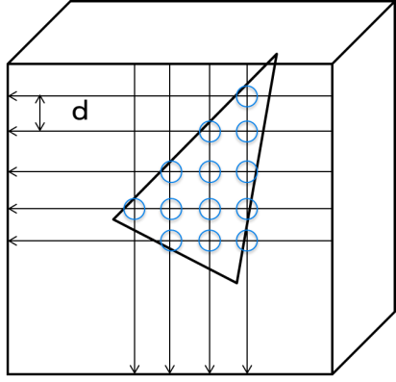

Figure 66: intersection check on voxel grid

## Predictive geometry coding

A predictive geometry coding scheme is introduced as an alternative to the octree-based approach. The predictive scheme offers the following advantages,

* Supports low latency applications/streaming, and
* Low complexity decoding.

### Prediction structure

Its main target is Category 3 content. It starts by defining a prediction structure on the point cloud. Such structure could be described by a prediction tree (see Figure 67), where each point in the point cloud is associated with a vertex of the tree. Each vertex could predict only from its ancestors in the tree. Various prediction strategies are possible. It is considered the following four predictors,

* No prediction
* Delta prediction (i.e., p0)
* Linear prediction (i.e., 2p0-p1),
* Parallelogram predictor (i.e., 2p+p1-p2),

where p0, p1, p2 are the positions of the parent, grandparent and grand-grandparent of the current vertex.



Figure 67: Example of prediction tree.

The tree structure is encoded be traversing the tree in a depth order and encoding for each vertex the number of its children. The positions of the vertices are encoded by storing the chosen prediction mode and the obtained prediction residuals. Arithmetic coding is used to further compress the generated values.

Building the optimal prediction tree is an NP-hard problem. The encoder could use different heuristics to build sub-optimal prediction trees that offer various compromises in terms of,

* Computational complexity
* Memory requirements
* Latency
* Robustness to errors, and
* Energy consumption among others.

In next section two strategies are described to build prediction trees adapted for three use cases,

(1) high latency use-case slow mode,

(2) high latency use-case fast mode, and

(3) Low latency use-case.

### High latency strategy slow mode:

The points are re-ordered based on their Morton codes. Other strategies are possible such as ordering the points according to their polar angle or polar radius. A kdtree data structure is used to keep track of potential predictors. At the beginning, the kdtree is empty. The points are visited iteratively in the selected order. The k-nearest neighbors in the kdtree of the current point are determined and one of them is chosen as the predictor based on various criteria such as

* the magnitude of the prediction residuals,
* the number of the node children, and
* the frequency of the chosen prediction mode among others.

Once a predictor is chosen, the current vertex is added to the children of the vertex associated with the predictor. Next, new predictors are created based on the current vertex (see the previous section for examples of predictors) and the predicted positions are added to the kdtree. This process is repeated until all the points are traversed. At the end of this process the prediction tree structure is determined.

### High latency strategy fast mode

Uses the same algorithm as the “high latency slow mode”, while replacing the kd-tree search by an approximate nearest neighbor search according to the Morton order. Here, a search range of 128 was used.

### Low latency strategy (window-based prediction)

The encoder processes the points in the same order as they are received. A buffer of limited size is used to limit the system latency. When looking for the best predictor for each vertex, the encoder will consider only the points that are in the buffer.

### Slicing and latency

Given a list of input points, the end-to-end latency is the maximum distance that a point may be displaced in the list. A slicing method has been added to TMC13 that generates a new slice every n points. This work evaluates three conditions. A single slice per frame, 512 points per slice, and 1024 points per slice.

Within each slice, the encoders are free to reorder the points as they wish. NB, the slicing constraint as implemented here is more strict than necessary for the predictive geometry scheme (however

this aspect is not explored further).

The predictive geometry scheme also contains an ability to introduce internal tree boundaries within a slice. This permits the above slicing method to be implemented inside the predictive geometry coder.

### Input point ordering [115]

To measure end-to-end system latency, it is necessary to have a defined input point order. While the cat3-frame content is originally acquired by a rotating LiDaR scanner, various processing operations have changed the order of the points in the PLY input.

To restore the input order to something approximating the original acquisition order, a pre-processing stage is added to TMC13 that orders the input point cloud prior to slicing according to the azimuth angle of the points.

While the QNX lidar point clouds are already in an azimuth angle order (the acquisition order), the ford data is not and requires this reordering to be implemented.

Prior to generating each predictive tree, the input points corresponding to the tree are sorted according to a sorting method. This helps to guide the tree construction process to build a more efficient tree. The sorting methods available are none, morton order, azimuth angle order, and radial distance order.

Especially, the azimuthal sorting by rounded azimuth, radius, and elevation generates stable ording shape as shown in Figure 68 and it improves the coding efficiency

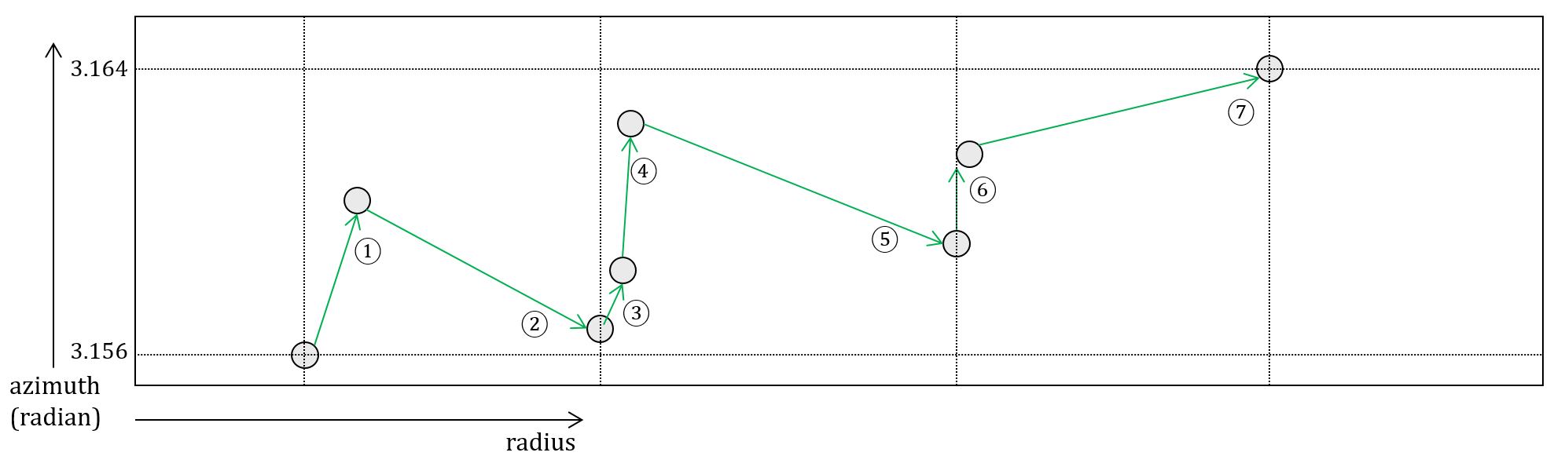

Figure 68: the rounding azimuth sorting example

### Duplicate points coding [101]

The process which encodes the number of duplicate points at the encoder will only be invoked when the unique_points_flag is set to 0. The number of duplicate points will be decoded at the decoder side only if the decoded unique_points_flag is equal to 0.

### Residual bit count coding [123]

The maximum absolute value of residual for predictive geometry coding depends on the bit depth of the point cloud in each axis and it would change for each slice. By considering this feature, the value of numBits which indidates number of bit needed to represent residual value is arithmetic encoded with variable bits based on the bit depth of the point cloud in each axis.

The information on bit depth of the point cloud is stored as pgeom_resid_abs_log2_bits variable in GeometryBrickHeader and encoded into the bitstream, so that it can be decoded for use to determine the residual bit count at the decoder side.

### Angular mode for predictive geometery coding [127]

The method focuses on point clouds acquired using a spinning Lidar model. Here, the lidar has N lasers (e.g., N=16, 32, 64) spinning around the Z axis according to an azimuth angle (see Figure 69). Each laser may have different elevation and height . Let’s suppose that the laser hits a point , with cartesian integer coordinates , defined according to the coordinate system described in Figure 69.



Figure 69: Spinning Lidar acquisition model.

This method introduces to model the position of M with three parameters *,* which are computed as follows:

* ,

More precisely, it uses the quantized version of , denoted *,* where the three integers and are computed as follows:

where

* (and are quantization parameters controlling the precision of and , respectively.
* is the function that return 1 if t is positive and (-1) otherwise.
* is the absolute value of .

To avoid reconstruction mismatches due to the use of floating-point operations, the values of and are pre-computed and quantized as follows:

where

* (and are quantization parameters controlling the precision of and , respectively.

The reconstructed cartesian coordinates are obtained as follows:

* ,

where and are approximation of and The calculations could be using a fixed-point representation, a look-up table and linear interpolation.

Note that may be different from due to various reasons:

* quantization
* approximations
* model imprecision
* model parameters imprecisions

Let be the reconstruction residuals defined as follows:

In this method, the encoder proceeds as follows:

* Encode the model parameters and the quantization parameters
* Apply the geometry predictive scheme described in [1] to the representation
  + A new predictor leveraging the characteristics of lidar could be introduced. For instance, the rotation speed of the lidar scanner around the z-axis is usually constant. Therefore, we could predict the current as follows:

Where

* + - is a set of potential speeds the encoder could choose from. The index could be explicitly written to the bitstream or could be inferred from the context based on a deterministic strategy applied by both the encoder and the decoder, and
    - is the number of skipped points, which could be explicitly written to the bitstream or could be inferred from the context based on a deterministic strategy applied by both the encoder and the decoder.
* Encode with each node the reconstruction residuals

The decoder proceeds as follows:

* Decodes the model parameters and the quantization parameters
* Decodes the parameters associated with the nodes according to the geometry predictive scheme described in [1]
* Computes the reconstructed coordinates as described above
* Decodes the residuals
  + As discussed in the next section, lossy compression could be supported by quantizing the reconstruction residuals
* Compute the original coordinates as follows

Lossy compression could be achieved by applying quantization to the reconstruction residuals or by dropping points.

The quantized reconstruction residuals are computed as follows:

Where , are quantization parameters controlling the precision of , and , respectively.

Trellis quantization could be used to further improve the RD (rate-distortion) performance results.

The quantization parameters may change at sequence/frame/slice/block level to achieve region adaptive quality and for rate control purposes.

**Low complexity prediction tree generation**

A simple and yet efficient way to build the prediction tree is described in Figure 70. Here, each node has as parent the latest node associated with the same laser index . If such a node is not available, the current node would use as parent a node with a different laser index with a minimum prediction residual.



Figure 70: Simple Prediction tree structure.

**Low Latency**

Low latency could be achieved by allowing a breadth first traversal of the nodes of Figure 70.

**Zero Predictor improvement [140]**

It was introduced to inherit the azimuth and laser index from the parentNode (ancestors) in angular mode, if parentNode is available. So, in a way, it is very similar to delta prediction, except radius is set to zero.

## Geometry Quantization

### Slice-based geometry quantization control [51][92]

The slice level geometry quantization scheme was introduced in G-PCC. It provides basic functionality to apply different QPs in different slice as different slice may have distinct characteristics.

In the slice-based geometry quantization scheme, different QPs can be assigned to different slices, where the delta of QP from a base QP is signaled at the slice header. An activation flag is introduced in the high-level syntax to enable or disable the slice-level quantization.

The transfer from QP to QStep is as follows,

QStep = geomLevelScale[ QP % 6 ] << (QP / 6),

where geomLevelScale [ k ] = { 659445, 741374, 831472, 933892, 1048576, 1175576 } with k = 0…5.

After investigation, the quantisation step size derivation function is replaced with the following,

qS =

This results in the step size series of 1, 1.25, 1.5, 1.75, 2, 2.5, 3, 3.5, 4, 5, 6, 7, 8, 10, 12, 14, 16, 20, 24, 28, 32, 40, 48, 56, 64, 80, 96, 112, 128, 160, 192, 224, 256, 320, 384, 448, 512, 640, 768, 896, 1024, ….

Only QPs 1, 2, 3, 5, and 7 result in non-integer powers of two. This is necessary to maintain the simple derivation. The minimum value of QP is 0 (qS = 1).

### Fine granularity quantization step size control [128]

This method allows the codec to configure a parameter k that specifies the level of granularity of QP value by giving a doubling of step size every 23-k values; the maximum granularity that maybe specified is when k=0. This means that for every doubling of step size, 8 QP distinct points maybe specified. For example, if k is signalled as 1, then the number of QP points for doubling of step size is specified to be 23-k = 4 (which is same as previsou section). However, if the encoder would like to signal more points per doubling of step size, it may signal the value of k to be 0. The value of k = 3 gives the minimum granularity and this means that only step sizes that are powers of 2 are allowed to be signalled. The maximum value of QP is also modified accordingly.

Specifying the QP granularity will help in the following:

* Improving the efficiency for signalling the QP value and QP offset in cases where the higher precision of QP is not necessary. This may happen for sparse content, or when the content is sparse at certain quantization node size, where additional precision of QP values is not necessary.
* In other cases, when certain modes are enabled (e.g., angular mode), it may be possible to easily restrict the quantization to be certain values (e.g., powers of 2). Other step sizes may not provide sufficient benefit when such tools are enabled – and this configurable parameter provides an easy way to prevent the selection of such step sizes.

Due to these reasons, the QP refinement factor, *k,* may be signalled in the GPS along with other syntax element related to geometry-specific tools.

|  |  |  |  |  |  |
| --- | --- | --- | --- | --- | --- |
| Step | Storage | Shift calculation | Step-size derivation | Scaling | # of non-integer step sizes |
| Fine granularity | - | (qp <<k)>> 3 | (8 + ((qp<<k)%8)) << sh | (x*qS + 4) >> 3 | 0 for k = 3  1 for k = 2  5 for k = 1 11 for k = 0 |
| - | 1 shift* | 1 addition, 1 modulo, 2 shift* | 1 multiplication, 1 addition, 1 shift |

### Octree-based geometry quantization control [52]

A new quantization scheme was introduced into the octree coding procedure in G-PCC, which enables adaptive geometry quantization for different regions of point clouds. As shown in Figure 71, this new internal quantization is independent from the external quantization in the pre-processing stage. It involves QP variation in octree coding, where QPs may vary for different nodes of octree partition. The proposed scheme enables new functionality of adaptive bit allocation across space for geometry coding, therefore rate control, quality control and other lower-level optimizations become feasible.

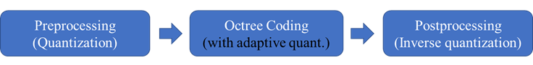

Figure 71 Adaptive quantization introduced into the octree coding process

In this scheme, a new internal quantization is introduced into the octree coding stage at a certain octree partition depth. Therefore, maximum two quantization stages can be enabled at the same time,

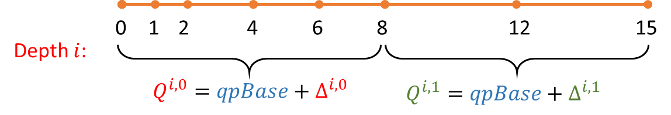

Figure 72: Illustration of signaling delta QP in 1D

### combination of slice-based and octree-based geometry quantization control [51]

A combination scheme of the slice-based and octree-based geometry quantization was introduced, since the slice-based scheme provides the basic functionality to each slice, and the octree-based scheme can provide more flexibility in lower partitioning level. In the combination scheme, instead of applying two internal quantization steps, one single operation is applied, i.e., internal quantization in the octree-level. It is as follows,

* If only octree-based quantization is enabled, it is the same with octree-based scheme, where the internal quantization is applied at a certain specified octree partition depth.
* If only slice-based quantization is enabled, the quantization will be applied in the first octree partition depth.
* If both slice-based and octree-based quantization are enabled, the actual quantization will be applied at the octree partition depth specified in octree-based scheme. The slice-level determined QP will be the base QP for signaling the delta QP at octree-level.

### Harmonization on octree-based geometry quantization control [73]

#### Harmonization with planar coding mode

Planar mode of child node is determined when the child node is created from current node. Geometry quantization, however, is applied when current node is processed. If the two schemes are enabled at the same time, problems may occur when the child node is going to perform quantization at next level, but the planar mode of the child node needs to be determined before quantization is performed. Encoder and decoder mismatch may therefore happen.

To solve this, it disables the planar mode for the octree nodes whose child node will perform quantization. This introduces the minimal change to the code and minor impact on the performance.

#### Harmonization with Implicit QTBT

Current implementation solves most interactions when enabling implicit QTBT and geometry quantization at the same time. But mismatch may occur when different QPs are applied.

To solve this, a new variable in the struct PCCOctree3Node, i.e., pos_q, which is used in reconstruction of geometry positions at the decoder side is introduced. Another existing variable pos is used for accessing the atlas map in context modeling.

### Quantization of IDCM nodes

In general, since information conveyed by isolated points is potentially less accurate than more dense regions, it may not be necessary to use the full precision available from the octree. Similarly, in order to match the quantization behaviour of IDCM nodes with their non-IDCM counterparts, an independent QP is introduced for use by non-IDCM nodes that occur prior to the depth at which per-node scaling QP offsets are signalled.

Figure 73 illustrates this problem, where an IDCM node occurs prior to the quantization depth. Each node after the quantization node size is able to specify a quantization parameter for its respective subtree. However, the node marked ‘a’ is not quantized.

The introduced solution is to quantize any IDCM nodes to the left of the line with a dedicated quantization parameter, idcmQp. Since nodes to the right of the line may have been quantized already according to the subtree that they belong, any IDCM nodes in subtrees to the right are not requantized, unless they belong to a subtree that has a derived QP of 4.

To achieve this, an additional parameter is added to the slice header indicating the QP to use relative to the sliceQp for IDCM nodes.

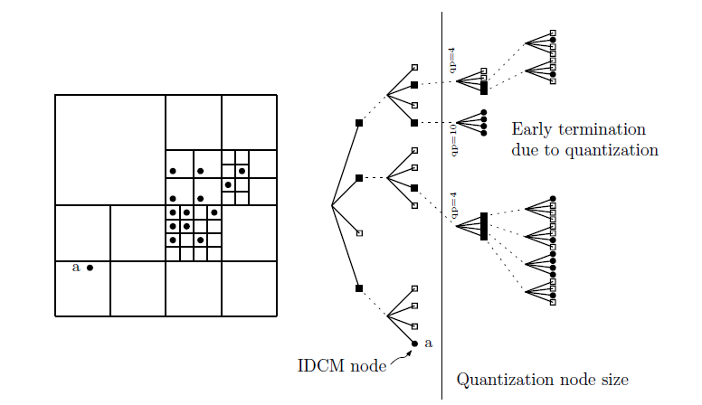

Figure 73: Illustration of a quad tree with in-tree quantization and an IDCM node

## Geometry Entropy encoding

### Binary coding of occupancy code

TMC13 supports two binary coding mode of occupancy code. In this section, both methods are described in order.

#### Bitwise based binary coding of occupancy code [12]

TMC13 has supported a binarization of the entropy coder that codes the occupancy information of the octree. Therefore, a cascade of binary coders is used together with dependency reduction when using ten neighbour configurations in order to obtain a “reasonable” number of entropy coders, with no compression loss.

An improvement of this method has been introduced to obtain a tunable number of binary coders at the price of a slight compression loss with a “more reasonable” number of coders. This method is compatible with intra schemes as described in section 3.2.3 for instance.

The bitwise based binary coder is depicted in yellow and orange as additional blocks in the flowchart of Figure 74 (encoder) and Figure 75 (decoder).

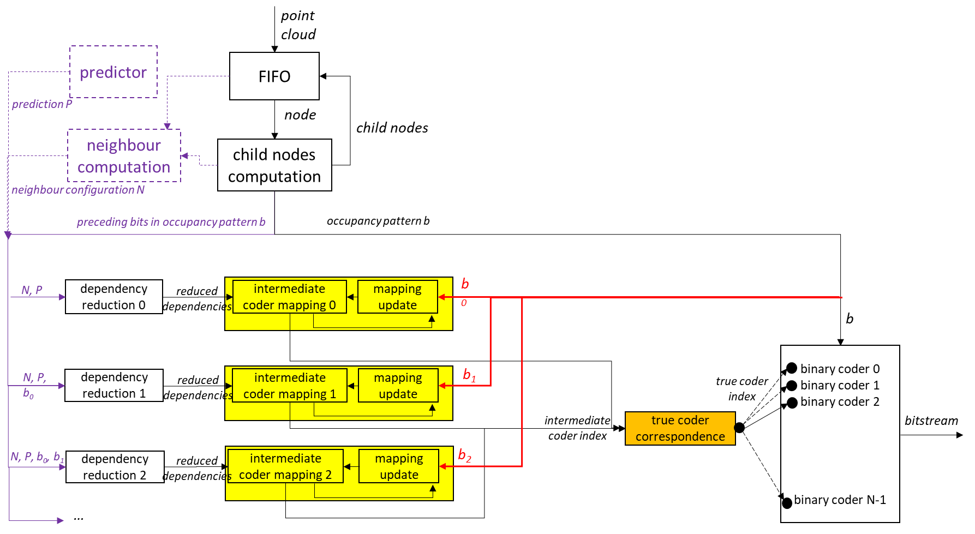

Figure 74: flowchart of the proposed encoder for the new binarization scheme

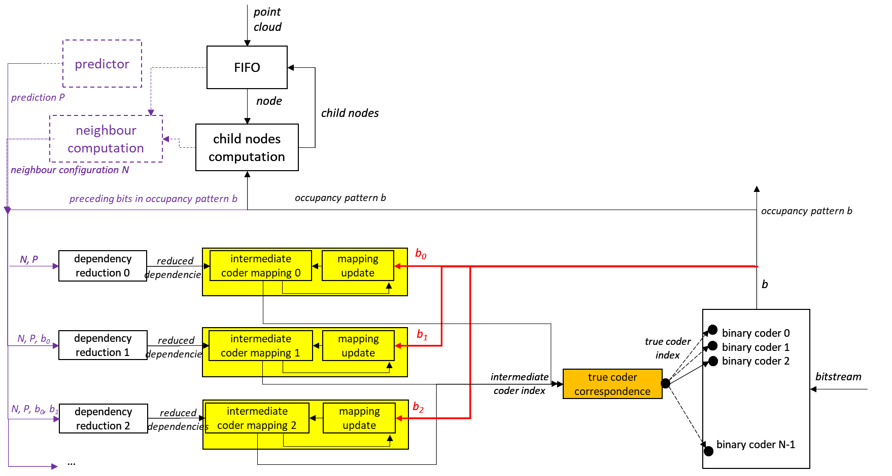

Figure 75: flowchart of the proposed encoder for the new binarization scheme

##### Binarization

A current cube has eight child cubes that may or may not be occupied by at least one point of the point cloud. To each child cube CCi is attached an occupancy bit bi representative of the occupancy state of the child CCi being occupied (bi=1) or non-occupied (bi=0). The concatenation of the eight bits bi forms an eight-bit integer b between 1 and 255; the value 0 being forbidden because at least one child is occupied by construction of the octree.

In order to profit from local geometry correlation, the bits bi should not be coded independently, and an ideal binarization can be obtained based on the well-known conditional entropy formula:

The first bit b0 is coded directly by a binary coder, the second bit b1 is coded by a binary coder depending on the value of b0, etc. The last bit b7 is coded depending on the 128 possible values of b0…b6. A practical implementation to solve these binary coders dependencies is desirable. A straightforward answer may be to introduce contexts as done for CABAC in video coding. For example, one may have 128 contexts to code b7 and the context is chosen based on the value of b0…b6. This would lead to 1+2+4+…+128=255 contexts for the eight bits bj to code. This is still manageable, however when introducing several prediction tools, the number of contexts may easily increase drastically to more than a few thousands, and HW implementations become difficult or impractical.

In the next section, a novel binarization scheme is described which reduces the number of needed contexts and allows for the use and development of additional occupancy prediction tools that will drive the binary entropy coders.

##### Optimal Binarization with Update On-the-fly

The binarization process has a fixed (small) number N of binary coders that are ideally arithmetic coders with an evolving internal probability, like CABAC or Dirac [15] coders. A bit bj representing the occupancy of a child node is coded using a binary coder Ci chosen among the coders C1 to Cn. The choice of the coder index i is performed depending on a dependency state D as depicted on Figure 76.

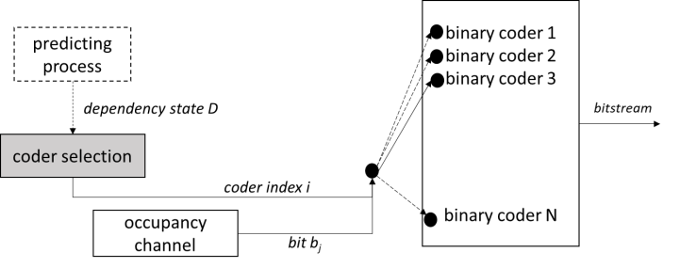

Figure 76: on choosing a binary coder to code an occupancy bit bj depending on a dependency state D

In general, the state D is an element of a set Ɗj, indexed by j from the child node CCj, of states. For example, the sets Ɗj can contain {b0...bj-1, NC, P1,…,PK} where

* NC is a neighbouring configuration that can take 10 different values, and
* the Pk’sare predictors for the occupancy of the cube associated with the bit bj. A predictor can typically take three values, namely “predicted occupied”, “predicted non-occupied” or “not predicted”.

Consequently, the state D can take 10.2j.3K different values, and the size of the set Ɗj of states can easily reach thousands of elements or even more. Example of construction of NC and Pk are explicated later in this paper.

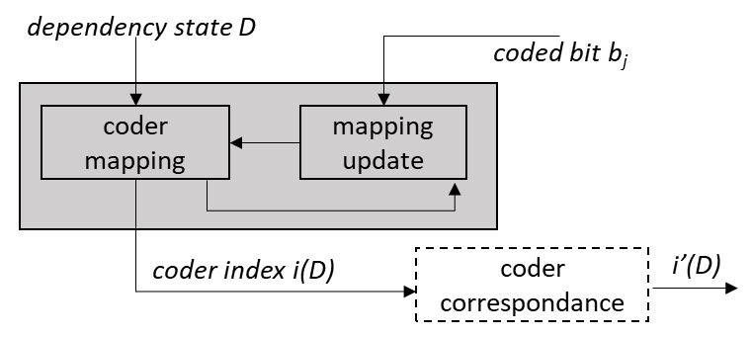

Figure 77: update process of the coder index i(D)

The coder selection consists of two processes. Firstly, a coder mapping provides a coder index i(D) obtained from the dependency state D, see Figure 77. Practically the mapping is a LUT having as many entries as elements in the set Ɗj of states. The LUT obviously depends on the index j of the child cube, thus one has eight LUTs that map D to i(D). Secondly, once the bit bj is (de)coded, the D-th entry of the mapping is updated from i(D) to a new value iupdate.

The mapping is based on a simple model of a channel with memory of L=10 symbols. A fixed theoretical probability pi (not to be confused with the internal evolving probability of the coder). of coding the symbol 1 is associated with each binary coder Ci. Consequently, in theory, the probability of getting bj=1 for the dependency state D is pi(D). After coding the bit bj, this theoretical probability is modified depending on the value of bj leading to a new probability pnew obtained by the relation, assuming a memory of L symbols:

The coder index is then updated to point to the coder whose probability piupdate is the closest to pnew, i.e.

Practically, the values iupdate obtained from the couple i and bj are precomputed into two LUTs, independent on j and D, such as to get a very compact update step by:

The fixed theoretical probabilities pi are determined such as to cover the interval [0,1] in some optimal way as follows. Let ε>0 be a positive real number. The set of coders {Ci} is said to be a set of ε-coders if

1. the fixed probabilities pi are an increasing sequence relative to the index i and cover the interval (0,1)
2. coding the symbols of a binary channel B, with associated probability pB in [pi-1, pi+1] of the symbols to be 1, using the coder Ci leads to an extra per-symbol entropy of at most ε relative to the coding with an optimal coder with associated probability pB.

In other words, one has an ordered set of coders, and coding a symbol with a marginally sub-optimal coder (Ci±1 instead of Ci) leads to at most ε extra bit per symbol. Therefore, an inaccuracy Δ in the coder index relative to the optimal coder index leads to an extra entropy bounded by Δε.

A set of ε-coders is said to be optimal if its number of coders is minimum among all possible sets of ε-coders. Covering the interval (0,1) is understood loosely as p1 being arbitrarily close to 0 and pN arbitrarily close to 1. Practically, one chooses ε such as to obtain a desired number N(ε) of coders. The probabilities pi can be determined using the following algorithm:

1. start with p1 arbitrary small
2. determine iteratively pi+1 from pi, until pi+1 is arbitrary close to 1, as follows
   1. for a probability p, define an entropy error E relatively to pi by
   2. take pi+1 as the lowest probability that guarantees the error to be bounded by ε, i.e. .

The value ε = 1.0870e-04 provides an optimal set of N(ε)=256 ε-coders.

It has been observed that the update step requires a fine granularity in term of probabilities pi, but the actual number of coders can be reduced without impacting noticeably the compression performance. Therefore, a coder correspondence (see Figure 77) has been added to map the coder index i(D) in [1,256] to an actual coder index i’(D) in [1,32]. The correspondence is simply a division by 8, and only 32 binary coders are used while maintaining an update working on 256 values. The binary coders Ci are initialized to their fixed theoretical probabilities pi before starting coding the octree.

#### Bytewise based binary coding for occupancy code [13]

In order to efficiently encode the non-binary occupancy values with a binary arithmetic encoder TMC13 introduce:

* an adaptive look up table (A-LUT), which keeps track of the N (e.g., 32) most frequent occupancy symbols,
* a cache which keeps track of the last different observed M (e.g., 16) occupancy symbols.

The algorithm proceeds as follows:

* + The A-LUT is initialized with N symbols provided by the user or computed offline based on the statistics of a similar class of point clouds.
  + The cache is initialized with M symbols provided by the user or computed offline based on the statistics of a similar class of point clouds.
  + Every time a symbol S is encoded the following steps are applied
    1. A binary information indicating whether S is the A-LUT or not is encoded.
    2. If S is in the A-LUT, the index of S in the A-LUT is encoded by using a binary arithmetic encoder
       - Let (b1, b2, b3, b4, b5) be the five bits of the binary representation of the index of S in the A-LUT. Let b1 be the less significant bit and b5 the most significant bit.
       - We propose two approaches to encode the index by using either 31 or 5 adaptive binary arithmetic contexts as shown in the pseudo-codes below (Note: _binaryModel0 is a static binary arithmetic context, and _binaryModelIndexInLUT[] is an array of adaptive binary arithmetic contexts)
         * 31 Contexts

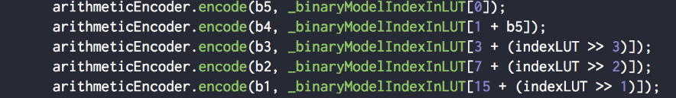

* + - * + 5 contexts

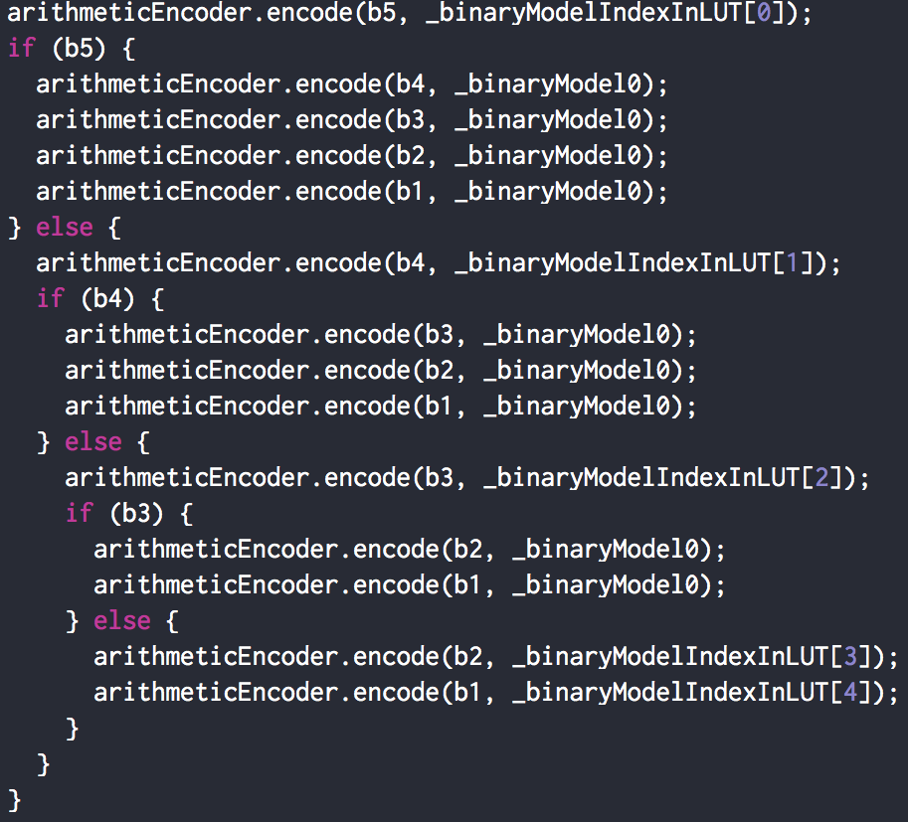

* + 1. If S is not the A-LUT, then
       - A binary information indicating whether S is in the cache or not is encoded.
       - If S is in the cache, then the binary representation of its index is encoded by using a binary arithmetic encoder
         * In the current implementation, the binary representation of the index is encoded by using a single static binary context as described in the pseudo-code below

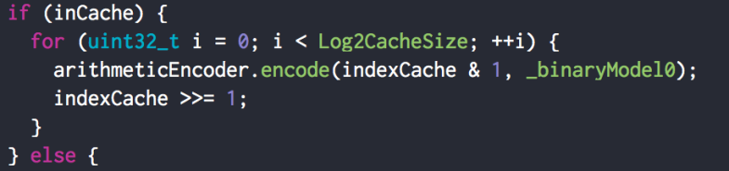

* + - * Otherwise, if S is not in the cache, then the binary representation of **S** is encoded by using a binary arithmetic encoder
        + In the current implementation, the binary representation of S is encoded by using a single adaptive binary context as described in the pseudo code below

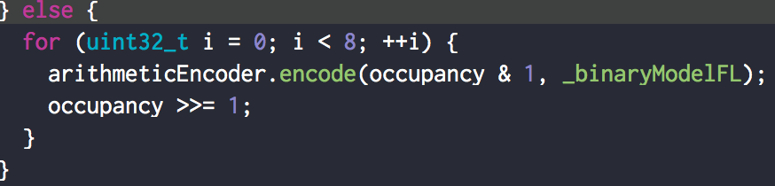

* + - * The symbol S is added to the cache and the oldest symbol in the cache is evicted.
    1. The number of occurrences of the symbol S in A-LUT is incremented by one.
    2. The list of the N most frequent symbols in the A-LUT is re-computed periodically (Note: the update period increases exponentially).
    3. At the start of each level of the octree subdivision, the occurrences of all symbols are reset to zero. The occurrences of the N most frequent symbols are set to 1.
    4. When the occurrence of a symbol reaches a user-defined maximum number (e.g., 1024), the occurrences of the all the symbols are divided by 2 to keep the occurrences within a user-defined range.

The approach described above makes it possible to reduce the number of adaptive binary contexts to 340 or 80, depending on the number of binary contexts used to encode the index in the adaptive LUT (i.e., 31 or 5).

This number could be further reduced by applying the adaptive neighborhood context selection described below. The idea is to reduce the number of neighborhood contexts from 10 to a lower number NC (e.g., 6), by assigning a separate context to the (NC-1) most probable neighborhood configurations, and making the neighborhood contexts corresponding to the least probably neighborhood configurations share the same context. The algorithm proceeds as follows:

* Before starting the encode, initialize the occurrences of the 10 neighborhood configurations:
  + Set all occurrences to 0
  + Set the occurrences based on offline/online statistics or based on user-provided information
* At the beginning of each subdivision level of the octree
  + Determine the (NC-1) most probable neighborhood configurations based on the statistics collected during the encoding of previous subdivision level
  + Compute a look-up table NLUT, which maps the indexes of the (NC-1) most probable neighborhood configurations to the numbers 0, 1, …, (NC-2) and maps the indexes of the remaining configurations to NC-1
  + Initialize the occurrences of the 10 neighborhood configurations to 0
* During the encoding
  + increment the occurrence of a neighborhood configuration by one each time such a configuration is encountered
  + use the look-up table NLUT[] to determine the context to use to encode the current occupancy values based on the neighborhood configuration index

If NC is set to 6, the variation described above makes it possible to use 48 adaptive binary contexts.

A high throughput version of the scheme described above could be achieved by encoding/decoding the occupancy symbols as a set of separate/independent streams, which could be processed in parallel. The idea is to encode/decode each P (e.g., 4, 8, or 16) consecutive occupancy symbols by using independent, which write to P independent binary sub-streams. The final bistream is obtained by concatenating the P sub-bitstreams. A header information describing the offset to each sub-stream is also included.

* + The occupancy symbols are accumulated in a fifo
  + If the fifo has at least P symbols
    - P symbols are extracted from fifo and encoded as described above by using P separate arithmetic encoders and with independent arithmetic contexts
    - The P symbols are pushed to the LUT or to the cache only after all symbols were arithmetically encoded.
  + If we reach the end of the encode process and less than P symbols are in the fifo, the fifo is padded with the last observed symbol until it has a size of P, then the P symbols are encoded as described above.

### Dirac / SMPTE VC-2 [14]

The Dirac video codec [15] was developed by the BBC with intra profiles being standardised by the SMPTE as VC2[16]. One of the principal objectives of the Dirac project was to produce a royalty free video codec.

For entropy coding, Dirac|VC-2 defines a context adaptive binary arithmetic codec using 32bit arithmetic and 16bit probabilities. Probabilities are updated on the basis that the current probability is an estimate for the number of symbols coded.

### Bypass coding of bypass bins [45]

G-PCC introduces an alternative to using an arithmetic entropy codec to code incompressible bypass symbols, using instead an approach to so-called bypass coding that bypasses the arithmetic codec completely without incurring additional signaling overheads.

It involves partitioning the symbol stream into two sub-streams: an arithmetically coded sub-stream and a bypass sub-stream. A data unit is constructed as per Figure 78 as the concatenation of the existing data unit header and (forward) AEC sub-stream with the byte reversed bypass sub-stream. Since the length of the entire data unit is known, using this construction it is not necessary to signal the length of either sub-stream.

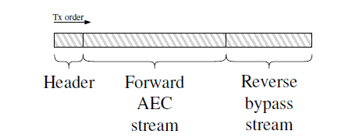

Figure 78: Construction of a data unit payload

From the point of view of a decoder, two read pointers are maintained, one for the payload and forward AEC sub-stream, the other for the reversed sub-stream. At the start of parsing a data unit, the read pointers are initialized to the first and last bytes of the data unit. For each byte read from each sub-stream the associated read pointer is respectively incremented or decremented.

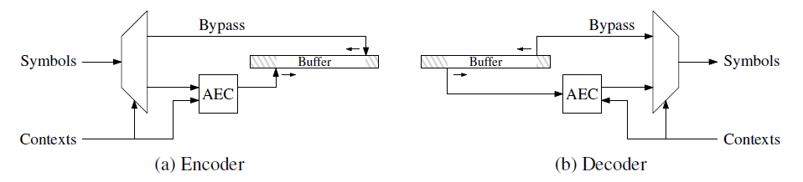

Figure 79: Conceptual semantics

### Chunked entropy streams [74][91]

This method is an alternative approach based on a chunk-interleaved representation of the two substreams. It aims to balance the benefit of not arithmetically coding bypass bins, the ability to transmit and receive the bitstream as a whole in the forward order, with the chunk signaling overhead.

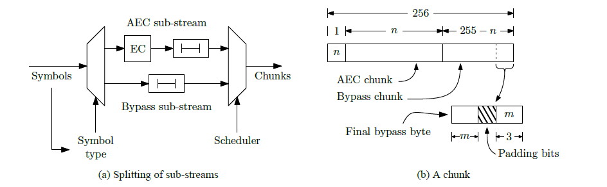

Figure 80: Construction of a multiplexed sub-stream chunk

Each 256 byte chunk is formed of (shown diagrammatically in Figure 80):

* a one byte header that indicates the number of arithmetically coded bytes present in the chunk, n,

• n bytes of arithmetically coded data, and

• 255 − n bytes of (non arithmetically coded) bypass data.

Special handling of the last bypass coded byte in a chunk allows an encoder to flush incomplete chunks in order to permit low latency coding and decoding. The last bypass byte, if present, contains a three bit value indicating the number of bits that have been flushed and should be discarded from the bypass sub stream.

Additionally, to recover in place writing by the encoder, it is introduced to reverse the byte order of the second chunk in Figure 81. This obvious change does not modify the compression performance of the TM. It provides also a slight simplification by removing a temporary buffer and a copy of this buffer.

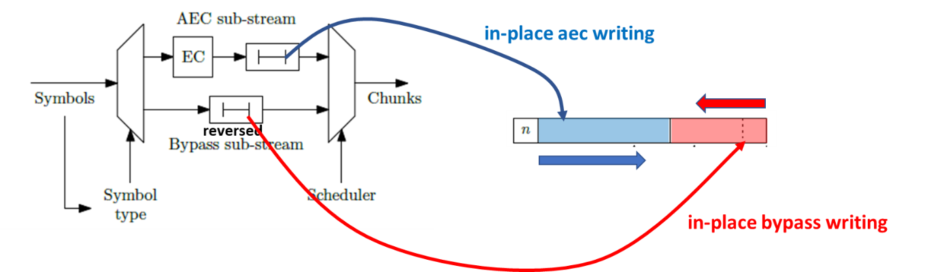

Figure 81: reverse the byte order of the second chunk

## Attributes transfer (recolouring)

Given the input point cloud positions/attributes and the reconstructed positions , the objective of the attributes transfer procedure is to determine the attribute values that minimize the attribute distortions.

The implemented approach proceeds as follows:

* Letand be the input and the reconstructed positions, respectively.
* Let and be the number of points in the original and the reconstructed point clouds, respectively.

If duplicated point are merged, then , otherwise .

* For each point in the reconstructed point cloud, let be its nearest neighbour in the original point cloud and the attribute value associated with .
* For each point in the reconstructed point cloud, let be the set of points in the original point cloud that share as their nearest neighbour in the reconstructed point cloud, is the number of elements in , and is one of the elements of Note that could be empty or could have one or multiple elements.
* If is empty, then the attribute value is associated with the point .
* If is not empty, then we proceed as follows:
* The attribute value associated with the point is obtained by Eq.1.

Note: currently --searchRange = 0 shall be used for coding in TMC13.

### Distance-weighted color transfer [48]

The improved color transfer algorithm is introduced in the following. For each point of the target :

1. Find the (1 < ) nearest neighbors in source to and create a set of points denoted by .
2. Find the set of source points that belongs to their set of nearest neighbors. Denote this set of points by .
3. Compute the distance-weighted average of points in and by:

where denotes the Euclidian distance between the points and , and denotes the color of point .

1. Compute the average (or the weighted average with the number of points of each set as the weights) of and and transfer it to .

## Attribute coding (Predicting Transform)

### Level of detail generation [84]

The level of detail (LOD) generation process (see Figure 82) re-organizes the points into a set of refinement levels , according to a set of L1 (Manhattan) distances specified by the user. Note that the distances need to satisfy the following two conditions:

* , and
* .

The re-ordering process is deterministic and operates on the quantized positions ordered according to the octree decoding process. It is applied at both the encoder and the decoder side. It proceeds as follows:

* First, all the points are marked as non-visited and the set of visited points, denoted as , is set as empty.
* The algorithm proceeds iteratively. At each iteration , the refinement level is generated as follows:
  + The algorithm iterates over all the points.
  + If the current point has been visited, then it is ignored.
  + Otherwise, the minimum distance D of the current point to the set is computed.
  + If D is strictly lower than , then the current point is ignored,
  + If D is higher or equal than , then the current point is marked as visited and added to both and .
  + This process is repeated until all the points are traversed.
* The level of detail l, , is obtained by taking the union of the refinement levels .
* This process is repeated until all the LODs are generated or until all the vertices have been visited.

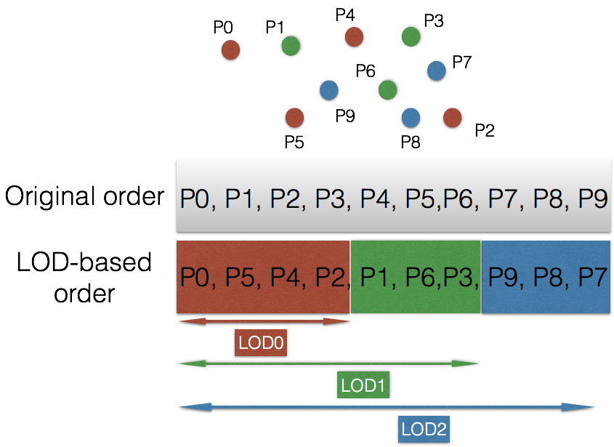

Figure 82: Level of detail generation process

### Scalable complexity implementation of LOD generation [19]

In order to provide a scalable complexity implementation of the lifting scheme, G-PCC introduces to:

* Use a bottom-up approach to build the LODs instead of the top-down technique
* Use an approximate nearest neighbor search instead of an exact nearest neighbor search to accelerate LOD and predictor creation.

Let be the set of positions associated with the point cloud points and let be the Morton codes associated with . Let and be the two user-defined parameters specifying the initial sampling distance and the distance ratio between LODs, respectively. Note that .

First the points are sorted according to their associated Morton codes in an ascending order. Let be the array of point indexes ordered according to this process. The algorithm proceeds iteratively. At each iteration , the points belonging to the LOD are extracted and their predictors are build starting from until all the points are assigned to an LOD. More precisely, the algorithm proceeds as follows:

* The sampling distance is initialized with
* For each iteration, where Let be the set of indexes of the points belonging to -th LOD and the set of points belonging to LODs higher than . and are computed as follows.
  + First, and are initialized
    - . Otherwise,
  + The point indexes stored in the array are traversed in order. Each time an index is selected and its distance to the most recent SR1 points added to is computed. SR1 is a user-defined parameter that controls the accuracy of the nearest neighbor search. For instance, SR1 could be chosen as 8 or 16 or 64. The smaller the value of SR1 the lower the computational complexity and the accuracy of the nearest neighbor search. The parameter SR1 is included in the bitstream. If any of the SR1 distances is lower than , then is appended to the array Otherwise, is appended to the array .
* This process is iterated until all the indexes in are traversed. At this stage, and are computed and will be used in the next steps to build the predictors associated with the points of . Let \ (where \ is the difference operator) be the set of points that need to be added to LOD(k-1) to get LOD(k). For each point in , we would like to find the -nearest neighbors ( is user-defined parameters that controls the maximum number of neighbors used for prediction) of in and compute the prediction weights associated with . The algorithm proceeds as follows.
  + Initialize a counter
  + For each point in
    - Let be the Morton code associated with and let be the Morton code associated with j-th element of the array
    - While (, incrementing the counter j by one (
    - Compute the distances of to the points associated with the indexes of that are in the range [j-SR2, j+SR2] of the array and keep track of the -nearest neighbors and their associated squared distances . SR2 is a user-defined parameter that controls the accuracy of the nearest neighbor search. Possible values for SR2 are 8, 16, 32, and 64. The smaller the value of SR2 the lower the computational complexity and the accuracy of the nearest neighbor search. The parameter SR2 is included in the bitstream. The computation of the prediction weights used for attribute prediction remains unchanged compared to [4].
      * + If the distance between the current point and the last processed point is lower than a threshold, use the neighbors of the last point as an initial guess and search around them.
        + The previous idea could be generalized to n=1,2,3,4… last points
        + Exclude points with a distance higher that a user-defined threshold.

### A method to compute dist2 values for LoD attribute coding [75]

A low complexity and fully automatic non-normative technique to compute the LoD generation parameters with competitive RD performance is introduced.

Rather than black magic, the general principle for choosing a dist2 value for LoD attribute coding is to obtain a ratio of 1:4 in the number of points in the finest and second finest levels of detail. The current dist2 values were initially determined in a response to the call for proposals. For new test sequences the dist2 values (which was originally a more cumbersome list) were copied from similar looking test sequences with little regard to correctness.

The LoD subsampling scheme is a form of down-sampler. It requires a squared distance value to workout the subsampling ratios. The octree that is used to encode the point cloud is also a form of downsampler. It down-samples by factors of 2 in each direction for each level of the octree.

A starting point for the method is to use information that can be discovered during octree coding to approximate an octree level that results in a ratio of one quarter of the total points. This assumes a uniform density where, eventually, surface-like structures are discovered and down-sampled. Since in reality this is unlikely to happen at the exact transition between two octree levels, the squared distance for LoD subsamping is derived by linearly interpolating between the levels either side of the transition. Figure 83 shows the ratio of points in each octree level for various sequences.

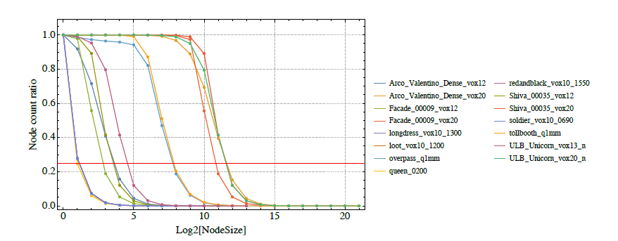

Figure 83: Plot of per level count of octree nodes as ratio to leaf node count

The specific process is as follows:

1. Let lvln be the number of unique points in the n-th lowest octree level. lvl0 represents the number of unique points in the source point cloud.
2. Let lvlRation = lvln / lvl0 as the ratio of unique points at the n-th level to the number of unique points in the source.
3. Find the smallest a that fulfils lvlRatioa > ¼.
4. Linearly interpolate between the values of lvlRatioa and lvlRatioa+1 to determine the value of x0 at y = ¼:

x0 = (¼ − lvlRatioa) / (lvlRatioa+1 − lvlRatioa) + a + 1

1. Determine the squared distance as di = ⌈⌉

While the base method provides a reasonable approximation, it does not always yield the desired ratio. The squared distance value may be refined by iterative interpolations as follows for slightly better RD performance at the cost of increased computational effort.

Starting with i = 0,

1. Perform LoD subsampling of the points using the squared distance di =⌈⌉ to determine the true ratio, lodRatioxi of points for the finest LoD.
2. Linearly interpolate as follows:

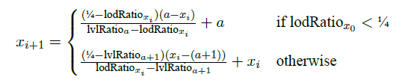

1. Repeat with successive values if i until either of the following conditions reached:
   * lodRatioxi is very close to ¼, i.e. ||lodRatioxi − ¼|| ≤ ϵ.
   * Successive values of di have converged. This is possible because di is an integer.
2. Use di from the final iteration as dist2 for LoD generation.

### Regular sampling based LoD generation [33]

A low-complexity LOD generation procedure, which better captures the initial point distribution and can enable a more efficient prediction for non-smooth attribute signals defined over irregularly sampled point clouds was introduced. It has a linear complexity and does not requires a second reordering of the points. Instead, it directly leverages the Morton-based ordering of the points that is used to determine prediction neighbors.

Let be the set of ordered indexes and the associated LOD that represents the entire point cloud. Instead of defining a set of sampling distances, it defines a set of sampling rates denoted , where is an integer describing the sampling rate for the LOD (e.g., ). The ordered array of indexes associated with LOD , denoted as , is computed by subsampling , while keeping one index out of every indexes. The sampling rate could be further updated with an LOD in order to better adapt to the point cloud distribution. More precisely, the encoder may explicitly encode in the bitstream for a predefined group of points (e.g., each consecutive H=1024 points) different values or updates to be applied to the latest available value. can be automatically determined based on the characteristics of the signal and/or the point cloud distribution, previous statistics, or could be fixed. Different subsampling rates may be defined per attributes (e.g., color, reflectance) and per channel (e.g., Y and U/V)

### Octree-based LOD generation [136]

The octree-based LOD generation which is the integrated method of decimation-based (See section 3.8.4) and scalable LOD generation (See section 3.15.4.1) was introduced. In this method, the decimation mechanism (sampling period) was added on scalable LOD generation

For scalable LOD generation, the value of sampling period is zero. Thus, there is no impact on scalable LOD generation with the changes. For LOD generation using decimation, the followings are changed.

* start sampling from dist2 level of octree
* select the centroid point in sampling range
* select one point even though the number of points in an octree node is greater than sampling period

The function subsampleByOctree() in TMC13 software is used for scalable LOD generation. The changes for adding decimation mechanism are marked in yellow-highlighted.

|  |
| --- |
| inline void  **subsampleByOctree**(  const PCCPointSet3& pointCloud,  const std::vector<MortonCodeWithIndex>& packedVoxel,  const std::vector<uint32_t>& input,  int32_t octreeNodeSizeLog2,  std::vector<uint32_t>& retained,  std::vector<uint32_t>& indexes,  bool direction,  int lodSamplingPeriod=0)  {  const int indexCount = int(input.size());  if (indexCount == 1) {  indexes.push_back(input[0]);  return;  }  bool direction = octreeNodeSizeLog2 & 1;  uint64_t lodUniformQuant = 3 * (octreeNodeSizeLog2 + 1);  uint64_t currVoxelPos;  std::vector<uint32_t> voxels;  voxels.reserve(8);  for (int i = 0; i < indexCount; ++i) {  uint64_t nextVoxelPos = currVoxelPos =  (packedVoxel[input[i]].mortonCode >> lodUniformQuant);  if (i < indexCount - 1)  nextVoxelPos = (packedVoxel[input[i + 1]].mortonCode >> lodUniformQuant);  voxels.push_back(input[i]);  if (i == (indexCount - 1) || currVoxelPos < nextVoxelPos) {  if((voxels.size() < **lodSamplingPeriod**) && (i != (indexCount-1))) continue;  uint32_t picked = subsampleByOctreeWithCentroid(  pointCloud, packedVoxel, octreeNodeSizeLog2, direction, voxels);  for (const auto idx : voxels) {  if (picked == idx)  retained.push_back(idx);  else  indexes.push_back(idx);  }  voxels.clear();  }  }  } |

* voxels.size(): number of points in one octree node or one sampling range
* indexCount : number of points in input list

When scalable lifting is enabled, or lod decimation is enabled, the octree-based LOD generation, subsampleByOctree(), is called with different parameter.

|  |  |  |  |
| --- | --- | --- | --- |
|  | sampling level | search direction | sampling period |
| Scalable lifting enabled | lodIndex | left/right | 0 |
| LOD decimation enabled | aps.dist2 + lodIndex | left | aps.lodSamplingPeriod[lodIndex] |

|  |
| --- |
| inline void  **subsample**( … ) {  if (**aps.scalable_lifting_enabled_flag**) {  int32_t octreeNodeSizeLog2 = lodIndex;  bool direction = octreeNodeSizeLog2 & 1;  **subsampleByOctree**(pointCloud, packedVoxel, input, octreeNodeSizeLog2,  retained, indexes, direction);  } else if (**aps.lod_decimation_enabled_flag)** {  auto samplingPeriod = aps.lodSamplingPeriod[lodIndex];  subsampleByDecimation(input, samplingPeriod, retained, indexes);  int32_t octreeNodeSizeLog2 = aps.dist2 + lodIndex;  **subsampleByOctree**(pointCloud, packedVoxel, input, octreeNodeSizeLog2,  retained, indexes, true, samplingPeriod);  } else { … }  } |

### Simplified prediction structure in case of LoD equal one [22]

Let be the set of positions associated with the point cloud points and let be the Morton codes associated with . First, the points are sorted according to their associated Morton codes in an ascending order. Let be the array of point indexes ordered according to this process. The encoder/decoder compresses/decompresses respectively the points according to the order defined by . At each iteration , a point is selected. The distances of to the (e.g., =64) previous points are analyzed and the (e.g., =3) nearest-neighbors of are selected to be used for prediction in the same manner as in the current version of G-PCC.

### Intra LoD prediction on attribute predicting transform [31][124]

An EnableReferringSameLoD flag is introduced to control the reference structure for predicting transform in order to keep tradeoff of coding efficiency and parallel processing. If EnableReferringSameLoD flag is set to 1, 3D point in the same LoD could be referred. Additionally, the function to allow to switch this tool on for certain LoD was also introduced. This tool is called by intra LoD prediction. It is noted that intra LoD prediction is always used when number of LoD is equal to 1.

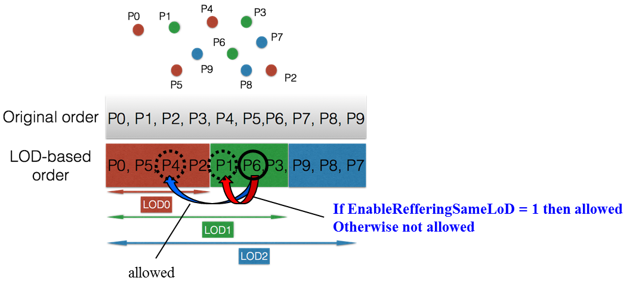

Figure 84: reference structure for intra LoD prediction

### Neighbour search at the same distance [59]

The lifting and prediction scheme extensively use nearest neighbor searches during the Level of Detail (LoD) generation and predictors building stages. Especially, it is introduced how neighbors at the same distance are handled as following,

* Neighbors in subsequent LODs with the same distance from the current point are handled according to the priority described in Figure 85.



Figure 85: Neighbors in subsequent LoDs: Handling neighbors with the same distance from the current point.

* Neighbors in the same LOD Neighbors with the same distance from the current point are handled according to the priority described in Figure 86.

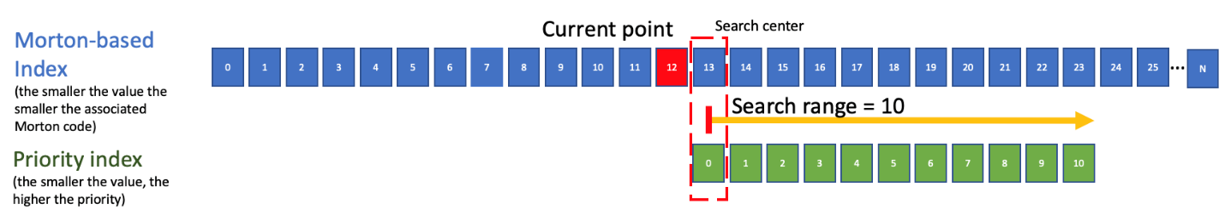

Figure 86: Neighbors in the same LoD: Handling neighbors with the same distance from the current point.

Neighbors in the subsequent LoDs have a higher priority than neighbors in the same LoD.

### Optimizing Nearest Neighbours Search for Lifting/Prediction [126]

An approximate -NN solution gives in practice a good approximation of the -NNs. However, it fails to capture the actuals nearest neighbors with significant jumps in terms of Morton order is observed between neighboring points (see Points P and Q in Figure 87).



Figure 87: Actuals nearest neighbors with significant jumps in terms of Morton orde

To improve nearest neighbours search, the first optimization consists in using a look-up table to accelerate the k-NN search. More precisely, and it would like to determine whether the neighbours of a voxels are occupied or not and use them to determine the k-NNs of the current point. More precisely, let (see Figure 88) be the set of neighbors of in . For instance, the 6/18/26-connectivity of the union the { }, and be the bounding cube of (i.e., .

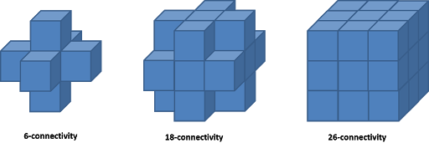

Figure 88: Example of voxel neighbours.

It is introduced to pre-compute a LUT that maps any point of to a range describing the indexes in of the points having the same position (or Morton code) as the point X. The set of points to be searched to determine the k-NN of a point is built as follows:

* For each neighbor check using the LUT if it belongs to. If , add all the points in the range to .
* If has less than elements
  + If is empty, then
  + If has at least one element
    - Let be the index of the nearest neighbor in
    - Apply an extra refinement search in

Note: LUT and the linear searches could also be applied in reverse order (i.e., first the linear search and then the LUT-based search).

Allocating a LUT that holds may be expensive in terms of memory. To reduce such requirements, the bounding cube may be partitioned into smaller sub-cubes of size (seeFigure 89). Since the points are traversed in Morton order, all the points in one sub-cubes, will be traversed in sequence before switching the next subcube. Therefore, only a LUT able to store a single sub-cube is needed. The LUT would be initialized every time enters a new sub-cube. Only the point of in that sub-cube would be added to the LUT. For points on the boundary of the sub-cube it ignores neighbourhood relationship across sub-cubes boundaries.



Figure 89: Space partitioning.

This approach could leverage the sparsity of the point cloud and LOD structure to reduce the size and improve the efficiency of the k-NN search. More precisely, it constraints the distances used for the Lifting/Prediction scheme as follows:

its constraint the sequence of distances , as follows:

is parameter computed by the encoder and explicitly signalled in the bitstream.

If order to determine , it is applied strategy. First, it chooses a random subset of the point cloud points and it computes for each point the distance it separates it from its nearest neighbour. Let be p-th percentile (e.g., 75th percentile) of those distances. is chosen as the smallest integer that verifies:

### Interpolation-based prediction

The attributes associated with the point cloud are encoded/decoded in the order defined by the LOD generation process. At each step, only the already encoded/decoded points are considered for prediction. More precisely, the attribute values are predicted by using a linear interpolation process based on the distances of the nearest neighbours of point i. Let be the set of the k-nearest neighbours of the current point i, and let be their decoded/reconstructed attribute values and their distances to the current point. The predicted attribute value is given by:

.

The number of nearest neighbours, k, is a parameter that is determined by the encoder for each point, and arithmetically encoded.

### Filter-based attribute prediction [133]

Filter-based attribute prediction was introduced. In this method, before doing the interpolation-based prediction, it applies a filter to adjust attribute values of three selected neighbors based on the relative geometric position between neighbors. It formulates the process as the following equation:

**,**

where is the interpolation weight and is the filtering parameter .

The grey part is the color filter and the yellow part is the distance-based interpolation. This method can not only consider the geometric relationship between the neighbor points and the current point (in interpolation part), but also focus on the local geometry distribution among selected neighbor points (in filtering part). It uses the relative distance relationship among selected neighbors to set filter parameters. The filter parameters have been off-line trained and it keeps three parameters for all datasets.

Its filtering parameters are set as follow, for color:

(1) set **10** for fixed-point parameter .

(2) set **=1,=5** when dist12<=dist13**,** **otherwise =5,=1.** Then filter the attribute of the 1st nearest neighbor as follows:

(3) set **=1,=5** when dist21<=dist23**,** **otherwise =5,=1.** Then filter the attribute of the 2nd nearest neighbor as follows:

(4) set **=1,=5** when dist31<=dist32**,** **otherwise =5,=1.** Then filter the attribute of the 3rd nearest neighbor as follows:

For ref:**8**, and the other is 4.

### Neighbour weight modification [57]

In autonomous vehicle scenarios, the points in X-Y plane direction are relatively dense and those in Z axis direction are relatively sparse. Therefore, it is assumed that x and y components are more important than z component for intra prediction. The weight of each neighbor is modified by decreasing the influence of z component with adding a new modification parameter *intraPredictionWeight*. The modification parameter (*intraPredictionWeight*) is stored in the Attribute Parameter Set (APS), and it is set manually in config file in the encoder.

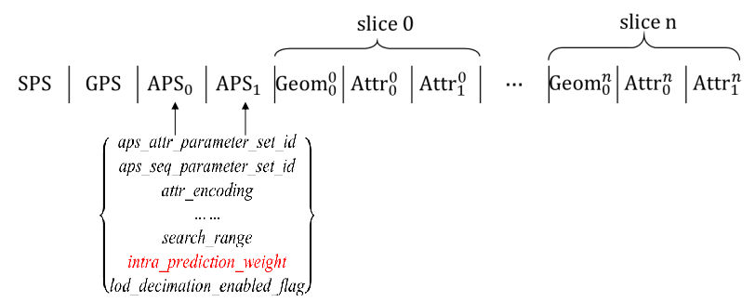

Figure 90: The modified bitstream structure for TMC13

In the decoder, the modification parameter (*intraPredictionWeight*) is obtained from APS, and modified weight of each neighbor is calculated with it.

Let be the position of the current point and be the positions of its 3-nearest neighbors. Let be the neighbors’ decoded/reconstructed attribute values, and be the weights associated with each of the 3-nearest neighbors.

In this scheme, based on the current result of neighbor point search in generating LoD.

The modified weight of each neighbor is calculated by:

. (1)

where .

Accordingly the predicted attribute value of the current point is derived as:

. (2)

### Adaptive predictor selection [17]

In current TMC13 attributes coding, LoD (Level of Detail) of each 3D points is generated based on the distance of each points, then the attributes value of 3D points in each LoD is encoded by applying prediction in LoD-based order (Figure 82). For example, the attributes value of P2 is predicted by calculating the distance based weighted average value of P0, P5 and P4 which were encoded or decoded prior to P2.

In this method, multiple predictor candidates are created based on the result of neighbor point search in generating LoD. For example, when the attributes value of P2 is encoded by using prediction, a distance based weighted average value of P0, P5 and P4 is set to predictor index equal to 0. Then, the value of nearest neighbor point P4 is set to predictor index equal to 1. Moreover, the value of next nearest neighbor point P5 and P0 are set to predictor index equal to 2 and 3 respectively (Table 4). After creating predictor candidates, best predictor is selected by applying a rate-distortion optimization procedure and then, selected predictor index is arithmetically encoded with the method described in the following section.

Table 4: Sample of predictor candidate for attributes coding

|  |  |
| --- | --- |
| Predictor index | Predicted value |
| 0 | average |
| 1 | P4 (1st nearest point) |
| 2 | P5 (2nd nearest point) |
| 3 | P0 (3rd nearest point) |

This method also includes the condition in which the variability of its neighborhood is computed to check how different the neighbor values are and if the variability is higher than a threshold, predictor selection is conducted.

#### Joint coding of predictor index and residual [137]

It was introduced to code the predIndex and residual jointly to resolve the parsing issue.

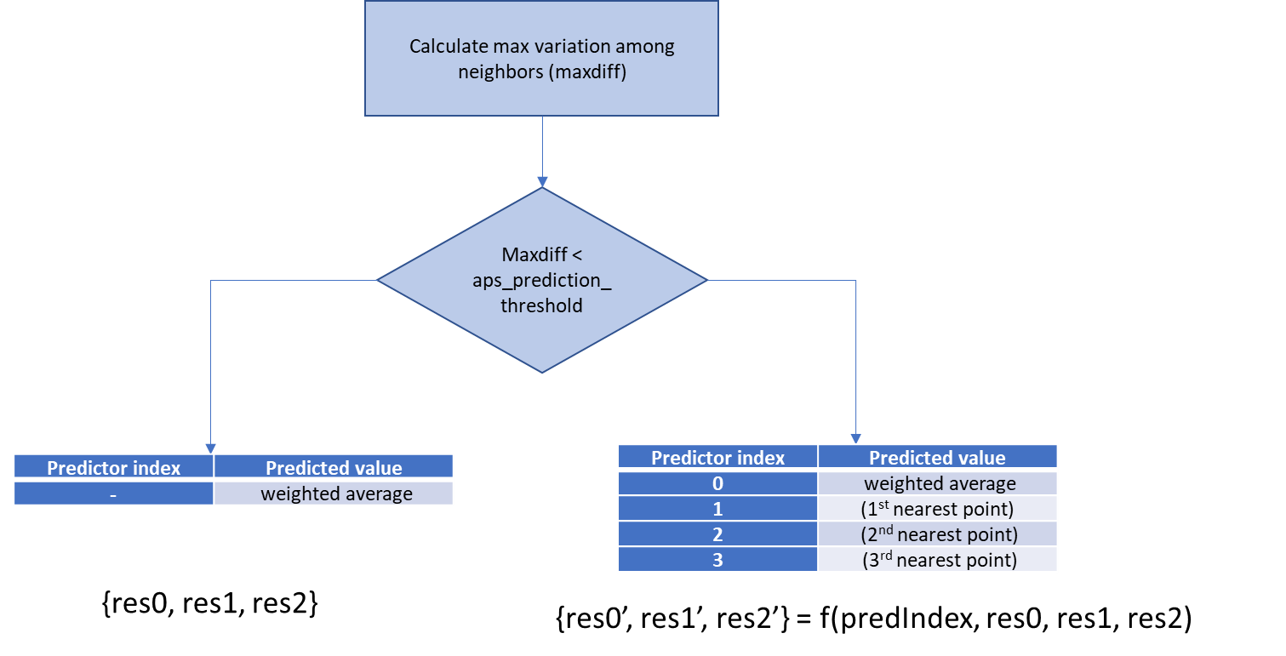

Figure 91: joint coding of residual and predIndex in predicting transform (for color attribute)

As described in the figure above, when the multiple predictor process is invoked (right branch), given the residual (res0, res1 and res2) – assuming three components of the residual for example color attribute – and predictor index (predIndex), the residual and a signaled index (sigIndex) is jointly coded using a predetermined/fixed or signalled/adaptive function “f” and the jointly coded values, i.e., res0’, res1’, and res2’ are signalled as residuals in the bitstream. On the left branch, where predictor index is not applicable, the residuals are directly signaled in the bitstream. predIndex is derived from sigIndex at the decoder side. At the decoder side, residuals are parsed and decoded in a normal way. During the attribute reconstruction, if the process invokes multiple predictor branch (in right), inverse function of “f”, let say “invf” is used to recover residual (res0, res1, and res2) and sigIndex from jointly coded residual (res0’, res1’, and res2’).

For G-PCC v1 standard, the maximum number of direct predictor is 3, so there could be 4 predictors at maximum (considering the default weighted predictor and 3 direct predictors). To achieve better flexibility, it is also allowed to only have direct predictors, i.e., excluding default weighted predictor. There is an APS level flag indicating whether only direct predictor is allowed or not. The determination of sigIndex is signaled in the modulo of the joint residual. If the attribute dimension is greater than 1 the last two components of the residual is used, otherwise for single attribute dimension, that only components of the residual is used. The maximum number of predictors can range from 2 to 4 where such joint signaling is applicable. The details of the determination of joint residual for color (multi components) and reflectance (single component) attribute are described in the following.

**For color (multi-component):**

Number of predictors = 4:

sigIndex is mapped to modulo 2 of last two components of the joint residual (i.e, res1’, and res2’) as described in the follwing.

|  |  |  |
| --- | --- | --- |
| |res1’| mod 2 | |res2’| mod 2 | sigIndex |
| 0 | 0 | 0 |
| 0 | 1 | 1 |
| 1 | 0 | 2 |
| 1 | 1 | 3 |

So, given (res1, res2, sigIndex) tuplet, i.e., original residual and the signaled index, joint residuals (res1’, res2’) are calculated as follows:

res1’ = sign(res1)* (|res1|<<1 + sigIndex>>1)

res2’ = sign(res2)* (|res2|*<<1 + sigIndex&1)

And at the decoder side, the inverse operation is performed as follows.

res1 = sign(res1’)*(|res1’|>>1)

res2 = sign(res2’)*(|res2’|>>1 )

sigIndex = (|res1’|&1)<<1 + (|res2’|&1)

Number of predictors = 3:

sigIndex is mapped to modulo 2 of last two components of the joint residual (i.e, res1’, and res2’) as described in the follwing.

|  |  |  |
| --- | --- | --- |
| |res1’| mod 2 | |res2’| mod 2 | sigIndex |
| 0 | - | 0 |
| 1 | 0 | 1 |
| 1 | 1 | 2 |

So, given (res1, res2, sigIndex) tuplet, i.e., original residual and the signaled index, joint residuals (res1’, res2’) are calculated as follows:

res1’ = sign(res1)* (|res1|*2 + (sigIndex > 0))

res2’ = (sigIndex > 0)? sign(res2)* (|res2|*2 + (sigIndex-1)%2) : res2

And at the decoder side, the inverse operation is performed as follows.

res1 = sign(res1’)*((|res1’| - (|res1’| % 2))/2)

res2 = (|res1’|%2 > 0)? sign(res2’)*((|res2’| - (|res2’| % 2))/2) : res2’

sigIndex = (|res1’|%2) + ((|res1’|%2 > 0)? (|res2’| % 2): 0)

Number of predictors = 2:

sigIndex is mapped to modulo 2 of last two components of the joint residual (i.e, res1’, and res2’) as described in the follwing.

|  |  |  |
| --- | --- | --- |
| |res1’| mod 2 | |res2’| mod 2 | sigIndex |
| 0 | - | 0 |
| 1 | - | 1 |

So, given (res1, res2, sigIndex) tuplet, i.e., original residual and the signaled index, joint residuals (res1’, res2’) are calculated as follows:

res1’ = sign(res1)* (|res1|<<1 + (sigIndex > 0))

res2’ = (sigIndex > 0)? sign(res2)* (|res2|<<1 + (sigIndex-1)) : res2

And at the decoder side, the inverse operation is performed as follows.

res1 = sign(res1’)*(|res1’|>>1)

res2 = (|res1’|&1 > 0)? sign(res2’)*(|res2’| >>1) : res2’

sigIndex = (|res1’|&1)) + ((|res1’|&1 > 0)? (|res2’|&1): 0)

**For reflectance (single-component):**

Number of predictors = 4:

Given (res, sigIndex) duplet, i.e., original residual and the signaled index, joint residual is res’ are calculated as follows:

res’ = sign(res)* (|res|<<2 + sigIndex)

And at the decoder side, the inverse operation is performed as follows.

res = sign(res’)*((|res’|>>2)

sigIndex = res’& 3

Number of predictors = 3:

Given (res, sigIndex) duplet, i.e., original residual and the signaled index, joint residual is res’ are calculated as follows (where res1’ is an intermediate residual):

res1’ = (sigIndex > 0)? (|res|<<1 + (sigIndex - 1)):|res|

res’ = sign(res)* (|res1’|<<1 + (sigIndex > 0))

And at the decoder side, the inverse operation is performed as follows (where res1 is an intermediate residual).

res1 = |res’|>>1

res = ((|res’|&1) > 0)? (res1 >>1): res1

sigIndex = (res’& 1) + ((res’& 1) > 0)? (res1 & 1)

Number of predictors = 2:

Given (res, sigIndex) duplet, i.e., original residual and the signaled index, joint residual is res’ are calculated as follows:

res’ = sign(res)* (|res|<<1 + sigIndex)

And at the decoder side, the inverse operation is performed as follows.

res = sign(res’)*((|res’|>>1)

sigIndex = res’& 1

When the neighbor variation is greater than a predetermined threshold, default predictor + up to 3 direct predictors can be used. However, there is no flexibility to remove the default weighted predictor in the current G-PCC standard.

A flag at the APS level (or alternatively in slice header) is introduced to indicate whether only direct predictors would be used or not. If it is set to 1, the predictor list excludes default predictor. Otherwise, if it is set to zero, it keeps the default weighted predictor. It is observed for Cat3 content, default predictor is not helpful when the variation is greater than threshold.

Mapping between sigIndex and predIndex:

For Cat-1A/1B

* max_num_direct_predictors is set to 3, and
* only_direct_predictor is set to 0,

For Cat-3

* max_num_direct_predictors is set to 3, and
* only_direct_predictor is set to 1

#### Adaptive predictor selection for reflectance [66]

The rate-distortion optimization procedure of adaptive predictor selection for reflection was modified when the maximum difference of the neighbor’s reflectance is equal or greater than adaptive prediction threshold. Figure 92 shows the procedure before modification.

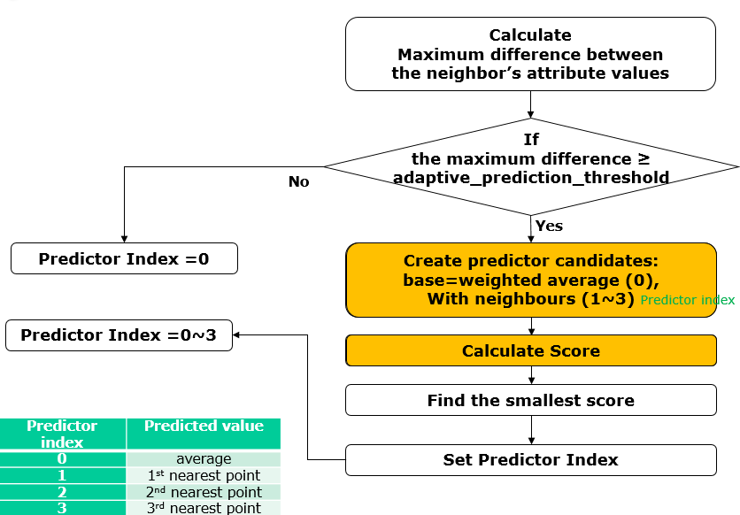

Figure 92: Adaptive predictor selection procedure before modification

The score equation is as follows:

*idxBits = i + (i == aps.max_num_direct_predictors - 1 ? 1 : 2);*

*score = attrResidualQuant + idxBits * kAttrPredLambdaR*

*\* (quant.stepSize() >> kFixedPointAttributeShift);*

The weighted average predictor is base predictor and *idxBits* value is 1. *i* is the neighbor index of the predictor.

In the modified process, an average predictor is not considered as base predictor, and the score equation is equation without idxBits. The modified score equation is as follows:

*score = attrResidualQuant*

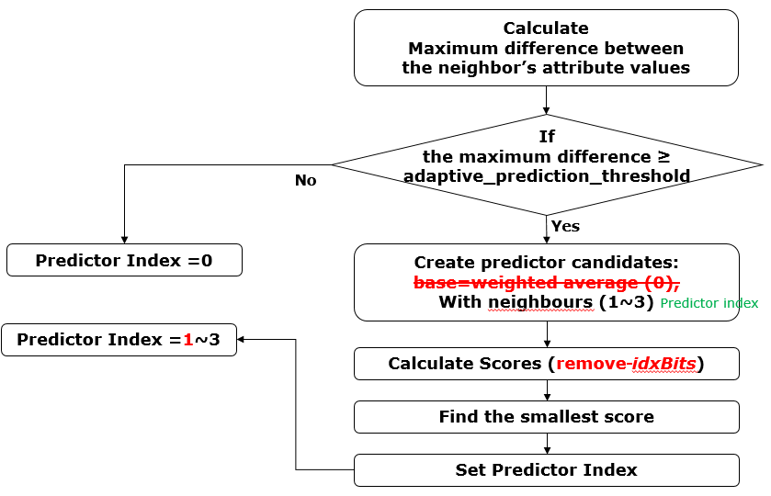

Figure 93: Modified procedure for adaptive predictor selection

#### Rate-distortion optimization for prediction mode selection [100]

The following RDO score equation for adaptive predictor selection is introduced to reflect distortion.

residualDiff = residual – reconstructed residual

entropyEstrimator(): estimate residual bits size

### Quantization and inverse quantization of attribute prediction residuals

Let be the input attribute values and the predicted attribute values computed as described in the previous section. The attribute prediction residuals are given by:

.

The quantization and inverse quantization procedures of the attribute prediction residuals are described in Figure 94 and Figure 95, respectively.

|  |
| --- |
| int PCCQuantization(int value, int quantStep) {  if (!quantStep) {  return value;  }  return sign(value) * ((abs(value) + quantStep / 3) / qs);  } |

Figure 94: Attribute prediction residuals quantization procedure

|  |
| --- |
| int PCCInverseQuantization(int value, int quantStep) {  return qs == 0 ? value : (value * qs);  } |

Figure 95: Attribute prediction residuals inverse quantization procedure

### Skip sorting process based on Morton code for low delay attribute coding [104]

In case of number of LoD equal to 1, the attribute value of each points are predictive coded by referring neighbour points which is defined with SeachRange (= lifting_search_range_minus1 + 1) in the same LoD layer. Before this process, all points are sorted based on Morton code to assign nearer points within the SearchRange for coding efficiency. It means that attribute coding can not be started until all geometry information are loaded or reconstructed.

To achieve the low delay attribute coding similar as geometry predictive coding, the function to skip sorting process based on Morton code in case of number of LoD equal to 1 is introduced. Specifically, the new syntax parameter "lifting_morton_sort_skip_enabled_flag" is introduced into APS, and if this flag equal to 1, the sorting process based on Morton code would be skipped before LoD generation process.

## Attribute coding (Lifting Transform)

The Lifting Transform builds on top of the Predicting Transform described in Section 3.8. Figure 96 and Figure 97 describe the direct/forward and inverse transforms in the proposed lifting scheme, respectively. The two main differences between the prediction scheme described in Section 3.8 and the lifting scheme that will be described in the current section, are the following:

1. Introduction of an update operator
2. Use of an adaptive quantization strategy.



Figure 96: Direct/forward transform in the lifting scheme

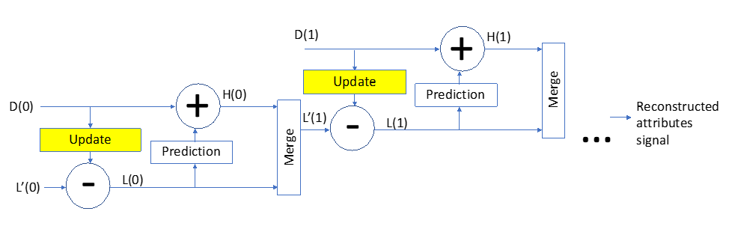

Figure 97: Inverse transform in the lifting scheme

### Update operator

The LOD-based prediction strategy described in Section 3.8 makes points in lower LODs more influential since they are used more often for prediction. Let be the influence weight associated with a point P. Then is computed by applying the following recursive procedure:

* Set for all points
* Traverse the points according to the inverse of the order defined by the LOD structure
* For every point , update the weights of its neighbors as follows:

.

The update operator uses the prediction residuals to update the attribute values of LOD(j). More precisely, let be the set of points such that . The update operation for P is defined as follows:

### Adaptive quantization

The influence weights computed during the transform process are leveraged in order to guide the quantization process. More precisely, the coefficients associated with a point P are multiplied by a factor of . An inverse scaling process by the same factor is applied after inverse quantization on the decoder side. Please note that the scaling factors are completely determined by the reconstructed geometry and they do not need to be encoded in the bitstream.

### Fixed-point implementation [32]

A fixed-point version of the Lifting and the Prediction schemes was introduced as follows:

* Floating-point arithmetic was replaced with fixed-point arithmetic
* An approximated version of the square-root function used
* (LUT-based division approximation was used to avoid expensive divisions needed to compute the prediction weights, the update weights and the quantized/unquantized coefficients.) 🡪 not yet
* The update operation was updated as follows in order to reduce the bit depth needed for fixed-point arithmetic:

### Division-free Implementation of the Lifting/Prediction scheme [105]

The original G-PCC implementation uses divisions to:

1. Compute prediction weights,
2. Apply Lifting update operator,
3. Compute the square root of the quantization weights,
4. Apply inverse quantization (decoder side), and
5. Apply quantization (encoder side).

For (1) and (2), it is introduced to replace the divisions with multiplication and bit-shift operations as the following.

* The algorithm described in here makes it possible to compute an approximated version of the ratio of two integers and , while avoiding the explicitly expensive division operation. The introduced algorithm leverages only multiply, add and bit-shift operations combined with a look-up table (LUT) of size (e.g., =8).
* First an approximation of the integer , denoted is computed as follows:

Where the and are two integers defined as follows

* is the smallest integer that verifies
* The LUT of dimension is computed offline as follows:
  + gives the fixed-point representation of the inverse of an integer
  + The fixed-point representation of the approximation of the inverse of any integer is obtained as follows:
  + The fixed-point representation of the approximation of , denoted , is given by:

where is the integer division operator, which could be implemented by bit-shift operation.

For (3), it is introduced to avoid explicitly computing the square root of the quantization weights by changing the update operator so it uses instead of .

The modified version is used:

instead of

For (4) and (5), the division-free inverse square root irsqrt function is introduced by the angular coding mode.

## Attribute coding (RAHT)

### Transform coding

The voxel colours , are transform coded, analogously to a colour image, by a spatial transform, quantizer, and entropy coder.

### Spatial transform

The colours are spatially transformed with RAHT [5][6] to obtain transformed colours , . Appendix B provides details of how to obtain the transformed colours , , from the voxel colours , given a list of associated voxel locations , as side information.

### Quantization

The transformed coordinates are quantized by a uniform scalar quantizer with stepsize quantizationStepLuma to obtain the quantized transform coordinates , . The same stepsize is used for all colour components. The quantizationStepLuma is communicated to the colour decoder through the bitstream header.

### Fixed-point RAHT implementation [40][41]

An alternative implementation of the RAHT was introduced. In particular, this method provided a fixed-point implementation of RAHT, which is described in more detail in the attached paper [39]. It has no floating-point operations, and the resulting compression performance is essentially identical to the original floating-point-based transform.

In summary, the transform used in RAHT is as illustrated in Figure 98(a), and its respective inverse transform as in Figure 98(b), where and , and *w*0 is the notation of the weight of the input coefficient *Fl*+1,2*n* while *w*1 is the same for *Fl*+1,2*n*+1.

This method simplify the transform to be like in Figure 98(c) (and its inverse in Figure 98(d)), where  is a fixed-point approximation of *b*2. The coefficients, however, are no longer *Fl*,*n* and *Gl*,*n* but scaled versions of the original coefficients. For that, one needs to adjust the quantizer step. If the quantizer step is , the overall steps for DC and AC coefficients are:

, ,

where *wDC* is the weight of the DC coefficient, or the number of all occupied voxels in the cloud. In order to only use fixed-point values, it needs to approximate  in fixed point and approximate the square root operations using only fixed-point arithmetic.

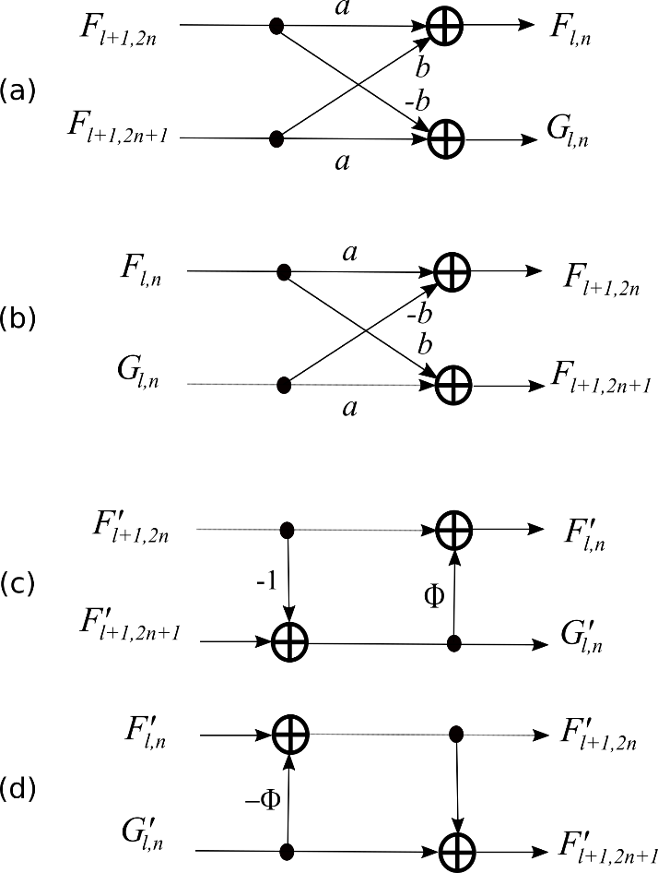

Figure 98: RAHT forward and inverse transforms

It can represent a natural number *a* with fixed-point and  bits of precision as:

*a* = Ma 2-,

where Ma is an integer value. Let us assume two other numbers, *b* = Mb 2- and *c* = Mc 2-. The four basic operations can be performed as:

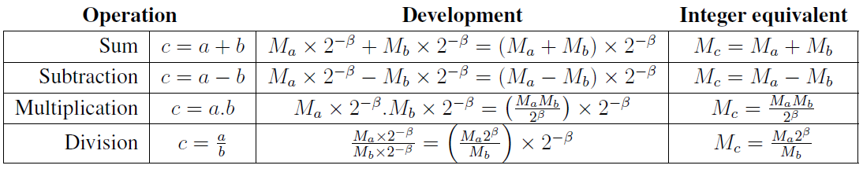

where the multiplication and division by powers of two can be performed by a binary shift in integer arithmetic.

Another operation required by RAHT is the square root operation. The square root is also computed with integer arithmetic using two basic steps: an initial guess and two iterations of the Newton-Raphson algorithm for refinement:

1. Initial guess
   1. The integer input number, represented using 64 bits, is segmented into 8 bins with 8 bits each, according to Figure 99.

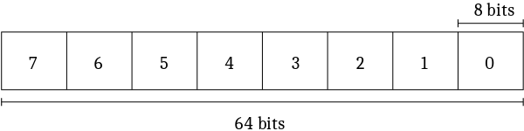

Figure 99: 64-bit segmentation

* 1. The number is right-shifted 8 by 8 bits until only the first bin has non-zero bits.
  2. At this point, we can guarantee that the resulting integer is smaller than 256.
  3. This value is used as an index to a previously computed table that stores integer approximate square roots values of numbers from 0 to 255.
  4. To compensate for the right-shifts, the value returned by the table is left-shifted half the number of bits of the right -shift.

1. Newton-Raphson refinement.

static uint32_t __tableSqrt[256] = {  
 1, 1, 1, 2, 2, 2, 2, 3, 3, 3, 3, 3, 3, 4, 4, 4, 4, 4, 4,  
 4, 4, 5, 5, 5, 5, 5, 5, 5, 5, 5, 5, 6, 6, 6, 6, 6, 6, 6,  
 6, 6, 6, 6, 6, 7, 7, 7, 7, 7, 7, 7, 7, 7, 7, 7, 7, 7, 7,  
 8, 8, 8, 8, 8, 8, 8, 8, 8, 8, 8, 8, 8, 8, 8, 8, 9, 9, 9,  
 9, 9, 9, 9, 9, 9, 9, 9, 9, 9, 9, 9, 9, 9, 9, 10, 10, 10, 10,  
 10, 10, 10, 10, 10, 10, 10, 10, 10, 10, 10, 10, 10, 10, 10, 10, 11, 11, 11,  
 11, 11, 11, 11, 11, 11, 11, 11, 11, 11, 11, 11, 11, 11, 11, 11, 11, 11, 11,  
 12, 12, 12, 12, 12, 12, 12, 12, 12, 12, 12, 12, 12, 12, 12, 12, 12, 12, 12,  
 12, 12, 12, 12, 12, 13, 13, 13, 13, 13, 13, 13, 13, 13, 13, 13, 13, 13, 13,  
 13, 13, 13, 13, 13, 13, 13, 13, 13, 13, 13, 13, 14, 14, 14, 14, 14, 14, 14,  
 14, 14, 14, 14, 14, 14, 14, 14, 14, 14, 14, 14, 14, 14, 14, 14, 14, 14, 14,  
 14, 14, 15, 15, 15, 15, 15, 15, 15, 15, 15, 15, 15, 15, 15, 15, 15, 15, 15,  
 15, 15, 15, 15, 15, 15, 15, 15, 15, 15, 15, 15, 15, 16, 16, 16, 16, 16, 16,  
 16, 16, 16, 16, 16, 16, 16, 16, 16};  
  
uint32_t sqrtFixedpoint(uint64_t P)  
{  
 uint32_t A;  
  
 // Initial guess  
 if( P >= ((int64_t) 0x1<<32) )  
 {  
 if( P >= ((int64_t) 0x1<<48) )  
 {  
 if( P >= ((int64_t) 0x1<<56) )  
 A = (__tableSqrt[P>>56]<<28) - 1;  
 else  
 A = __tableSqrt[P>>48]<<24;  
 }  
 else  
 {  
 if( P >= ((int64_t) 0x1<<40) )  
 A = __tableSqrt[P>>40]<<20;  
 else  
 A = __tableSqrt[P>>32]<<16;  
 }  
 }  
 else  
 {  
 if( P >= ((int64_t) 0x1<<16) )  
 {  
 if( P >= ((int64_t) 0x1<<24) )  
 A = __tableSqrt[P>>24]<<12;  
 else  
 A = __tableSqrt[P>>16]<< 8;  
 }  
 else  
 {  
 if( P >= ((int64_t) 0x1<< 8) )  
 A = __tableSqrt[P>> 8]<< 4;  
 else  
 return __tableSqrt[P];  
 }  
 }  
  
 A = (A+P/A)>>1;  
 return (A+P/A+1)>>1;  
}

### Upsampled transform domain prediction in RAHT [49] [117]

The transform domain prediction is introduced to improve coding efficiency on RAHT. It is formed of two parts.

Firstly, the RAHT tree traversal is changed to be descent based from the previous ascent approach; ie a tree of attribute and weight sums is constructed and then RAHT is performed from the root of the tree to the leaves for both the encoder and the decoder. The transform is also performed in units of 2×2×2 blocks, rather than breadth-first method. Within the block, the encoder transform order is from leaves to the root. The inverse transformed coefficients of one 2×2×2 block become the inherited DC coefficients of the next level.

Secondly, for each 2×2×2 block, a predicted block is produced by upconverting the previous transform level.

The prediction is transformed and subtracted from the transformed attributes at the encoder.

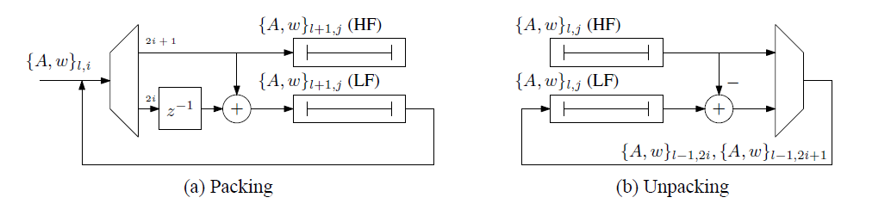

Figure 100: Construction of the transform tree levels

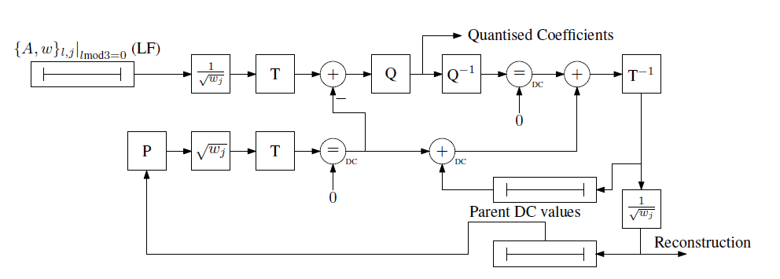

Figure 101: Transform and prediction process overview

Figure 102 shows the principle on the upsampled transform domain prediction and the detail processes on prediction, residual calculation, decoding and up-sampling are shown in Figure 103, Figure 104, Figure 105 and Figure 106 respectively.

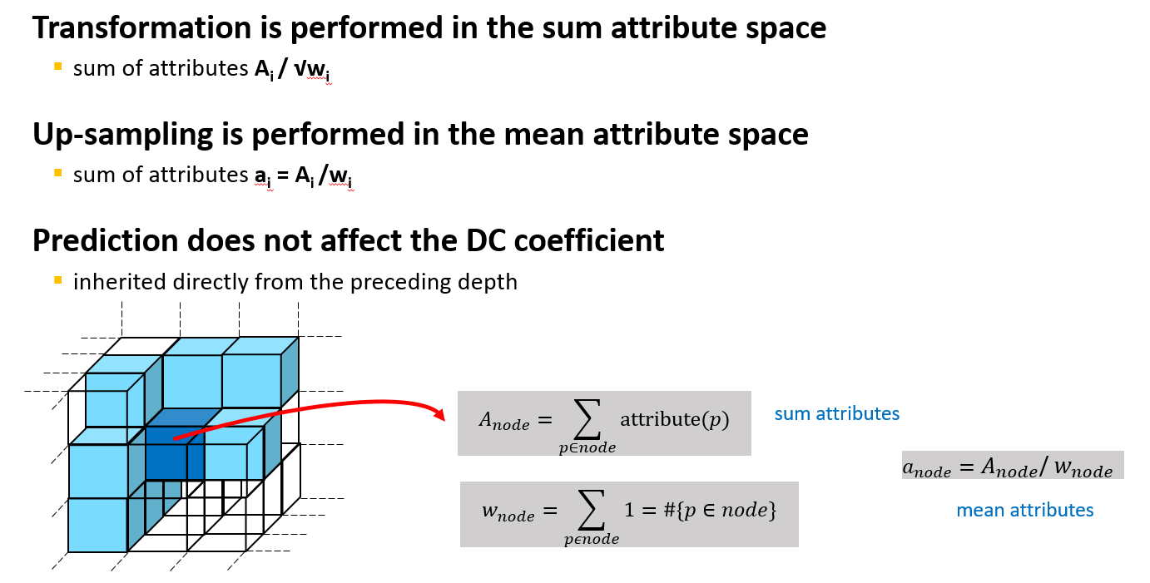

Figure 102: Principle on prediction

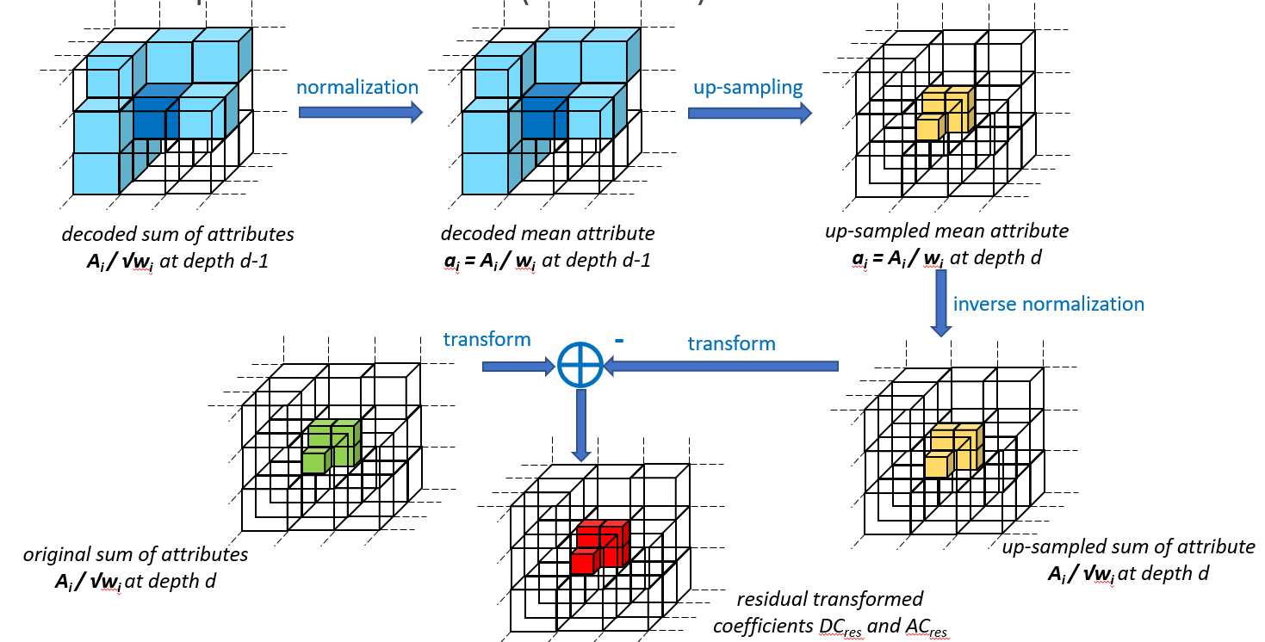

Figure 103: Prediction per 2x2x2 (encoder)

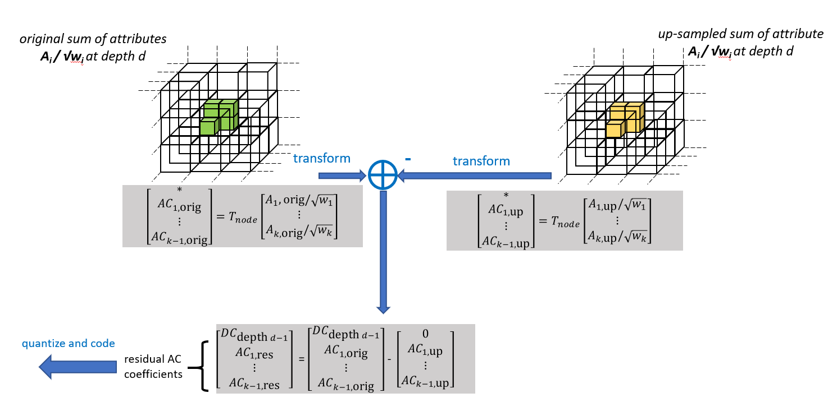

Figure 104: Computing the residual

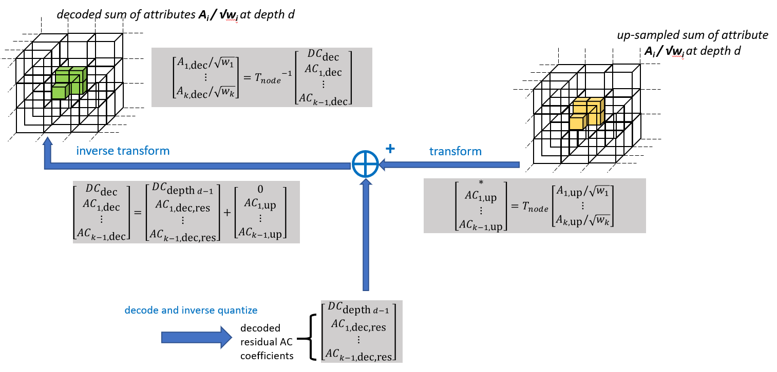

Figure 105: Decoding process

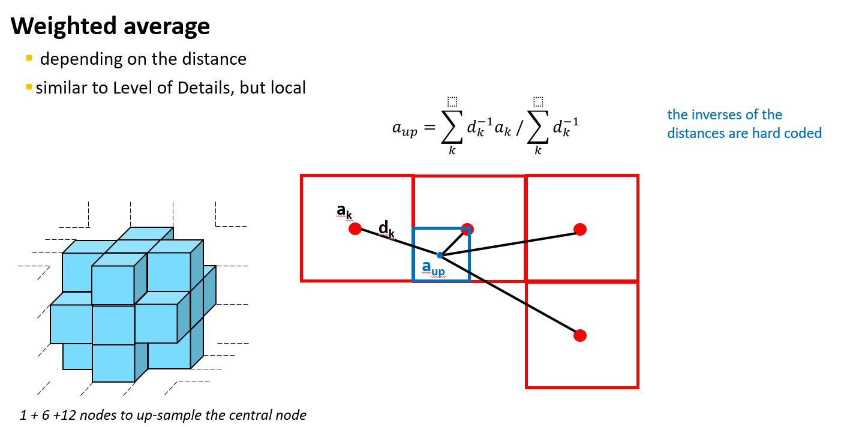

Figure 106: Up-sampling process

As some neighbours may have quite different attribute value if compared with the current sub-node to be predicted, using all the 7 neighbours may result in a relatively large prediction residual. As illustrated in Figure 107, to better predict the sub-nodes of the central node, it is preferable to not use the neighbours in the top tier.



Figure 107: Neighbours with significantly different attribute values.

To improve the prediction, it was introduced to screen the attribute value of neighbours and only eligible ones are used for prediction. The process is as follows:

1. Calculating the attribute ratio of neighbors to the central parent node.

where is the attribute value of the *i-*th neighbour among the total 18 neighbours, and is the attribute value of the central parent node. Note when coding colour information, represents the luma value.

1. If , the *i-*th neighbor will be used for prediction; otherwise it is screened out for prediction

Note that the two thresholds are fixed for all sequences in the implementation. A division-free implementation was applied to calculate the ratio. Currently, the two thresholds are and (after performing an 8-bits left shift).

### Early termination for transform domain prediction of RAHT [71]

In the transform domain prediction, 19 neighbour parent nodes are used to create the prediction value for the encoding target nodes (child nodes) of the center node. The accuracy of the prediction would be better in the denser point cloud like cat1 contents because the number of valid neighbour parent nodes is large. As the result, the coding efficiency is more significant in cat1 content compared to cat3 sparse contents.

Based on this feature, the early termination function for the transform domain prediction is introduced to reduce the coding time. In this function, the following two parameters in every 8 child nodes are calculated.

* NumValidP: total number of valid neighbour parent node
* NumValidGP: total number of valid neighbour grandparent node

Then, the prediction will be disable in case that either NumValidP or NumValidGP is less than threshold. It means that the prediction is terminated when the number of valid neighbour nodes becomes small.

Figure 108 shows the example of the transform domain prediction and parameter definition on this method. In default setting, the threshold TH1 is set to equal to 2 and TH2 is set to equal to 6.

Figure 109 shows the decision flow to disable the prediction in every encoding 8 nodes. At first, NumValidGP is checked if it is larger than TH1 (= 2) before finding neighbour parent nodes. Then if it true, the neighbour parent nodes are searched and the value of NumValidP is calculated. In this flow, if either NumValidGP or NumValidP is less than TH1 or TH2 respectively, the prediction is disable and target 8 node is encoded without it. Otherwise, it is encoded with prediction.

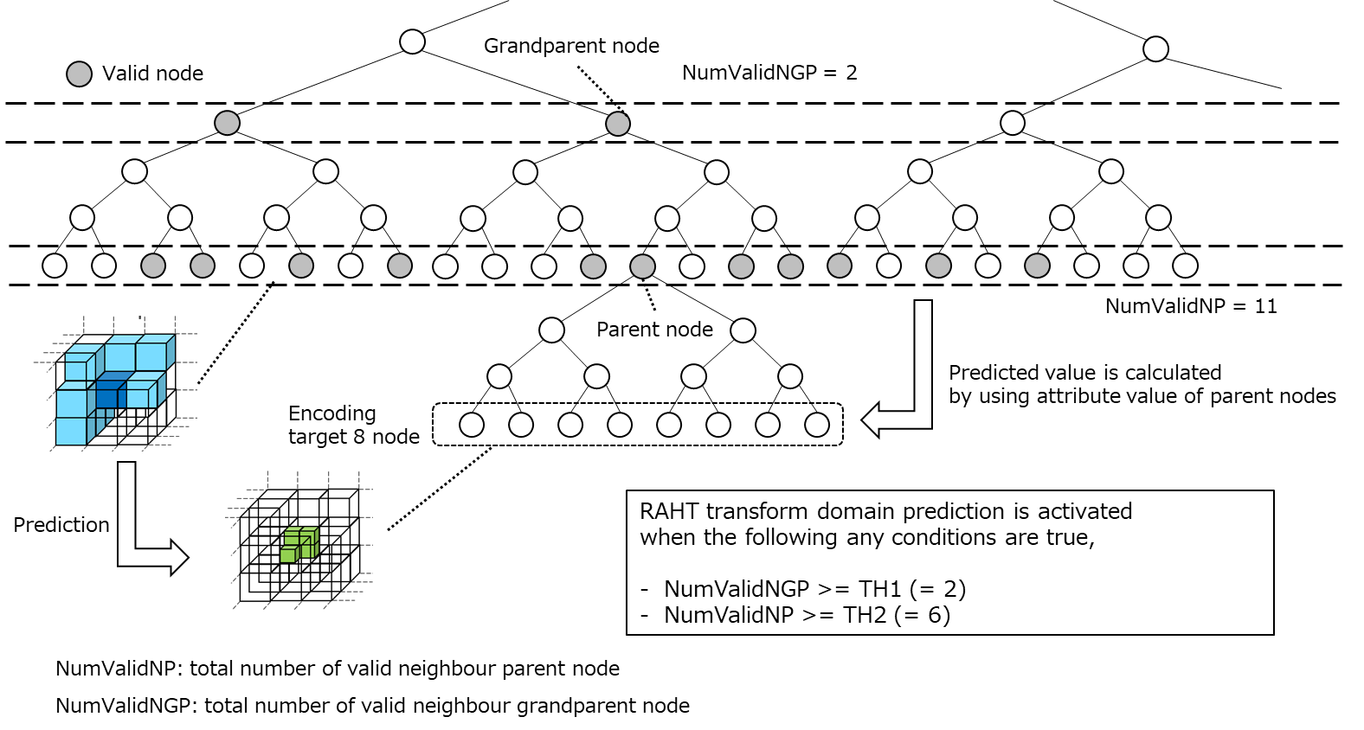

Figure 108: Example of the transform domain prediction and parameter definition

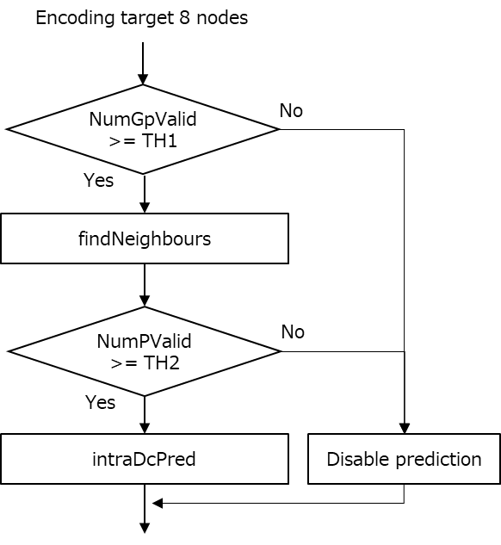

Figure 109: Decision flow to disable transform domain prediction

### Division-free RAHT coding [77]

The RAHT attribute coding scheme involves many divisions in

* the RAHT kernel,
* the DC inheritance,
* the inter-depth prediction,
* and the core function fixed-point square root isqrt itself.

Above all divisions were suppressed by mainly

* leveraging the division-free inverse square root irsqrt function (Figure 110) introduced by the angular coding mode for geometry coding, and calculating isqrt as following,

isqrt ( x ) = x * irsqrt( x )

* marginally changing LUT values in the inter-depth prediction algorithm.

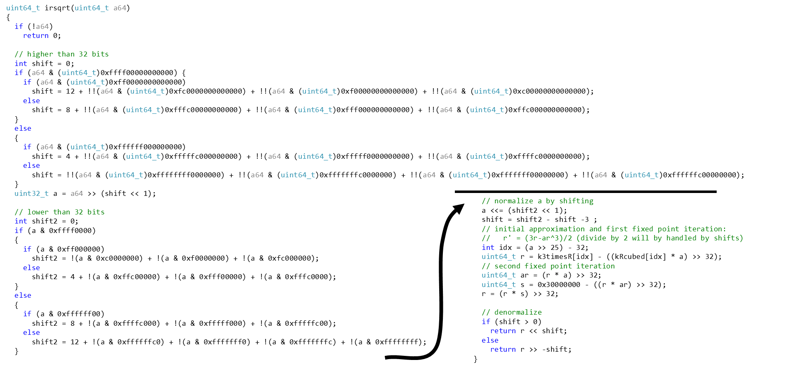

Figure 110: division-free inverse square root irsqt function

### Increasing internal precision of inter-depth prediction [82]

Attribute coding using the RAHT scheme consists in the following main three steps

* + inter-depth prediction and transform of the attributes,
  + quantization of transformed coefficients,
  + and lossless entropy coding of the quantized coefficients.

It was introduced to improve the internal precision of the inter-depth prediction by adding two bits of precision. This is a well-known technique from video coding, for example by using 10-bit internal precision for prediction of 8-bit blocks.

In storing the attributes from current depth, the following process in Figure 111 is conducted.

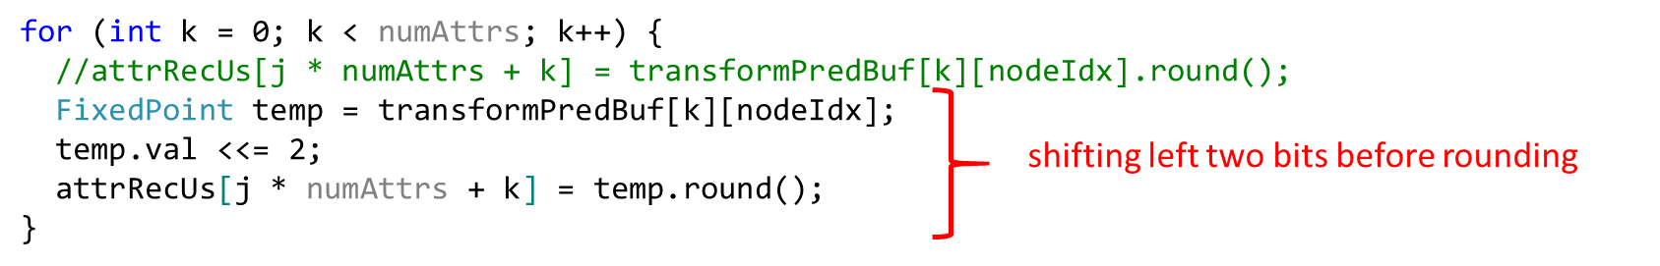

Figure 111: added two bits on the buffer for DC coefficient inheritance

And, in using attributes from preceding depth, the following process in Figure 112 is conducted.

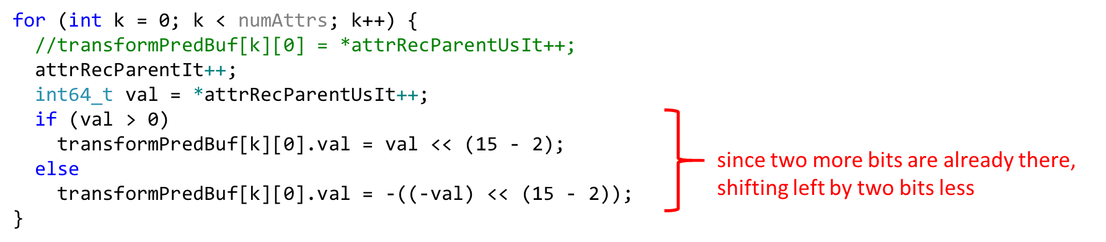

Figure 112: shift left by two bits less in using attributes from preceding depth

Number of bits needed to store a DC coefficient for w= points is 2+d+N/2 bits, which is calculated as followings,

* bit-depth d on attributes (d= 8, 10 bits for colors, d=16 for reflectance, etc.)
* A = sum of points requires d + N bits
* sqrt(w) = sqrt() = /2 is N/2 bits
* the DC coefficient A/sqrt(w) has a max value requiring d + N –N/2 = d + N/2 bits
* added a shift by 2 for the precision, this leads to 2+d+N/2 bits to represent a node with points in buffer

Example with 31 bits (int type) available

* N up to 2*(29-d)
* 10-bit color, d=10 -> N = 38 -> almost a quadrillion of points
* 16-bit reflectance, d =16, -> N=26 -> 64 millions of points

### Optimization of RAHT coefficients [83]

A well-known encoding only method, the so-called Rate-Distortion Optimization of Quantization (RDOQ), is introduced to improve compression efficiency by optimally modifying the quantized values of RAHT transformed coefficients. Basic principles are as followings,

* Lagrange cost
  + C = Distortion + λ Rate = D + λR
  + Lagrange parameter λ that depends on the coding precision, say λ(QP)
  + the goal is to minimize the cost
* Rate-Distortion
  + change the quantized value of a (RAT) coefficient
  + this induces
    - a change in distortion ΔD >0
    - a change in coding rate ΔR
  + the goal is to reduce (ΔR<0) the rate enough such that ΔC = ΔD + λ ΔR <0
  + if the change of cost is negative, changing the coefficient value is beneficial
* Determine the best quantized value such as to minimize ΔC

The following RODQ process for RAHT is introduced, which is implemented with the code in Figure 113

* Testing changing coefficient to zero
  + for all non-zero set of coefficient (set YCbCr or R)
* Compute a cost change based on
  + the induced distortion
  + the saving in bit rates compound of
    - saved bitrate from the coding of the set of coefficients
    - saved bitrate from the Run Length Coding
* Simple implementation of rate estimation
  + estimate bins instead of bits
  + no need to plus RDOQ to the entropy coder

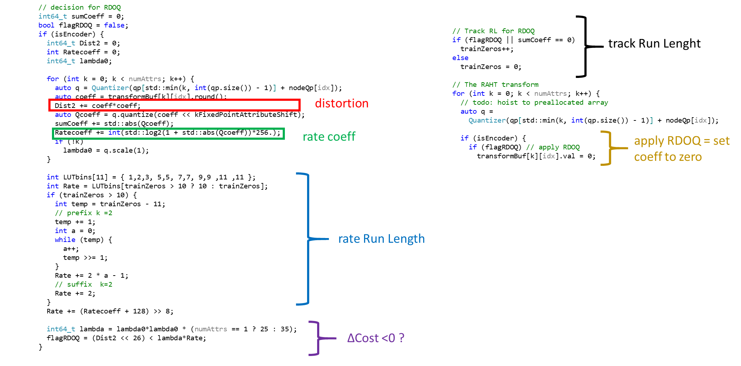

Figure 113: overview of code on RDOQ for RAHT

### Dyadic RAHT decomposition [113]

Dyadic RAHT was introduced on top of original RAHT decompostion. Original RAHT decomposition was performed on 2x2x2 block of nodes along a first direction in Figure 114. Transformed nodes were split in low (L) and high (H) frequency nodes. The decomposition was then applied along a second direction on L nodes, to obtain low (LL) and high (LH) frequency nodes. Finally, the decomposition was applied along the third direction on the LL nodes, to obtain low (LLL) and high (LLH) frequency nodes.

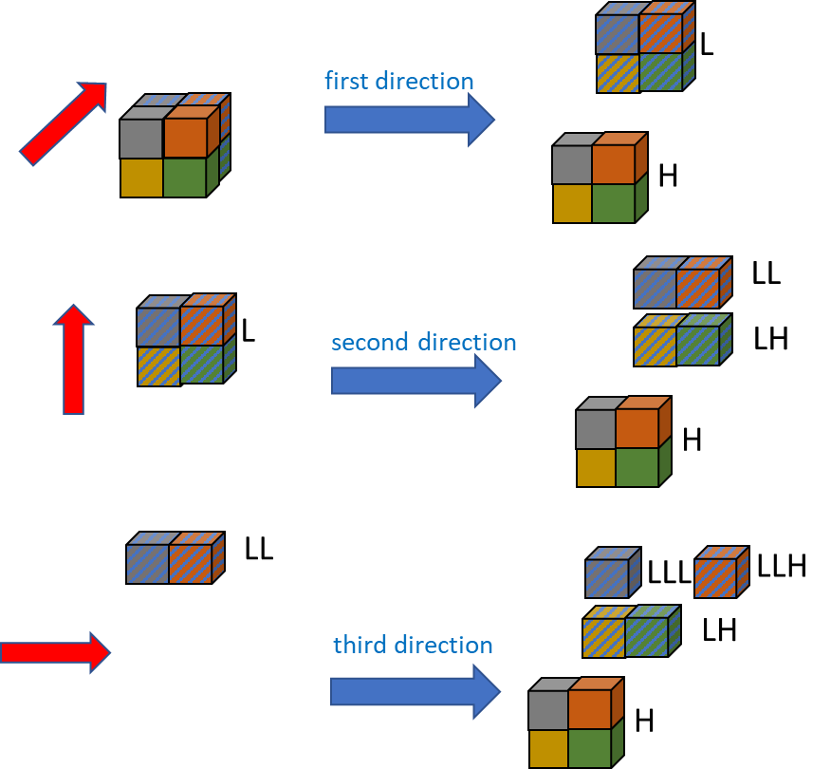

Figure 114: Original RAHT decomposition of a 2x2x2 block of nodes

The LLL nodes of each 2x2x2 blocks, at a given decomposition level, corresponds to DC coefficients and are further decorrelated at next decomposition level. The high frequency H, LH, LLH nodes corresponds to AC coefficients. They are quantized and coded, as is, without being further decorrelated.

Dyadic RAHT decomposition is still performed on 2x2x2 blocks of nodes in Figure 115. In comparison to original RAHT, it involves additionally applying the decomposition along the second direction on the H nodes, to obtain HL and HH nodes, and applying the decomposition along the third direction on LH, HL and HH nodes, to obtain LHL, LHH, HLL, HLH, HHL and HHH nodes.

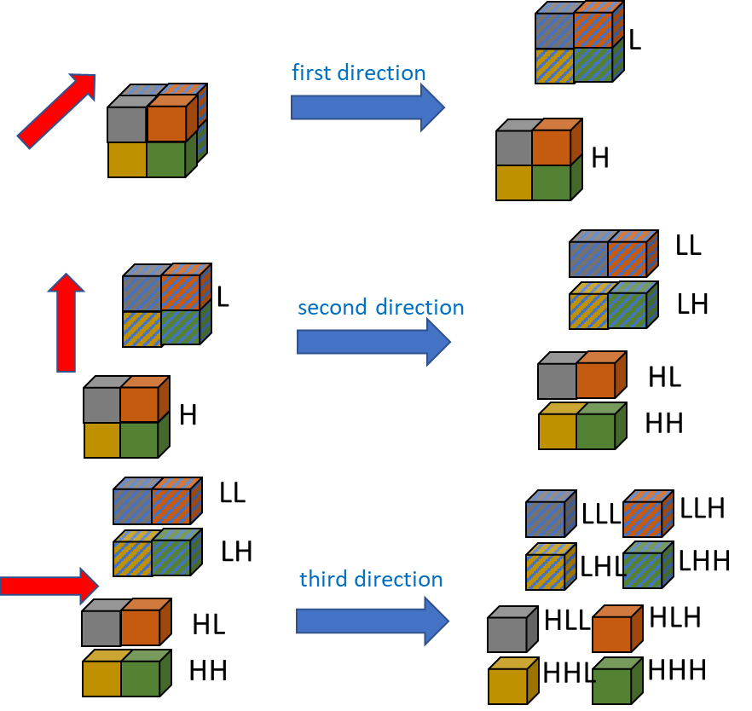

Figure 115: Dyadic RAHT decomposition of a 2x2x2 block of nodes

In the general case a 2x2x2 block does not often contain 8 occupied nodes. With RAHT, the decomposition of a block along a given direction involves decorrelating/transforming each pair of neighboring nodes in that direction and updating associated weights.

In case of a single node (i.e. with no other occupied node in the block along the decomposition direction), it is simply put in the low frequency nodes L and keeps its weight.

When there is a pair of nodes, it is RAHT transformed, and the weight of the low frequency node is set equal to the sum of the weights of the pair of nodes. Since high frequency nodes are not further decomposed their weights are not updated. With dyadic RAHT their weights are also set equal to the sum of the weights of the pair of nodes, as they will be further decomposed.

Note that when the 2x2x2 block has been decomposed in the three directions, with dyadic RAHT, every transformed node in the block have the same weight.

Additionally, the order of encoding of high frequency coefficients of each 2x2x2 block was modified. They are coded in the following order: LLH, LHL, HLL, LHH, HLH, HHL, HHH.

In case of the Dyadic RAHT decomposition (see Figure 115) 4 RAHT transforms are performed per direction. Therefore, a total of 12 RAHT transforms are performed per 2x2x2 block. But, as the 4 decompositions per level can be computed in parallel, with a well-designed implementation, it is possible to not introduce additional latency. Obviously, the worst case does not occur very often, thus the practical runtime increase is much less than 12 for 7. Table 1 provides the complexity increase factors for each possible occupancy configurations of a 2x2x2 block of nodes. As can be seen the factor 12 for 7 drops rapidly with the number of occupied nodes in the block.

## Attribute Quantization

### Quantization table [35][36]

The quantization of lifting and RAHT transformed residual coefficients is performed by input signalled QP parameter. This is like the traditional AVC/HEVC/VVC QP based quantizer design whereas a QP parameter is used to determine the quantizer step size. QP parameter is based on a logarithmic structure with every increase of 1 in QP value quantizer step size is increased by approximately 12% and an increase by 6 results in an increase by a factor of 2.

(1)

= (2)

It is clear that to derive the quantizer step sizes of an input signal it is only necessary to store the 1st 6 values of quantizer step size as a function of QP, namely QP = 0 to 5. Accordingly, QP parameter based formulation and derivation is shown below:

(3) where

<< 8 =

(4)

The scaling factor is in accordance with the fixed-point scaling factor introduced in the fixed point RAHT implementation. It also provides enough granularity when changing the QP values.

QP table is shared in three attribute encoding methods: Predicting, Lifting, and RAHT. The decoding processing is modified, because QP table has the function of multiplication by 28. This can be said as quantization and left shift processing are merged as QP table.

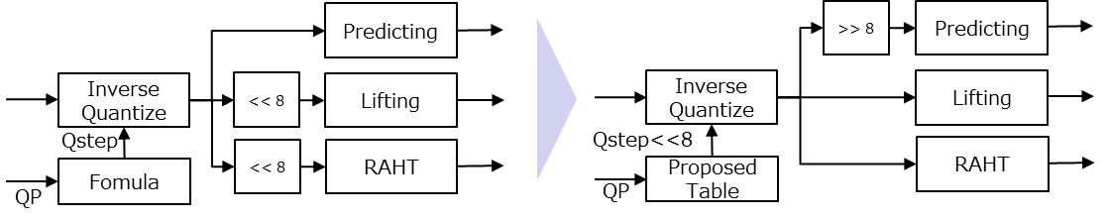

Figure 116 Modification of the Decoder process TMC13v5

### LUT-based quantization [47]

The general idea is to perform quantization using a forward quantization table and de-quantization using an inverse quantization table, as illustrated in the following block diagram.

QP

fLUT

gLUT

Derive InvQstep

Derive ForQstep

De-quantization

Quantization

quantized

value

value

reconstructed value

Illustration of LUT-based quantization and

De-quantization.

Given a quantization parameter QP, a forward and an inverse quantization step are derived (ForQstep and InvQstep) based on two different quantization tables (forward *fLUT* and inverse *gLUT*). The input value is quantized using ForQStep and dequantized using InvQstep. This scheme allows for the removal of the division operation in the quantization process, as will be described.

Consider the quantization table *gLUT*. This table is defined in previous section. The forward quantization table *fLUT* is derived as follows.

Currently N = 8. And it is considered M = 14, since it was enough to achieve the desired precision. In this case, *fLUT* becomes,

### Adaptive quantization scheme for RAHT

Given a dead-zone , a RAHT coefficient with weight is quantized as:

|  |
| --- |
| // increase the dead-zone by multiples of step-size |
|  |
|  |
| // apply default quantizer as in TMC13 |
|  |

where is a parameter chosen to differentiate between the low-frequency and the high frequency coefficients.

The inverse quantization is done by:

### Slice-based attribute quantization control [34]

The quantization parameters (QStepAPS) are stored in the Attribute Parameter Set (APS), and the parameters can be changed slice-by-slice.

By adding the Q step delta value (, ) in each attribute slice header, the Q step value can be changed for each slice. Q step delta value is the difference between QStepAPS and Q step value of each slice. Q step delta is present only if slice_quant_step_present_flag in APS is set to 1.

In the decoder, obtain QStepAPS from APS and Q step delta value from each attribute slice header, and Q step value can be calculated.

In the current specification, Qstep delta was replaced with QP delta.

As1

APS

Gs1

GPS

As2

Gs2

QStepslice1 = QStepAPS + ΔQStepslice1

QStepslice2 = QStepAPS + ΔQStepslice2

QStepAPS

ΔQStepslice1 ＝ QStepslice1 - QStepAPS

ΔQStepslice2 ＝ QStepslice2 - QStepAPS

Figure 117: The modified bitstream structure to support delta Qstep

### Attribute Layer based quantization control [42][134][144]

The attribute quantization parameter of each layer can be controlled by using this method. A delta QP layer parameter is implemented on each attribute slice header.

Figure 118 shows Delta QP layer implementation on Lifting/Predicting transform and specific delta QP is applied on each layer. The effective QP value for each layer in a particular slice is added between delta QP of that layer with QP for that slice. The final residue value will be the product of the attribute with quantization weight and effective QP value.

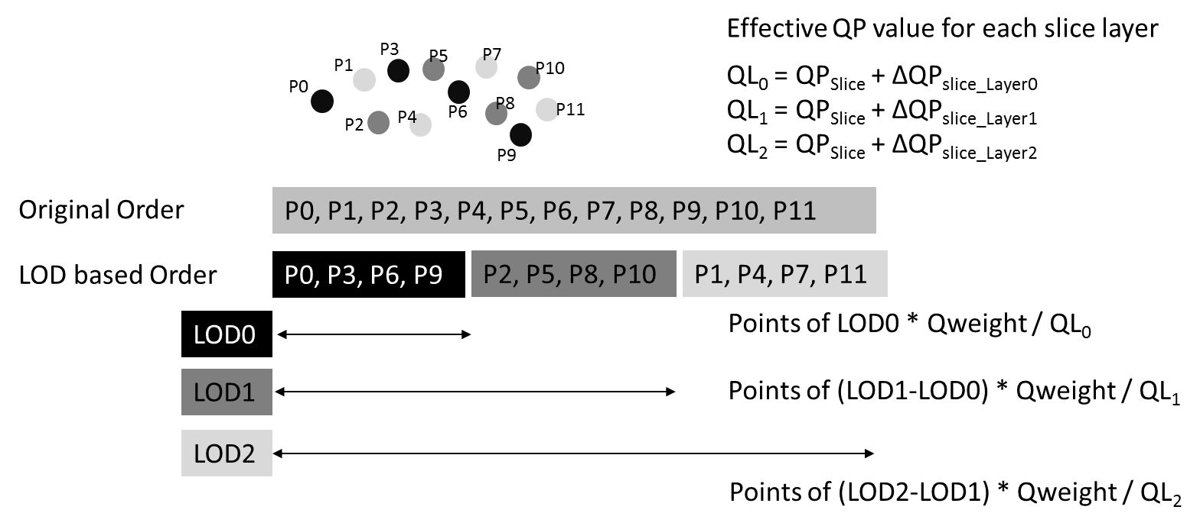

Figure 118 Operation of Delta Layer QP for Predicting/Lifting Transform

As a first example, because the first 7 LOD layers (from LOD 0 to LOD 6) have fewer points and are frequently used to predict the points in the other layers, slice QP minus 10 will be used to quantize the residual value of first 7 LOD layers to improve coding efficiency, whereas the remaining layers still use the slice QP.

As a second example, a more detailed individual QP setting scheme for different layers can be used. The delta-QP value for each LOD in Predicting Transform can be set as Table 6 for condition CY (lossless geometry, near-lossless attribute).

Table 5: QP at predefined CTC Rate Point for Predicting Transform

|  |  |  |  |  |
| --- | --- | --- | --- | --- |
| **QP at rate point** | | | | |
| **R1** | **R2** | **R3** | **R4** | **R5** |
| 10 | 16 | 22 | 28 | 34 |

Table 6: Delta QP Settings for Predicting Transform

|  |  |  |  |  |  |
| --- | --- | --- | --- | --- | --- |
| **Layer_Delta_QP_Luma and Chroma** | | | | | |
| **LOD** | **R1** | **R2** | **R3** | **R4** | **R5** |
| 0 | -6 | -12 | -18 | -24 | -24 |
| 1 | -6 | -12 | -18 | -18 | -18 |
| 2 | -6 | -12 | -18 | -18 | -18 |
| 3 | -6 | -12 | -12 | -12 | -12 |
| 4 | -6 | -12 | -12 | -12 | -12 |
| 5 | -6 | -6 | -6 | -6 | -6 |
| 6 | -6 | -6 | -6 | -6 | -6 |
| 7 | 0 | 0 | 0 | 0 | 0 |
| 8 | 0 | 0 | 0 | 0 | 0 |
| 9 | 0 | 0 | 0 | 0 | 0 |
| 10 | 0 | 0 | 0 | 0 | 0 |
| 11 | 0 | 0 | 0 | 0 | 0 |
| 12 | 0 | 0 | 0 | 0 | 0 |

Table 7: Actual QP for Predicting Transform

|  |  |  |  |  |  |
| --- | --- | --- | --- | --- | --- |
| **Effective QP Luma and Chroma**  Actual QP Luma = QP_Luma + LayerDeltaQPLuma | | | | | |
| **LOD** | **R1** | **R2** | **R3** | **R4** | **R5** |
| 0 | 4 | 4 | 4 | 4 | 10 |
| 1 | 4 | 4 | 4 | 10 | 16 |
| 2 | 4 | 4 | 4 | 10 | 16 |
| 3 | 4 | 4 | 10 | 16 | 22 |
| 4 | 4 | 4 | 10 | 16 | 22 |
| 5 | 4 | 10 | 16 | 22 | 28 |
| 6 | 4 | 10 | 16 | 22 | 28 |
| 7 | 10 | 16 | 22 | 28 | 34 |
| 8 | 10 | 16 | 22 | 28 | 34 |
| 9 | 10 | 16 | 22 | 28 | 34 |
| 10 | 10 | 16 | 22 | 28 | 34 |
| 11 | 10 | 16 | 22 | 28 | 34 |
| 12 | 10 | 16 | 22 | 28 | 34 |

The QP set in the encoder can be used for the LOD7 and its subsequent LOD layers. For the layer lower than LOD 7, the QP will be subtracted 6 for every two layers until the actual QP of the layer is less than or equal to 4 (means lossless quantization).

Figure 119 shows RAHT with delta QP for each layer and specific delta QP is applied on each layer. The effective QP value for each layer in a particular slice is added between delta QP of that layer with QP for that slice. The final residue value will be the square root of the attribute divided by weight and effective QP value.

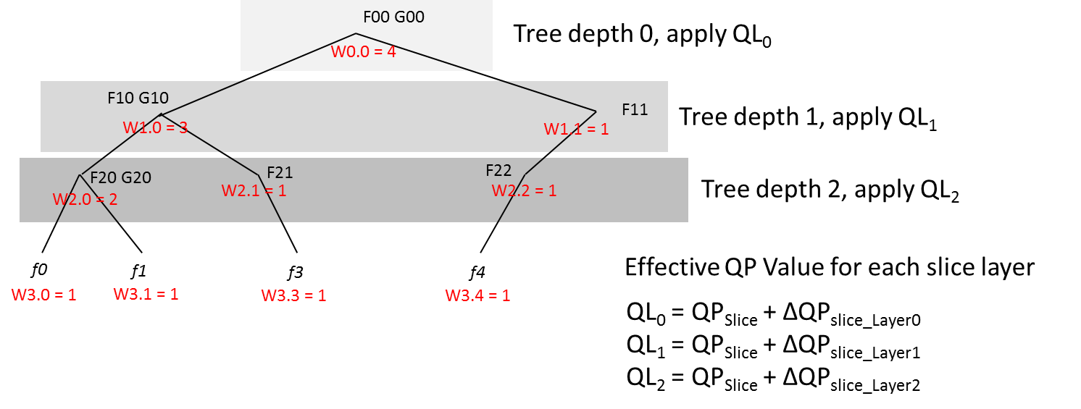

Figure 119 Operation of Delta Layer QP for RAHT

The quantization parameter (QPAPS) are stored in the Attribute Parameter Set (APS), and the parameters can be changed slice-by-slice and further layer by layer.

By adding the delta QP layer value (, …) in each attribute slice header, the QP value can be changed for each layer of a particular. Delta QP layer value is the difference between QPslice and effective QP value of that slice’s layer. Delta QP layer is present only if layer_QP_present_flag in attribute slice header ASH is set to 1.

As1

APS

Gs1

GPS

As2

Gs2

QPslice1 = QPAPS + ΔQPslice1

QPslice2 = QPAPS + ΔQPslice2

QPfinal_slice1_LoD1 = QPSlice1 + ΔQPslice1_Layer1

QPfinal_slice1_LoD2 = QPSlice1 + ΔQPslice1_Layer2

QPfinal_slice2_LoD1 = QPSlice2 + ΔQPslice2_Layer1

QPAPS

ΔQPslice1 ＝ QPslice1 - QPAPS

ΔQPslice1_Layer1 ΔQPslice1_Layer2 ΔQPslice1_Layer3 ….

ΔQPslice2 ＝ QPslice2 - QPAPS

ΔQPslice1_Layer1 ΔQPslice1_Layer2 ΔQPslice1_Layer3 ….

Figure 120: The modified bitstream structure to support layer delta QP

### Region-wise attribute quantization control [50][69]

In the 3D point cloud, the required visual importance and quality is different depending on the 3D region. For example, the face region of a human has higher importance and thus required better quality. Region-wise quantization control in Attribute coding changes the quantization parameter based on the geometry position in a slice. It can keep the compression performance compared to a slice base QP Control because the attribute prediction structure will not be changed.

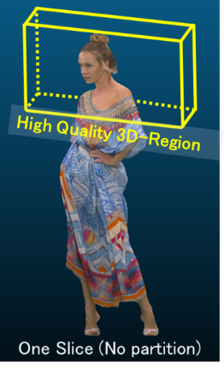 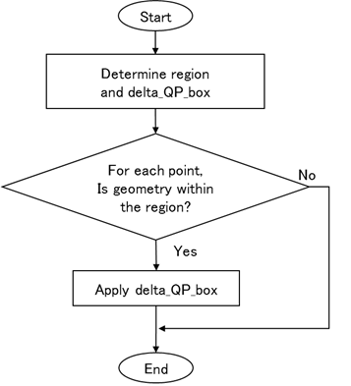

Figure 121 Concept of Region-wise QP control

In 3D-region-wise QP control method, the different attribute QP value is applied to specific region. In the encoding / decoding process, the region box where QP value should be changed and its differential QP from slice QP in each layer are determined.

In attribute coding, The QP value for each point is determined by using geometry,

If each point of 3D point cloud is within the box region, then delta QP value will be added on the slice QP in each layer to get the effective QP for that point.

After that, the attribute value is quantized using effective QP value.

In RAHT process, delta QP value for each node on region-wise QP control method is derived using the ones of the two lower level nodes. Herein, the average delta QP value of the two lower-level nodes is used as the one of the current node. The average method will smoothen the different QP value between the nodes.

Figure 122shows the flow chart to calculate the quantization step size including slice, layer and region QP [129].

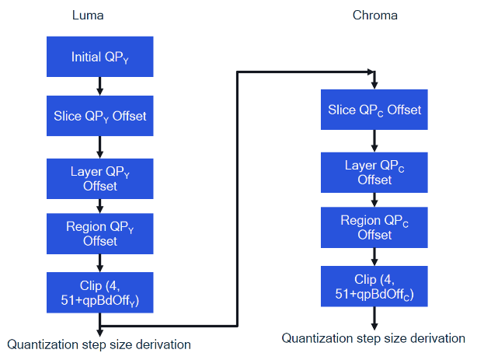

Figure 122: Calculation of quantization step size

## Attribute Redisual and Entropy encoding

The quantized, transformed coefficients are entropy encoded using zero run length coding and an arithmetic coder.

### Attribute residual coding [37][112]

Zero run length coding for attribute residual value and a flag “isOne” which indicates if residual value is equal to 1 based on the current residual coding specification were introduced. In zero run length coding, the number of zero prior to each residual value is counted as zerorun, and then zerorun is encoded instead of encoding sequence of 0s. Figure 123 shows how to encode residual value with zero run length and isOne flag. A zerorun parameter is encoded by unary code with 3 contexts, Truncated Rice coding and exponential Golomb coding as illustrated in Figure 124, and a isOne flag is encoded with 7 contexts by using same way to encode isZero flag. This method is applied not only Predicting Transform and Lifting Transform but also RAHT.

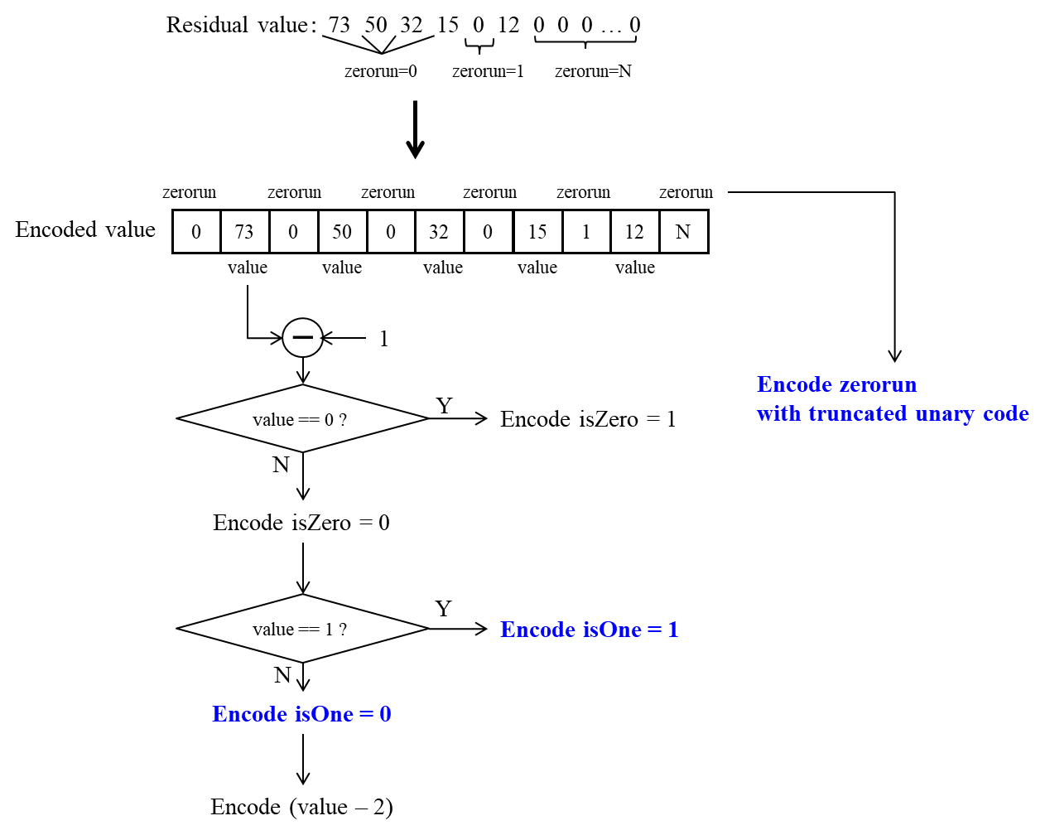

Figure 123: encoding flow for residual value

.

Figure 124: Run-length coding of successive zero-valued coefficient.

### Inter-channel residual prediction [55][76][139]

The inter-channel residual prediction is to perform prediction of residuals between channels and code the residual resulting from this second prediction. Specifically, this scheme codes the G-channel first, then use its quantized residual to predict the quantized residuals of R and B channels. The quantization indices of the residual from the additional prediction step is entropy-coded.

A pseudo code is as following,

X : channel X signal (X can be R,G, or B)

X_pred: predicted channel X signal (obtained from reconstructed neighbor samples in G-PCC)

X_delta_index : quantization index of the prediction residual of channel X

X_delta_recon : reconstructed residual for channel X

X_recon : reconstructed channel X signal

X_delta_residual_index: the quantization index of the residual from the residual-prediction

Encoding Process

2.1 Encoding

// G-Channel

G_delta_index <- Quantize(G- G_pred)

G_delta_recon <- InverseQuantize(G_delta_index)

G_recon <- G_pred + G_delta_recon

EntopyEncode(G_delta_index)

// C-Channels (‘C’ can be either R or B)

C_delta_residual_index <- Quantize (C- C_pred – G_delta_recon)

C_delta_recon <- InverseQuantize(C_delta_residual_index) + G_delta_recon

C_recon <- C_pred + C_delta_recon

EntopyEncode(C_delta_residual_index)

Decoding Process

// G-Channel

G_delta_index < - EntropyDecode()

G_delta_recon <- InverseQuantize(G_delta_index)

G_recon <- G_pred + G_delta_recon

// C-Channels (‘C’ can be either R or B)

C_delta_residual_index < - EntropyDecode()

C_delta_recon < - InverseQuantize(C_delta_residual_index) + G_delta_recon

C_recon <- C_pred + C_delta_recon

It was also extended that generic scaling values of Sb and Sr are signalled per LoD, which are then used to scale value of ResG for performing the residual prediction. In essence, the final residuals are derived as follows:

Res’B = ResB + Sb*ResG

Res’R = ResR + Sr*ResG

Where, Sb, Sr belongs to {-2, -7/4, -6/4, -5/4, -1, -3/4, -2/4, -1/4, 0, 1/4, 2/4, 3/4, 1, 5/4, 6/4, 7/4, 2}. Sb and Sr are delta coded (scale[lod] – scale[lod-1]), it is coded in the attribute data unit header.

#### Encoder improvements for inter-component residual prediction (ICRP) [106]

ICRP exploits the correlation between the residuals of different colour components. Currently, it is used with predicting transform in near-lossless coding condition. However, in the RDO loop for selecting the best prediction mode, ICRP is not applied for calculating the attribute residual and computing the RD cost. The encoding method is introduced to improve coding performance by considering ICRP in the RDO loop.

### Last component residual prediction for Lifting transform [128][138]

For point cloud attributes such as color, there are significant redundancy among channels. In order to improve coding efficiency, a color space conversion is often performed as a pre-/post-processing step. Even after such conversion, there still is significant correlation among channels in the converted color-space. The correlation among color channels can be employed to improve attribute coding efficiency. Specifically, a method to improve coding-efficiency by applying the inter-channel decorrelation only between the chroma signals was introduced.

Let and denote the lifting coefficients of Cb and Cr channels, respectively. Unlike the relationship between luma and chroma channels, it can be observed that the Cb and Cr chroma coefficients from lifting are well-approximated by the following relationship:

where s is a scalar value.

In this technique, it is assumed that s is either +1 or -1 when the two channels are correlated. In certain cases, there may not be any evident correlation and s will be assumed to be zero.

This method detects the above scalar value s, which can be one of 1,-1, and zero, per LOD at the encoder and signals it. In a nutshell, it codes and - instead of and when s =1 and code and + instead of and when s= -1. It first decides s for each LOD, if there is any meaningful sign-correlation and signal a one-bit flag (***ChromaResidPredSignNonzeroFlag*)** first. In addition, If this flag is 1, it additionally sends one bit (***ChromaResidPredSign*)** to indicate the sign. In addition, an additional flag in APS, **aps.inter_chroma_prediction_enabled_flag** is introduced to enabled/disable this feature at high level.

The decoding implementation can be divided into two parts. The first part is to obtain the chroma residual prediction sign, i.e., chromaResiPredSign (+1, -1, 0) for each LOD layer, shown as following:

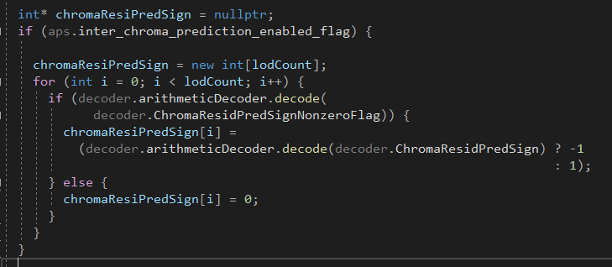

The second part of decoding process is to apply the chroma residual prediction sign, i.e., chromaResiPredSign, to recover the chroma residual for Cr component while Luma and Cb components remain the same.

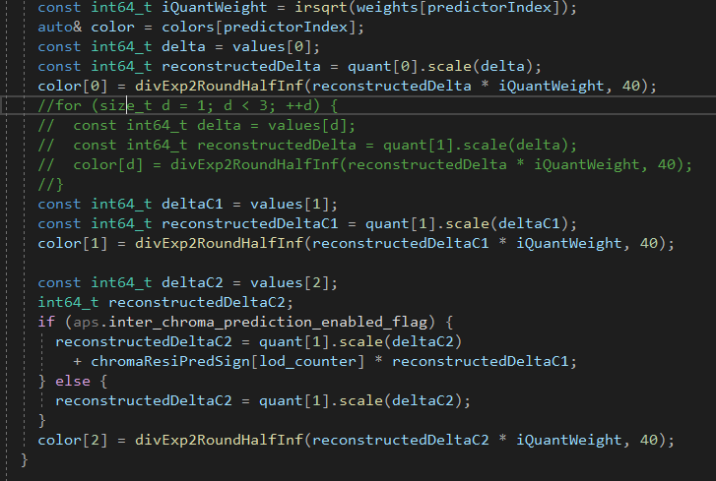

Note the commented part are in the original TMC13v10 anchor while the code after that part are added. Clearly the last color channel component color[2], i.e., Cr are modified based on the chromaResiPredSign[lod_counter] at each LOD layer.

For encoding process, there are many ways determine the chroma residual prediction sign and the following is one of the example of them.

The encoding process is also divided into three steps:

* First Step, Chroma residual prediction sign at each LOD layer is to be determined after the Lifting transform is performed, when the transformed chroma coefficients(color[1] & color[2] in the code) become available. The detail is shown in the following code snippet.

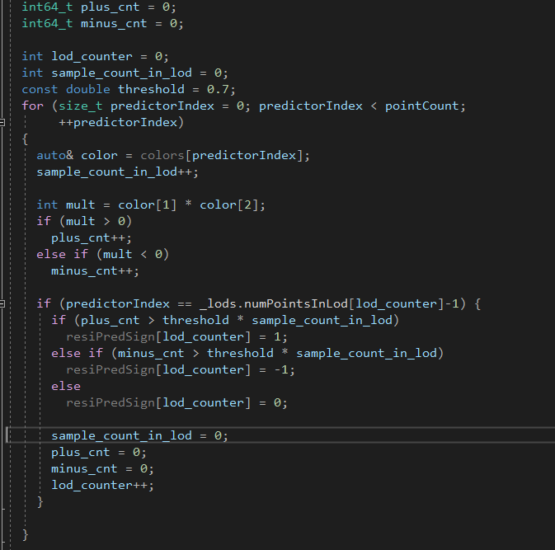

* Second Step, it checks if the chroma residual prediction is efficient at each LOD layer. If not, the prediction scheme is turned off for the layer. The detail is shown in the following code snippet.

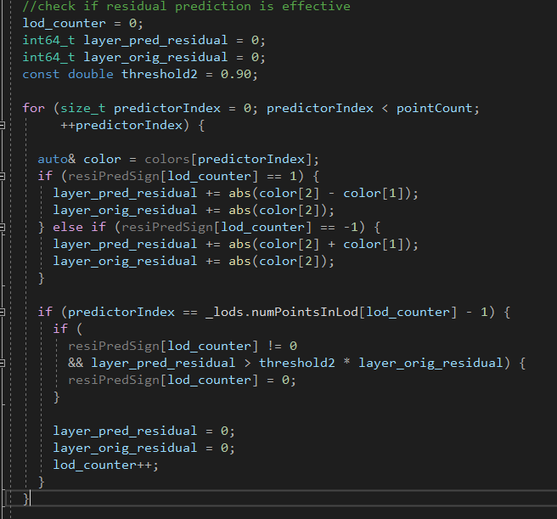

* Third step, chroma residual prediction is applied at color[2] component. Since this process is similar to the decoding side, it is omitted here.

The following aspects were introduced as extension of this method.

1. Use a larger set of scale (s) values in quarter weight accuracy.
   * Encoder side: restricted to (-2, +2) 🡪 {-2, -7/4, -6/4, -5/4, -1, -3/4, -2/4, -1/4, 0, 1/4, 2/4, 3/4, 1, 5/4, 6/4, 7/4, 2}.
   * Delta coding of scale values per LoD (prediction from previous LoD scale value).
   * Put the scale values in Attribute data header and thus they are not CABAC coded

### Entropy coding for attribute transformed coefficients [112]

Attribute coefficient coding illustrated in Figure 125 was introduced to reduce the number of coded bins by fixing the expGolomb parameter ‘k’ to 1. To try to keep or even improve the coding efficiency, the modified expGolomb coder is further extended to use additional contexts on the prefix and suffix part.

The number of contexts is 2x7=14 for ‘Is 0?’ and ‘Is 1?’ (for both reflectance or color). And there is 1 modified expGolomb coder for reflectance or 2 modified expGolomb coder for color: 1 for first component (e.g. Y) and 1 shared by the two other components. The extension of the modified expGolomb coder is using L+1=3 contexts for prefix coding, and K+1=3 contexts for suffix coding. Thus, in total only 14+(3+3)=20 contexts are used for reflectance, while 14+(3+3)x2=26 contexts are used for color.

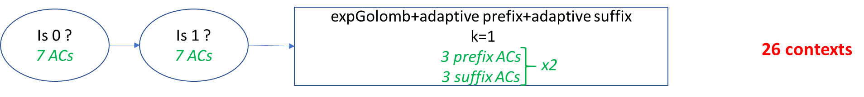

Figure 125: Attribute coefficient coding

The extension of the modified expGolomb coder which is used is using L+1 adaptive coding contexts for coding the prefix bits instead of a single context. The changes in comparison to usual expGolomb coder are highlighted in yellow bellow (the line highlighted in blue should be ignored).

template<class Base>

template<class AdaptiveBitModel0, class AdaptiveBitModel1>

inline unsigned int

EntropyDecoderWrapper<Base>::decodeExpGolomb2(

  int* numBits, int k, const int K, const int L,

  AdaptiveBitModel0 bModel0[], AdaptiveBitModel1 bModel1[])

{

  const int k0 = k;

  unsigned int l;

  int symbol = 0;

  int binary_symbol = 0;

  do {

    l = decode(bModel1[std::min(L,k-k0)]);

    if (l == 1) {

      symbol += (1 << k);

      k++;

    }

  } while (l != 0);

  *numBits = 0;

  bool significant = k != k0;

  if (significant)

    *numBits = k;

  while (k--)  //next binary part

    if (decode(bModel0[std::min(K,k)]) == 1) {

      binary_symbol |= (1 << k);

      if (!significant) {

        significant = true;

        *numBits = k + 1;

      }

    }

  return static_cast<unsigned int>(symbol + binary_symbol);

}

### Redorderd attribute residual coding [131]

This purpose of this method is to remove the redundant coding of the scenario “value0 = value1 = value2 = 0”. The bit-savings case is encountered when two of the residuals have a value of 0, so that while coding the third residual it can be inferred that it can’t be 0. As value0 indicates luma residuals, and value1/value2 indicates chroma residuals, the chances of value1 = value2 = 0 (chroma residuals are zero) is higher than value0 = value1 = 0, or in other words, the first scenario is more frequent than the second one. So, the coding of value1 and value2 before coding of value 0 (i.e., changing the order of coding) may bring more bit-savings. Accordingly, an alternative way of handing the redundancy is to code value1 and value2 before value0, and code abs(value0) – 1 instead of abs(value0) for the magnitude part, when value1 = value2 = 0.

void

PCCResidualsEncoder::encode(int32_t value0, int32_t value1, int32_t value2)

{

int mag1 = abs(value1);

int mag2 = abs(value2);

int mag0 = abs(value0);

int b0 = (mag1 == 0);

int b1 = (mag1 <= 1);

int b2 = (mag2 == 0);

int b3 = (mag2 <= 1);

encodeSymbol(mag1, 0, 0, 1);

encodeSymbol(mag2, 1 + b0, 1 + b1, 1);

if (b0 && b2) {

assert(mag0 > 0);

encodeSymbol(mag0 - 1, 3 + (b0 << 1) + b2, 3 + (b1 << 1) + b3, 0);

}

else

encodeSymbol(mag0, 3 + (b0 << 1) + b2, 3 + (b1 << 1) + b3, 0);

if (mag0)

arithmeticEncoder.encode(value0 < 0, binaryModel0);

if (mag1)

arithmeticEncoder.encode(value1 < 0, binaryModel0);

if (mag2)

arithmeticEncoder.encode(value2 < 0, binaryModel0);

}

void

PCCResidualsDecoder::decode(int32_t value[3])

{

value[1] = decodeSymbol(0, 0, 1);

int b0 = value[1] == 0;

int b1 = value[1] <= 1;

value[2] = decodeSymbol(1 + b0, 1 + b1, 1);

int b2 = value[2] == 0;

int b3 = value[2] <= 1;

value[0] = decodeSymbol(3 + (b0 << 1) + b2, 3 + (b1 << 1) + b3, 0);

if (b0 && b2)

value[0] += 1;

if (value[0] && arithmeticDecoder.decode(binaryModel0))

value[0] = -value[0];

if (value[1] && arithmeticDecoder.decode(binaryModel0))

value[1] = -value[1];

if (value[2] && arithmeticDecoder.decode(binaryModel0))

value[2] = -value[2];

}

## Attribute coding with coordinate conversion [119][147]

In LiDAR, points are obtained by sampling the reflectance of lights emitted by the vertically arranged lasers in the rotating header. Therefore, the captured point cloud is in the shape of cylinder as shown in Figure 126, where the points can be represented in the cylindrical coordinate system with radial, azimuthal, and elevation angular directional sampling with the limited elevation angle range.

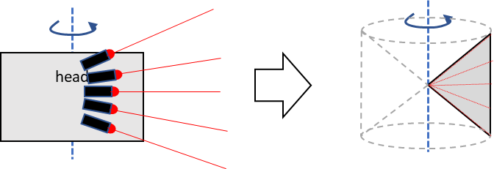

Figure 126: Vertical laser array in LiDAR and corresponding cylindrical distribution

In addition to the cylindrical sampling, the points sampled at an azimuth and an elevation angle are distributed on the direction of the light ray. In Figure 127, laser light is given with red line where the samples are pointed with green dots. Since the points are in the same azimuth and the elevation direction, the Euclidean distance between adjacent points in each direction is getting bigger as the radial distance is increased. In other words, the sampling distance is not uniform which cause inefficiency in the attribute coding.

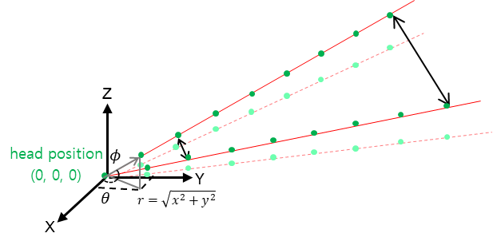

Figure 127: Non-uniform sampling distance caused by rotational sampling

To improve the coding efficiency, it was introduced to use coordinate system with uniform sampling distance where the coordinate conversion is conducted to the position of the input point cloud data. In the decoding process, the decoded attribute will be matched with the real point position by using the same coordinate conversion.

To correct the non-uniform sample volume, it was introduced to convert cat3 frame data in the cylindrical coordinates to the rectangular coordinate. Given a point position (x, y, z) in XYZ coordinate system, the radius, azimuth angle, and elevation angle of a point in cat3 frame data can be calculated by follows where and represent the center position of the LiDAR head and the relative position of each laser, respectively,

,

.

.

In the conversion to X’Y’Z’ coordinate system, it is used the followings

where represents the laser index which samples the point in the elevation angle , and the scaling parameters are derived by the largest length of point distribution of three axes divided by the length of point distribution along each axis.

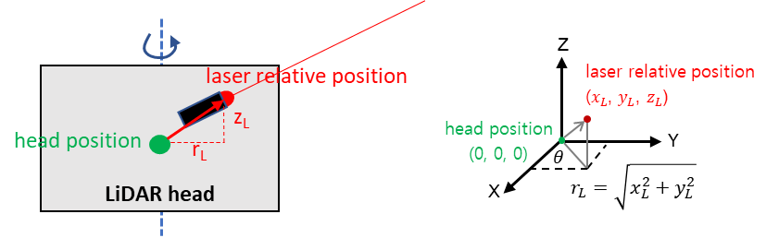

Figure 128: Laser relative position

In Figure 129, cat3 frame data and coordinate conversion result is shown in radius- theta, phi-theta, phi-radius planes.

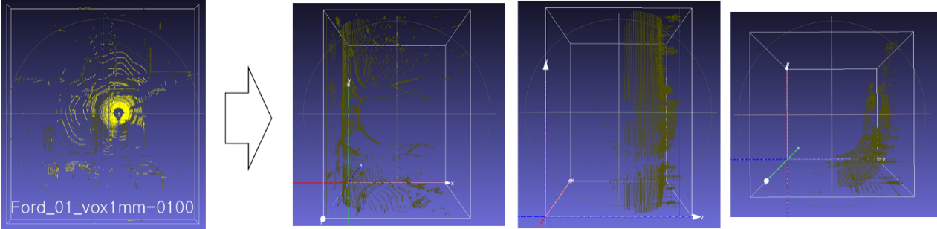

Figure 129: Coordinate conversion of cat3 frame data

When using spherical coordinates in attributes coding, the spherical coordinates decoded for the geometry are scaled according to scaling factors provided in attributes parameters. Especially because the spherical coordinates can contain negative values (for the azimuthal angle), and because attributes coding requires positive coordinates, the scaling operation also requires applying scaling offsets:

sck,i = max(0, (ck,i - ok)) * sk + 128 >> 8 for k in {0, 1, 2},

where i is point index in decoding order, ck,i are spherical coordinates, sck,i are scaled spherical coordinates, sk are integers representing fixed point scaling factors with 8 bits decimal precision, and are scaling offsets which is predefined as following,

(o0, o1, o2) = (0, -(2geom_angular_azimuth_scale_log2_minus11+11-1), 0)

where o1 = -(2geom_angular_azimuth_scale_log2_minus11+11-1) represents an azimuthal angle of -π.

## A raw attribute coder [108]

There exists non-integer data that may be pertinent to a point cloud. For example, some attributes may be coded in a floating-point format and may not be amenable nor desired to undergo lossy integer conversion. Other data may exceed the codec’s bit-depth requirements. In order to provide a means to include such data in a coded point cloud, a method of uncompressed attribute coding is introduced.

The uncompressed (raw) attribute representation codes attributes as a sequence of fixed or variable-width values. No attempt is made to interpret or compress the coded values even though it would be straightforward to add compression using a method such as deflate or LZ4.

## Functionality

### Tile and Slice

#### Tile and Slice partition process [43][120]

Figure 130 shows the process of slice and tile partition.

a) The original point cloud would be firstly quantized according to corresponding condition.

b) Then the quantized cloud is splitted into tiles, which are several cube areas with a certain side le*ngth TileSize*. The tile bounding box information be signalled in the tileinventory syntax.

c) After that, each tile is splitted into slices only when the number of points of a tile is larger than *MaxPointNum* that indicates the maximum number of points in a slice.

d)The process of slice partition contains two steps.

Step1: Slice partition

Slice partition with slice partition schemes in TMC13.

Step2: Refine Slice

Each slice is merged and splitted on two parameters *MaxPointNum* and *MinPointNum*, which try to get slices with suitable number of points. The modification on partition and quantization order could ensure the point number of each slice to meet the requirement.

e) After slice partition, slice origin of each slice is calculated based on partitioned slices, for example slice origin is set to origin of bounding box of the slice.

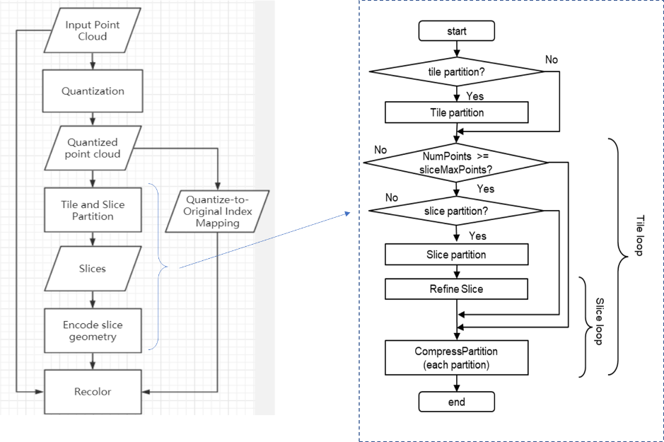

Figure 130 Slice Partition process

#### Tile partition schemes [43]

The tile partition schemes is as follows:

* Let tileMaps be a map of tile IDs to point indexes that correspond to the tile, initially empty.
* For each point in the reconstructed point cloud after quantization, determine the tile to which it belongs:

- Let tile_origin = floor(pos / *TileSize*)

- Append point index to tileMaps[tile_origin]

* Then the tile ID is simply the index into the tileMaps
* Do slice partition in each tile.

#### Slice partition schemes

##### Uniform-Geometry partition along the longest edge or using Octree [25] [43] [44]

The process of slice partition contains two steps. First, do the preliminary slice partition with slice partition schemes. Second, based on two parameters MaxPointNum and MinPointNum, do further merging and splitting operations on slices after first step, which try to get slices with suitable number of points. The method could adaptively determine the number of slices by datasets without per-sequence configurable parameters.

If the number of points is more than MaxPointNum, the following slice partition is done, otherwise the whole point cloud is compressed directly without partition.

TMC13 software supports two slice partition schemes in the encoder.

1. Uniform-Geometry partition along the longest edge
2. Assume the longest edge and the shortest edge as *maxEdge* and *minEdge*, slice number as *sliceNum*, slice size as *sliceSize*. The default value of *sliceNum* is set as *maxEdge* / *minEdge* and *sliceSize* is set as *minEdge*.
3. Clear *partitions.slices* and resize it to *sliceSize*. Divide the point cloud into *sliceNum* slices by uniform-Geometry partition scheme.
   * Evaluate the proportion of points smaller than the maxPointNum in all slices. Set a ratio threshold . If is bigger than , go to next step. Otherwise, back to procedure 1) and double the *sliceNum*.



Figure 131: Uniform-Geometry partition along the longest edge

When trisoup is used, first check whether the original slice partition interval is an integer multiple of the block size . If not, the partition interval will be rounded up to the nearest integer that is exactly divisible by the block size.

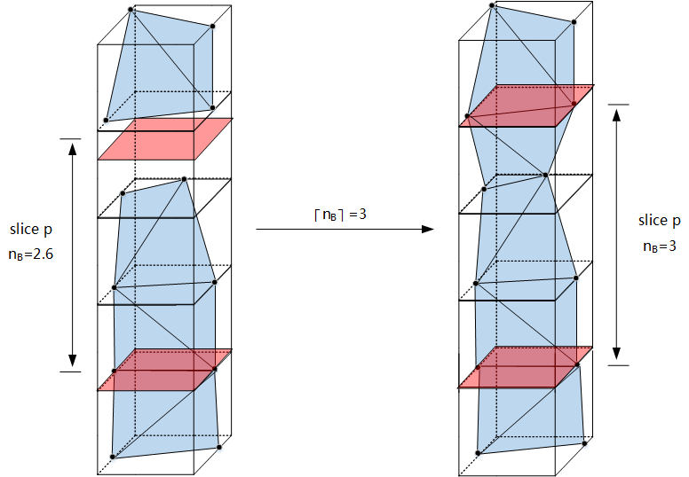

Figure 132: Partition interval when using trisoup

1. Uniform-Geometry partition using Octree
2. Set the depth of octree partition *depOctree* = 1 by default
3. Divide the input point cloud into 8depOctree slices by Octree partition scheme.
   * Evaluate the proportion of points smaller than the maxPointNum in all slices. Set a ratio threshold . If is bigger than , go to next step. Otherwise, back to procedure 1) and set *depOctree* += 1.



Figure 133: Uniform-Geometry partition using Octree

After slice partition, the point cloud of slice whose point count is more than *MaxPointNum* is splitted, and the point cloud of slice whose point count too few points is merged.

* + Split: If the point count (*Asize*) is more than M*axPointNum*, split the slice into *n* partitions, where *n* = ceil (*Asize* / *MaxPointNum*).
  + Merge: If the point count of current slice is less than *MinPointNum*, merge it with either prior slice or next one. The principles of choosing the direction to merge are as follows:

1. If current slice is in the first place, then the direction of merging is:

merge -> next slice

1. If current slice is at the end, then the direction of merging is:

merge -> prior slice

1. If current slice is neither the first nor the last one, then assume the point count of slice as *SumFront* and *SumNext* after merging with prior slice and next one respectively.

* If *SumFront* > *MaxPointNum* and *SumNext* > *MaxPointNum*,

or *SumFront*< *MaxPointNum* and *SumNext* < *MaxPointNum*,

then choose the merging direction with the one with more points.

* Otherwise, that is one of *SumFront* and *SumNext* is larger than *MaxPointNum*

and another is not, then choose the merging direction with the smaller one.

After merging, traverse all slices generated after merging, assuming the point count of merged slice as *SumMerged*, compare the *SumMerged* with *MaxPointNum*.

* + If *SumMerged* < *MinPointNum*, keep merging for current slice.
  + If *SumMerged* > *MaxPointNum*, split the merged slice with the interval as *MaxPointNum*.

If *MinPointNum <SumMerged< MaxPointNum,* keep current slice and check next slice.

##### Uniform square partitioning

In order to partition the slices in localized region, first this method partitioned the slices in uniform squares. The maxAxis and midAxis is segmented by the length of the minAxis. Figure 134 shows an example of uniform square partitioned grid.

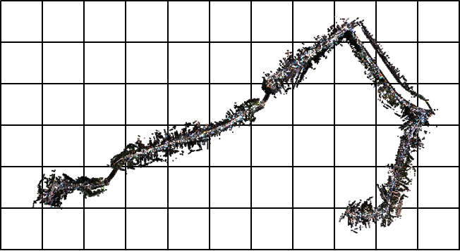

Figure 134: Uniform square partitioning

After partitioning, following process are:

1. Generate adjacent information: each none refined slice have an adjacent information in grid area, four directions (bottom, left, top, right) of current slices will be the adjacent information.
2. Merge: merge is processed with the slice having the least point number of the four.
3. Split: split is processed by the direction of next ordered slice.

After processing the merge and split, refined slices are located adaptive to region. Figure 135 shows flow of this method and Figure 136 shows the identical region of required points and decoded points.

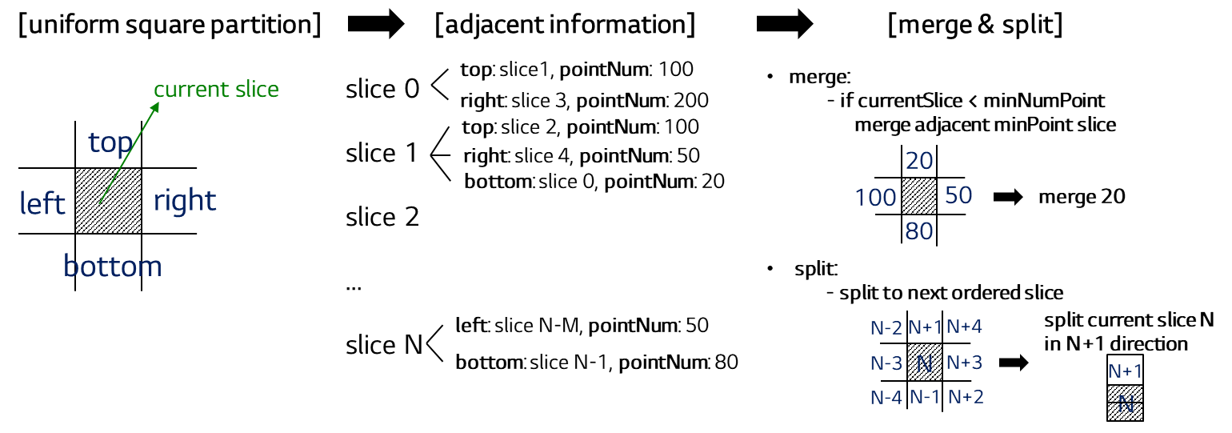

Figure 135: Partitioned result of this method (citytunnel_q1mm)

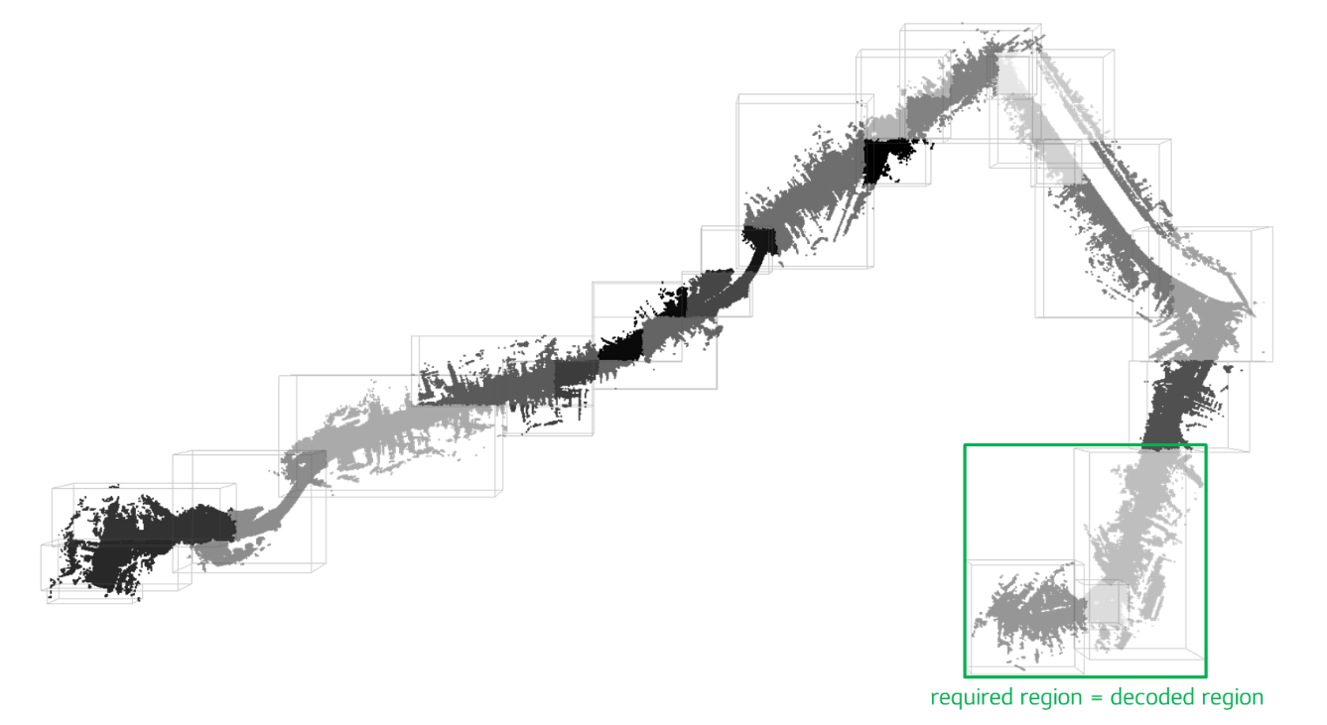

Figure 136: Example of decoded region of this method

##### Integration of refining slices on existing partitioning methods [98]

The three partitioning methods described in previous section use different refining processes. The uniform geometry and octree uniform partitioning’s merge & splitting process uses the slices which are located in forward or backward. On the other hand, uniform square partitioning’s merge & splitting process uses the slices which are located in 4-ways (up, down, right, and left).

To integrate two different refining methods, merge & splitting process that uses 6-ways (up, down, right, left, front, and back) adjacent slices information was introduced. For uniform geometry partitioning, each slices have only left and right slices information which corresponds to 2D domain. For uniform square partitioning, each slices have up, down, right and left slice information. Octree uniform partitioning has 6-ways of slice information for each slices. To cover all methods, the implementation of using 4-ways of slice information was modified to use 6-ways of slice information.

### Header reduction by quantize minimum position using gsh_box_log2_scale [30]

Minimum position value of the slice is quantized by gsh_box_log2_scale bit shifting.

Slice origin is set to quantized minimum position.

In octree partition method, gsh_box_log2_scale of every slice origin is set as below.

* gsh_box_log2_scale = total_bit – octree_depth

By setting above way, shifted origin value become equal to Morton order of octree partition.

When the same gsh_box_log2_scale is set to all slices, it is not necessary to store them in slice headers, so common log2_scale is set to new syntax in GPS and it is indicated by a flag whether it is stored in GPS or geometry slice header.

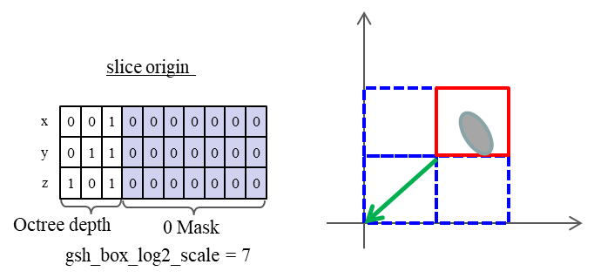

Figure 137: Header reduction by quantize position and scaling

### Parallel Octree Coding [72]

A new octree coding (encoding and decoding) scheme is introduced, by which the parallel coding can be performed for each octree partition depth instead of sequential coding of each depth.

#### Parallel octree coding by reinitialization of context variables

This method starts parallel coding from a certain octree coding depth , which is specified in the high-level syntax. It indicates that the octree coding can be processed simultaneously from depth to the maximum depth , where is the total number of octree partition depths. Assuming two depths are coded in parallel, each octree node in depth can be encoded or decoded once its parent node and neighbors of parent node in depth are encoded or decoded. As shown in Figure 138, the parallel coding starts from depth , the nodes marked as “0” in depth can be coded right after its parent node “0” and its neighbors in depth are coded; and the nodes marked as “1” and “2” in depth can be coded right after its parent node “1” and its neighbors in depth are coded; and the same strategy applied to depth , , etc.

To enable the parallel coding, for every octree partition depth that are coded in parallel, the probabilities of all context variables that are related to octree coding need to be reinitialized. It uses the probabilities of the context variables after coding the depth to reinitialize the rest octree depth from to .

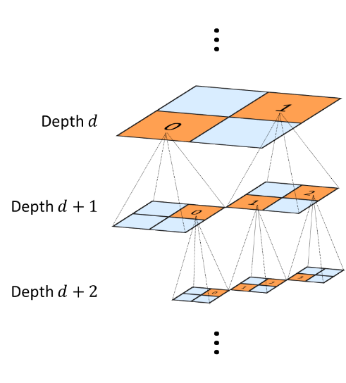

Figure 138: Illustration of parallel octree coding scheme.

##### Reinitialization of the probability of context variables for bit-wise occupancy coding

When the octree partition reaches the beginning of the specified depth , the probability of context variables for bit-wise coding need to be stored in memory. For the remaining octree partition depths that would proceed in parallel, the probability of context variables needs to be reinitialized to be the same as the stored ones.

##### Reinitialization of the look-up tables for byte-wise occupancy coding

When the octree partition reaches the beginning of the specified depth , the values of look-up tables for byte-wise coding need to be stored in memory. For the remaining octree partition depths that would proceed in parallel, the values of look-up tables need to be reinitialized to be the same as the stored ones.

The related variables that need to be stored and recovered include the following:

* An array of values lut0[k] storing the most frequent symbols, where k is in the range of 0 to 31, inclusive.
* An array of values lut0Histogram[k] storing the symbols occurrences, where k is in the range of 0 to 255, inclusive.
* Two variables lut0UpdatePeriod and lut0SymbolsUntilUpdate storing the update period for lut0 and the number of symbols remaining until the next update, respectively.
* A variable lut0Reset specifying whether lut0 should be reset during the next lut0 update or not.
* An array of values lut1[k] storing the last 16 decoded symbols with different values, where k is in the range of 0 to 15, inclusive.
* A variable lut1IndexLastSymbol storing the index of the last decoded symbol.
* A set of adaptive binary arithmetic contexts ctxLut0Hit, ctxLut1Hit, and ctxSymbolBit.
* An array of adaptive binary arithmetic contexts ctxLut0Index of size 5 if limitedContextMode equals 1, and 31 otherwise (i.e., limitedContextMode equals 0).

##### Reinitialization of the history variables for planar coding mode

In Planar coding mode, two history variables are introduced that keep updating during octree coding. Therefore, to enable the parallel octree coding scheme, the two new variables need to be reinitialized as well.

When the octree partition reaches the beginning of the specified depth , the history values for planar coding mode need to be stored in memory. For the remaining octree partition depths that would proceed in parallel, the history values need to be reinitialized to be the same as the stored ones.

#### Parallel decoder parsing mechanism

Parallel parsing mechanism can be further enabled by specifying the bitstream offsets of the starting position of each parallel octree depth.

As shown in Figure 139, the geometry octree bitstream is composed of several parts. The first part is the geometry slice header which contains the high-level syntaxes used for geometry coding. The remaining part contains the octree coding sub-bitstream of each partition depth. According to the applicability of parallel octree coding, the remaining part can be further categorized into two parts for unparallel and parallel octree coding, respectively.

To enable parallel decoder parsing, first of all, the sub-bitstream of each parallel octree partition depth needs to be aligned in byte positions, thus each sub-bitstream has integer length in bytes. Second, the bitstream offset of each parallel octree partition depth, denoted by , should be specified. The offsets can be specified by their differences, i.e., . Therefore, the decoder can start parsing several octree depths from the specified bitstream segments in parallel. Specifically, the parsing of depth is from the bitstream position to with the length of .

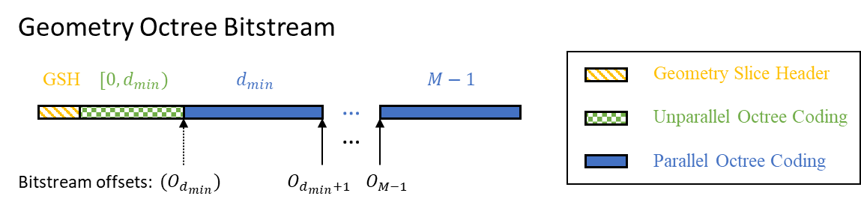

Figure 139: Illustration of geometry octree bitstream and bitstream offsets of each octree partition depth.

### Spatial scalability support [46] [116] [118]

The spatial scalability is important functionality for G-PCC. It is especially useful when the source point cloud is dense even in the local area as the Level of Detail (or, the octree depth) should be large enough to represent the original quality. With the spatial scalability, one can access a lower resolution point cloud as a thumbnail with less decoder complexity and/or with less bandwidth.

When the spatial scalability is needed, it is desirable to decode lower geometry and the corresponding attribute bitstream in a harmonized way as shown in Figure 140. Without the attribute (especially without the color attribute), it is difficult to understand the content at a glance.

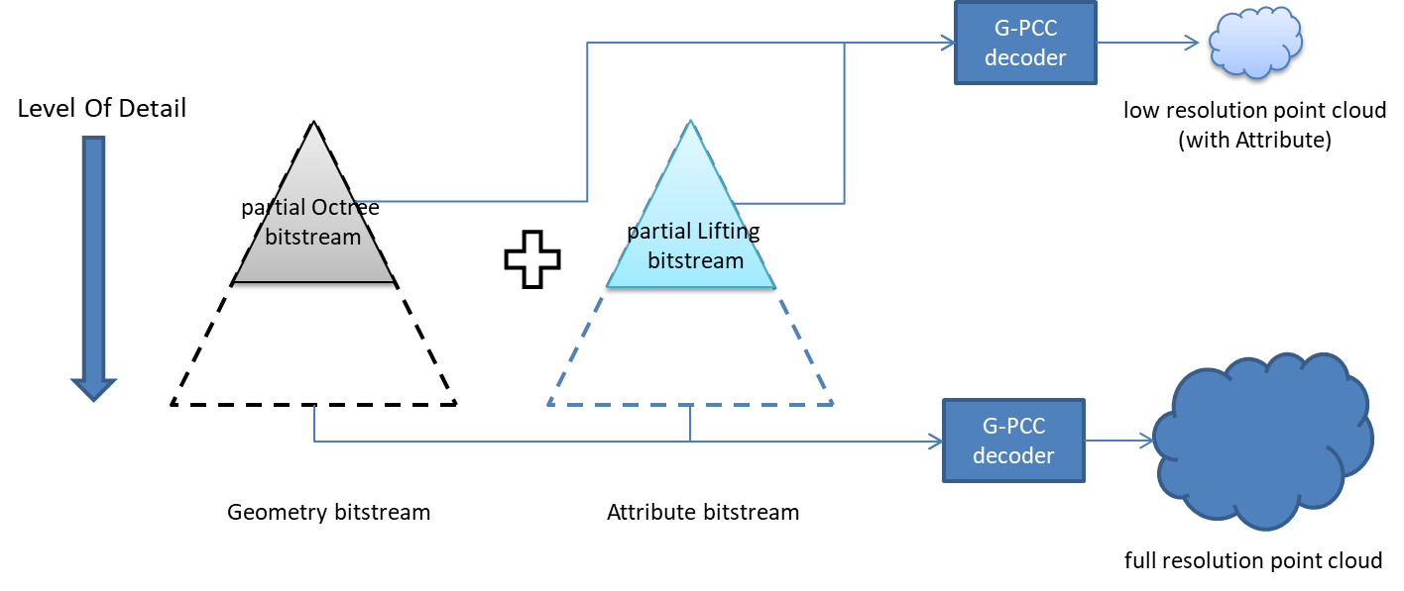

Figure 140: Extended geometry & attribute harmonized spatial scalability

To achieve the harmonized spatial scalability, the attribute decoder is extended to allow the lower resolution geometry point cloud from the partially decoded Octree bitstream, where the position is quantized as INT(pos/2k)*2k.

Additionally, the number of points at each depth is added to the syntax elements for scalable decoding. This recoding function is optional. By using this function, the decoder knows the number of points at each depth in advance. Therefore, low resolution points cloud having less than the limited number of points can be decoded easily.

The following subsections describe the extended changes for the Lifting and Predicting Transform scheme to support spatial scalability.

#### Octree harmonized LoD construction

The LoD generation process is extended to align with the geometry Octree structure.

Figure 141 and Figure 142 show the normal and the extended LoD generation process, respectively.

In the normal process, the distance between points is considered. In the extended one, the Octree structure is considered to separate the grouping. The motivation is to align the number of points for the geometry and the attribute.

By this, when the partial octree decoded point cloud is given to the attribute decoder, it can be constructed the Lifting LoD from the given level in the decoder side correctly.

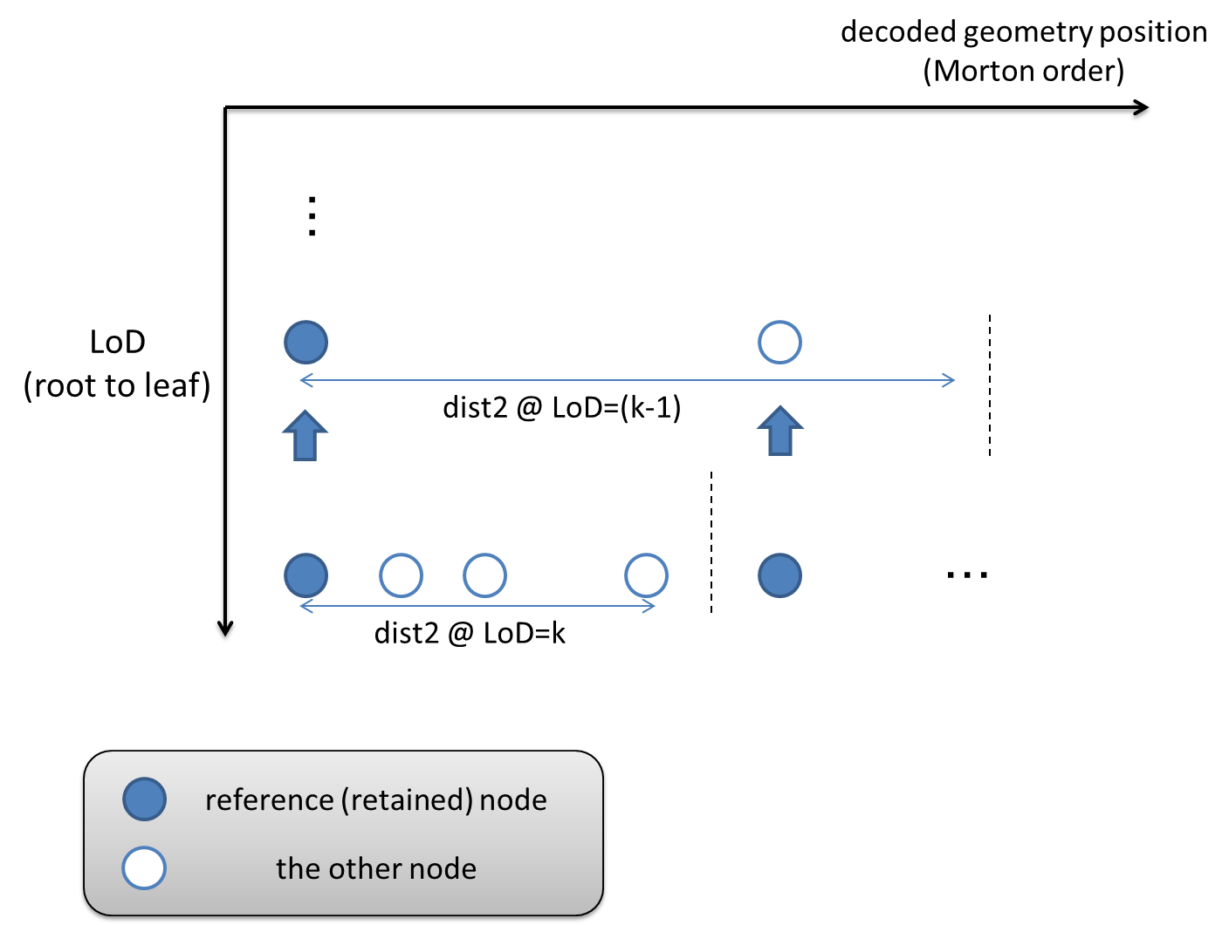

Figure 141: Normal LoD generation (Independent from Octree LoD)

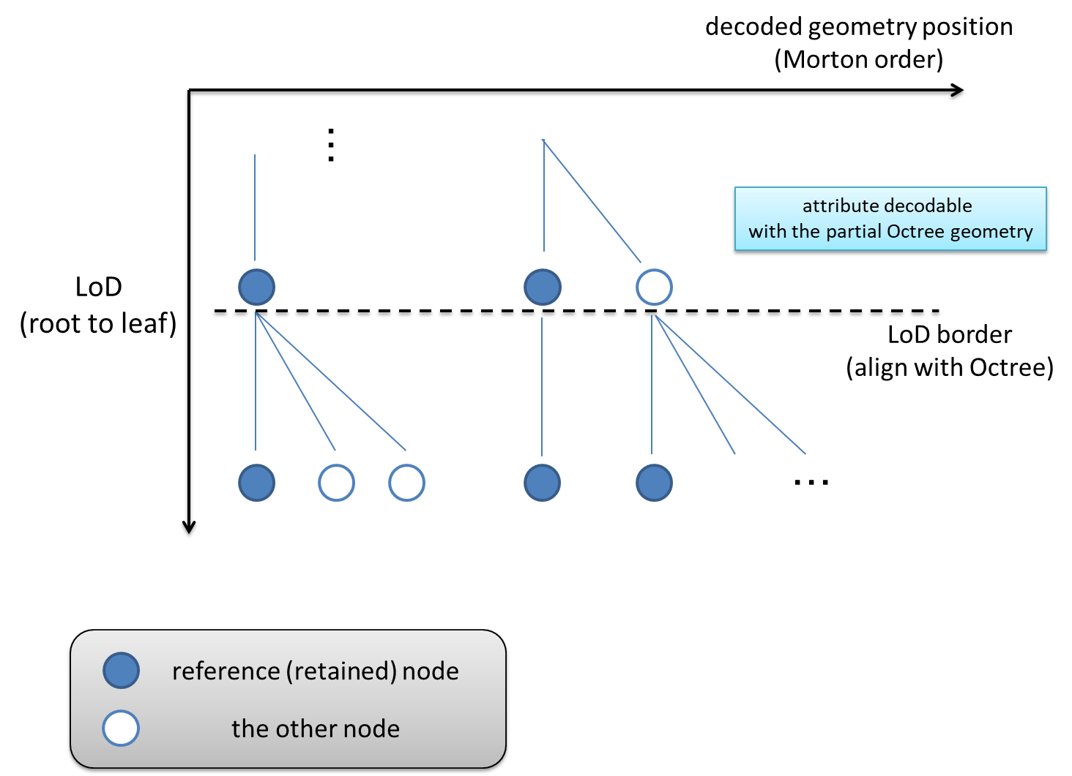

Figure 142: Extended LoD generation (align with Octree LoD)

#### Weight derivation

In the normal process, the weight value is derived from the sum of distances in the higher LoD level. When the partial octree decoded point cloud is given to the attribute decoder, the decoder cannot calculate the correct weight (because the lower LoD information is unknown).

In the extended one, instead of deriving from the distance, the weight is fixed by the point number in the LoD.

Wextended = (Total point number) / (Point number in current LOD)

This simplification assumes that the point distribution in the higher LoD is equally dense enough for the content where the spatial scalability is needed.

#### Improved weight derivation for spatial scalability [90]

The weight derivation for spatial scalability is improved. The level of detail l, , is obtained by taking the union of the refinement levels . The nearest neighbours for the points in are searched from , which is the union of . The improved weight factor for scalable lifting is derived with , because is actually effected from .

The improved weight for is the following.

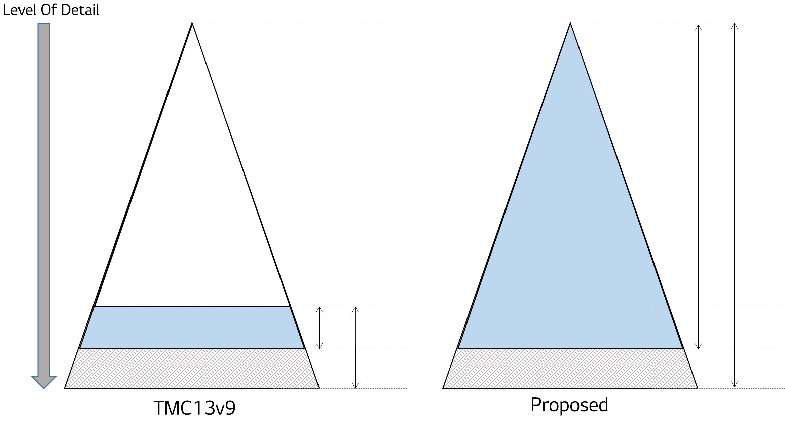

Figure 143: weight derivations (left: before, right: after)

#### Distance normalization

Related to the previous subsection, the weight value is derived from the normalized distance based on LoD.

In the normal process, the distance is calculated as follows.

Dist = ( **P**ref − **P**i )2

, where **P** denotes the x,y,z position for the ref and the i

In the extended one, the distance is calculated as follows.

Dist = ( Quant(**P**ref, LoD) − Quant(**P**i) )2

, where Q(x, LoD) is defiend as ((x>>LoD)<<LoD).

With the normalization, the decoder can calculate the correct weight value with the partially decoded geometry.

#### Reference structure modification [56][67]

The attribute Lod structure is changed as octree based LoD so that the tendency of number of attributes in LoD is also changed in some cases (see Figure 144). Because octree branch is terminated depend on point density.

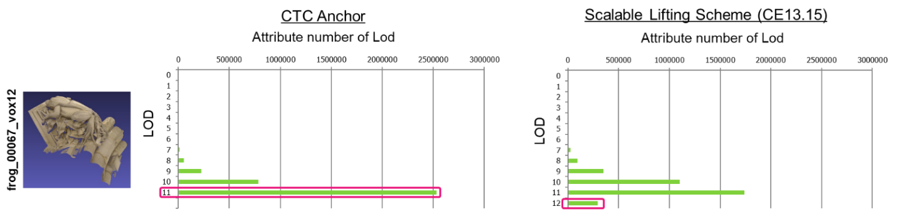

Figure 144: the number of attribute node in lod (Left is non scalable case, Right is scalable case)

Since it is not necessary to divide Lod12 and Lod11 in terms of coding efficiency of attribute, the lifting reference scheme was modified. For example, in the Figure 144 right case, the reference from Lod12 to Lod11 is prohibited, instead, Lod12 refers Lod 10 or less. This reference structure modification is applied to any Lod levels.

#### LoD generation modification [65][85]

In LoD generation method for scalable lifting, how to select retained node is modified to reduce distance distortion caused by distance normalization.

The distance normalization is as follows:

Dist = ( Quant(**P**ref, LoD) − Quant(**P**i) )2

, where Quant(x, LoD) is defined as ((x>>LoD)<<LoD).

Quant(x, LoD) changes the position of a point to the center position of each octree-based node at the LoD. Figure 145 shows the example of how to calculate distance between two points.

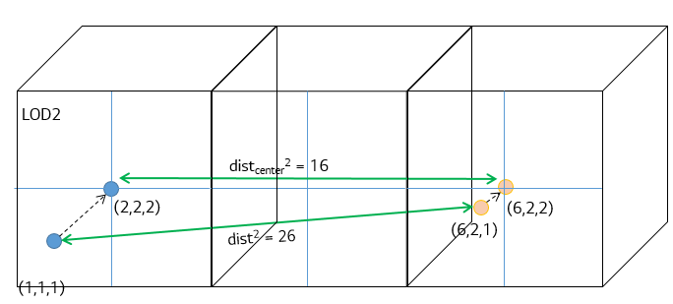

Figure 145: Example of distance distortion with distance normalization

Therefore, to reduce distance distortion caused by distance normalization, the modified retained node selection is as follows:

* If the LoD is even, select the first child node of the node as the retained node.
* If the LoD is odd, select the last child node of the node as the retained node.

Figure 146 shows the example of the modified selection as retained node.

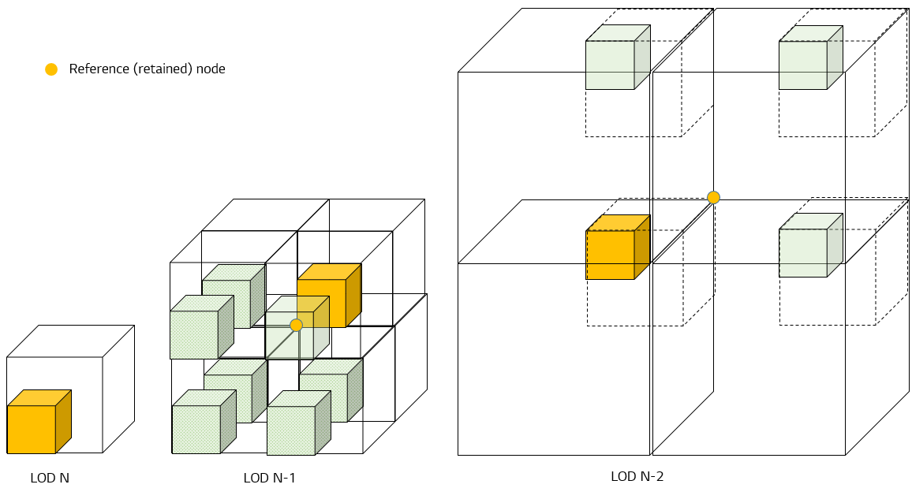

Figure 146: Example of the proposed retained node selection (yellow box)

Additionally, the method which decides retained node using occupied voxel in 2x2x2 area is introduced. Basically, the nearest node from the centroid of occupied voxels in 2x2x2 is picked up as the retained node. If there are two or more nodes which are nearest to the centroid, the first or the last node in the Morton order is chosen among them. The first or the last is selected by Lod.

#### Geometry reconstruction for spatial scalability [88]

The method to reconstruct positions of partially decoded geometry for spatial scalability is introduced. When geometry is partially decoded, the procedures to reconstruct geometry positions is following.

‐If s = 1, reconstruct geometry with the left/bottom/front position of the octree node.

‐If s > 1, reconstruct geometry with the center position of the octree node

s is the number of LoDs skipped from the bottom of octree.

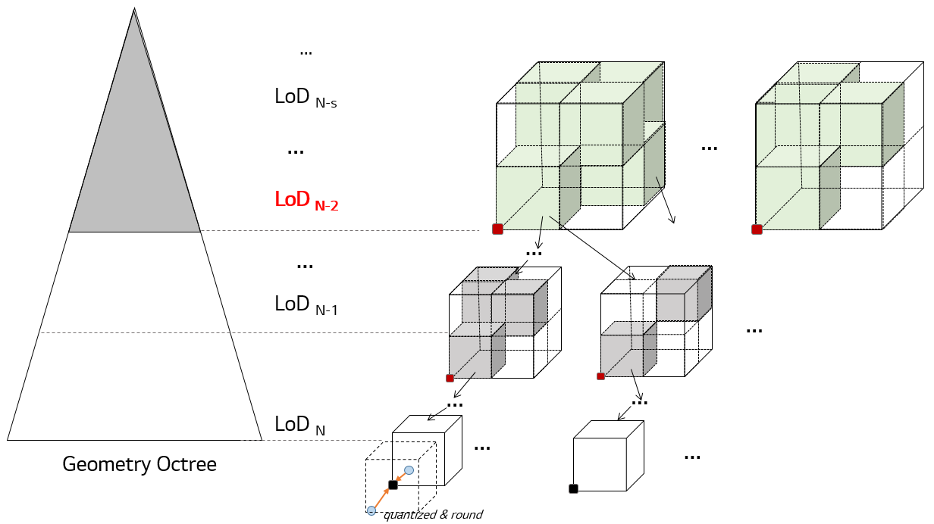 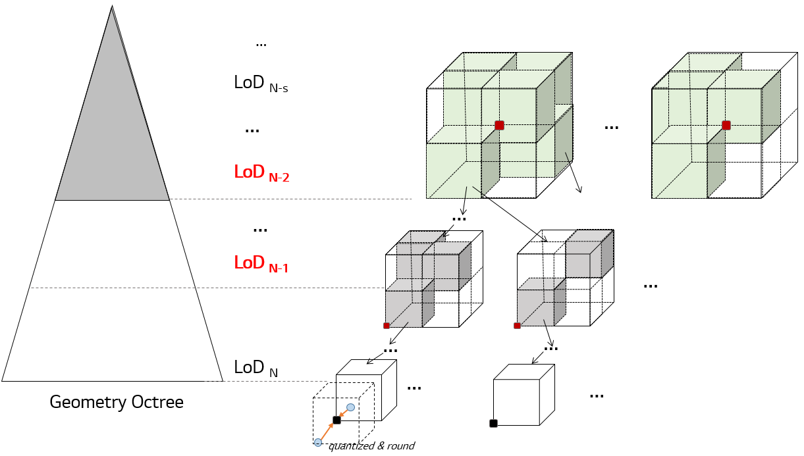

Figure 147: example of partial geometry reconstruction (left: before, right: after)

#### Nearest neighbour search for spatial scalability [89] [114]

It is introduced to apply the maximum nearest neighbor distance for nearest neighbour search. Since LoDs for scalable lifting are generated with octree-based sampling, the maximum distance of one node at each LoD can be calculated as followings. (shown in Figure 148).

Maximum L2 distance of one node at each LoD

= Base L2 distance *LoD*

=

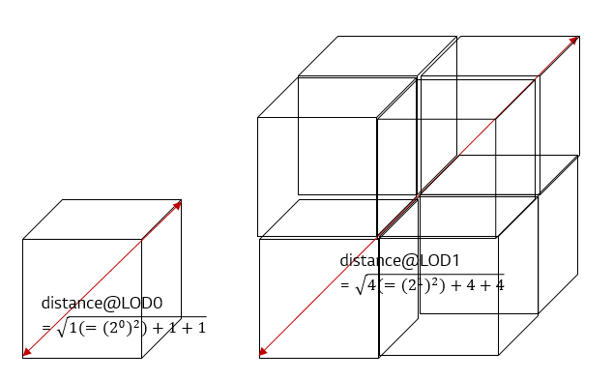

Figure 148: maximum distance of one node at each LoD.

The nearest neighbor range, NN_range, is the number of nodes around the point. Figure 149 shows an example of nearest neighbor range.

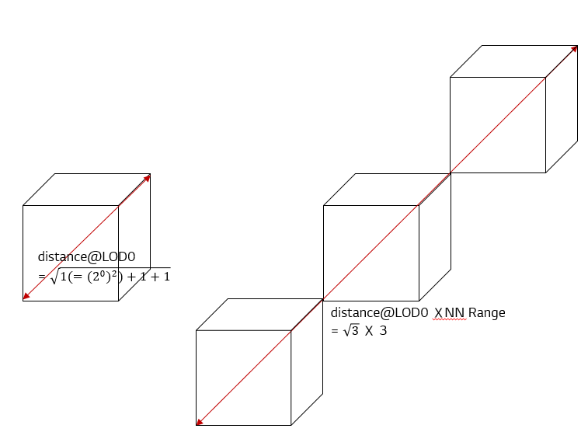

Figure 149: example of nearest neighbor range. NN_range=3

The maximum nearest neighbor distance at each LoD is calculated with equation below.

Maximum nearest neighbor L2 distance *LoD*   
= Base distance L2 *LoD* nearest neighbor range

=

The distance between the points to select nearest neighbor should be equal or smaller than the maximum nearest neighbor distance.

The maximum nearest neighbor range nn_range is detemined as following,

* The density_destimation value is estimated as following,
* According to the value of density_estimation, nn_range is calculated as following,

nn_range is initialized to 7

for (int i = 0; i < 5; i++) {

if (density_estimation > kAttributeNeighbourRange[i]) {

nn_range = i + 1;

break;

}

}

Herein, kAttributeNeighbourRange[5] = {0.00001, 0.000001, 0.0000002, 0.0000002, 0.00000002};

### Combine Frame Coding [24]

In frame-based point cloud content, each frame may be relatively smaller in file size, which is less efficient for the I/O interface. Another issue is the overhead of initializing decoder becomes more significant in the edge device as well. The decoder need to run from the initial bounding box and do the dividing for each single frame, but for combine coding the process is conducted only once for each combined Group of Point cloud (GOP), which could be beneficial to less powerful devices.

The first issue could be easily addressed by concatenating the encoded bit-stream of consecutive frames. The second one, however, is inevitable unless the point clouds are combined before encoding. The proposed combine frame coding addresses both issues by introducing the encoding of frame index in the combined point cloud. Moreover, it improves coding efficiency largely so that it could be also beneficial for storage usage of frame-based point cloud content.

Shown below, frames from frame-based point cloud data, for example, Ford content, are combined to a single point cloud. In the Ford content, depending on the movement of the vehicle, some parts of the frame appear to be stationary, while others have moved.

When each of point cloud source is correlated to one another, individual Octree of each frame has a similar structure in the higher level.

In the leaf node of the combined frame, there are some duplicated points that of different frames.

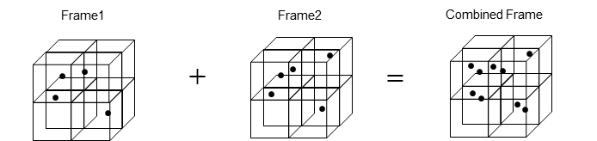

Figure 150: Image of Combine Point Cloud Input Data

A single bitstream is outputted after encoding the entire sequence. Group of Point cloud (GOP) is created and each frame inside the GOP is assigned a unique index, which we call the frame index. The frame indices, which are used in the decoder to reconstruct the input frames, are encoded using two different approaches. Frame index can also be encoded as an attribute. A new attribute is defined to represent frame index. The existing attribute coding method is used to encode it. Note the coding of frame index should be lossless in order to reconstruct correctly.

When using combine coding, to indicate the number of duplicated frames in leaf node in geometry slice data,

1. unique_geometry_points_flag is recommended to be set to 0
2. Frame index in attribute is recommended to be encoded as lossless encoding

### Neighbour point search sharing function [60]

Category3-fused dataset (e.g. city tunnel) has two types of attributes, which are color and reflectance. If the configuration for LOD generation and maximum number of neighbors for both attributes are same, the result from common process can be shared. This can save encoding and decoding time or computation power and redundant memory usage.

In this function, neighbour search process will run one time in generating LOD and the searched neighbor points are used for both color and reflectance encoding/decoding process.

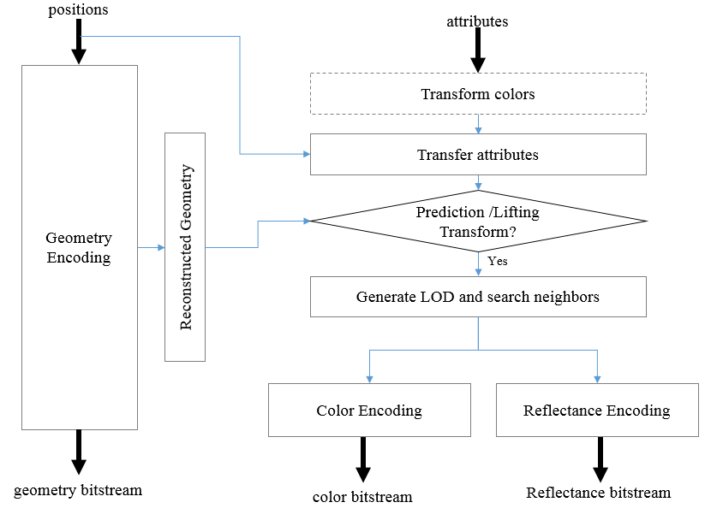

Figure 151: flow of neighbour point search sharing for the attribute encoding

### Scale and offset of Attribute in SPS [103][130][146]

Current G-PCC support only unsigned integer type for attribute encoding/decoding and does not support signed value.

For example, when encoding normal vector as one of attribute type, each axis of normal vector has the value in range [-1, 1]. To encode a normal vector with integer value, the value must be converted to [0, 256] before encoding by scaling and offset.

The scale factor (attribute_source_scale_log2) and offset factor (attribute_source_offset_log2) are signalled in the attribute loop in the SPS so that the decoder can re-scale and offset to original values.

In the decoder, after slice are decoded and concatenated, attribute value may be convert to source value as below.

for (PointCount = 0; PointCount <= geom_num_points_minus1; PointCount ++) {

for (cIdx = 0; cIdx < NumAttributeComponents; cIdx++)

RecPic[PointCount][3 + cIdx]

= float(RecPic[PointCount][3 + cIdx] – (1 << source_attribute_offset_log2))

>> source_attribute_scale_log2;

}

For more finer control of scaling and offset, it was introduced that the scale and offset be signalled without the log2() conversion (source_attr_offset, source_attr_scale and source_attr_ scale_precision_bits). The scaled version of an attribute value x may be derived as follows:

sh = source_attr_scale_precision_bits  
off = 1 << (source_attr_scale_precision_bits – 1)  
ScaledAttributeVal(x) = ( x * source_attr_scale + off ) >> sh + source_attr_offset

Point clouds may have reflectance component that values of the all points are multiples of 255 such as cat3-fused content. In such a case, values are divided by 255 before encoding as pre-process, and multiplied by 255 after decoding as post-process. This function could be done to signal the reflectance scaling parameter using attribute_parameters in SPS.

### Entropy continuation flag for low latency coding [103][121][122]

An entropy coding is widely used in G-PCC, it is an encoding or decoding method based on a probability models that are selected adaptively based on local context. So as the local context encoded changes, the state of the encoder / decoder engine varies. Based on the different context, as more encoding process is conducted. The probability models become more efficient in encoding the data.

Currently from 1 slice to another, there is a process to re-initialize the state of the engine to default value at the end of each slice for parallelism. It will not be possible to continue context table for multicore processing and this value is required to be initialized to default. Ideally each slice unit will be independent from one another.

But if slice is implemented for data segmentation purposes for low latency application and not for parallelism in multicore processing, the initialization of entropy context table will cause drop in encoding performance. This is because probability model will need to start from default value instead of continuing from a well predicted probability model. Due to this, the entropy context continuation flag can help play a role by saving the context table probability table at the end of slice and set it back at the beginning of the next slice to continue with the same context probability. This method will be able to improve encoding performance for slice.

The decoder will require to have similar implementation to save context table probability value at the end of slice and set it back for new slice.

The entropy continuation process can work both on octree geometry or prediction geometry. Separate parameters are used to save and set the context table. It is the same for attribute entropy coding table, continuation flag for geometry and attribute are separated so that user can control and produce G-PCC bitstreams with higher compression ratio. The entropy_continuation_flag for geometry will be put in geometry data unit header (gsh) while entropy_continuation_flag for attribute will be put in attribute data unit header (ash).

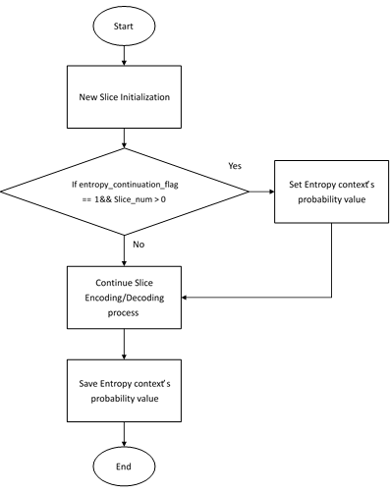

Figure 152: entropy continuation process based on the flag

The method to initialize or continue context is introduced in G-PCC specification with slice-partition-framework software as a baseline. Both the encoding and decoding process is modified to write/read entropy_continuation_flag parameter. The entropy_continuation_flag for encoding and decoding in geometry is added into geometry data unit header (gsh). The context_continuation_flag can be individually controlled for every single slice.

At the beginning of slice encoding, if entropy_continuation_flag is set to zero and the slice number is bigger than 0 (not first slice), then the context table probability value will be set to previous saved value. At the end of slice encoding, the context table probability value will be saved before exiting slice encoding. The same implementation is applicable for decoder. At the beginning of slice decoding, the context table probability value will be loaded if the condition matches. At the end of slice decoding, the entropy context table probability value will be saved

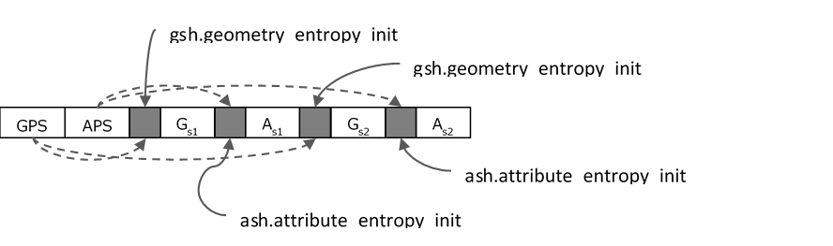

Figure 153: syntax on entropy_continuation_flag

Some additional restrictions are needed to use this function as following,

* This function can be used only reorder of the slice is restricted. (sps.slice_ reorder_constraint_flag = 1)
* Entropy context state is initialized at the beginning of the slice. For example, at the first slice in a frame or the first slice in a tile
* Entropy context state is initialized when the context that used for coding is changed by switching the encoding parameters. For example,
  + Geometry octree coding -> Predictive geometry coding
  + Bit-wise occupancy coding -> Byte-wise occupancy coding
  + Raht -> predicting

### Non-normative scaling and SPS bounding box [107]

The final position (xF, yF, zF) for the reconstructed position (x, y, z) of each point of the point cloud could be derived by dividing the reconstructed point positions by the source scale factor, clipping the result to the SPS bounding box dimensions, and shifting the points based on the SPS bounding box origin offsets as follows:

off = (sps_source_scale_factor_numerator_minus1 + 1) >> 1

scaleNum = sps_source_scale_factor_numerator_minus1 + 1

scaleDen = sps_source_scale_factor_denominator_minus1 + 1

xS = (x * scaleDen + off) / scaleNum

yS = (y * scaleDen + off) / scaleNum

zS = (z * scaleDen + off) / scaleNum

bboxOffX = sps_bounding_box_offset_x << sps_bounding_box_offset_log2_scale

bboxOffY = sps_bounding_box_offset_y << sps_bounding_box_offset_log2_scale

bboxOffZ = sps_bounding_box_offset_z << sps_bounding_box_offset_log2_scale

xF = Min( xS, sps_bounding_box_width) + bboxOffX

yF = Min( yS, sps_bounding_box_height) + bboxOffY

zF = Min( zS, sps_bounding_box_depth) + bboxOffZ

Herein,

* sps_bounding_box_offset_x, sps_bounding_box_offset_y, and sps_bounding_box_offset_z indicate quantised x, y, and z offsets of the source bounding box in Cartesian coordinates. When not present, the values of sps_bounding_box_offset_x, sps_bounding_box_offset_y, and sps_bounding_box_offset_z are each inferred to be 0.
* sps_bounding_box_offset_log2_scale indicates the scaling factor to scale the quantised x, y, and z source bounding box offsets. When not present, the value of sps_bounding_box_offset_log2_scale is inferred to be 0.
* sps_bounding_box_size_width, sps_bounding_box_size_height, and sps_bounding_box_size_depth indicate the width, height, and depth of the source bounding box in Cartesian coordinates.
* sps_source_scale_factor_numerator_minus1 plus 1 indicates the scale factor numerator of the source point cloud.
* sps_source_scale_factor_denominator_minus1 plus 1 indicates the scale factor denominator of the source point cloud.

### Adaptive axis coding order detemination [110]

G-PCC defines the axis coding order in sequence level. The method in this section is a simple approach to determine the axis coding order from all possible order combinations. As shown in Figure 154, the point cloud to be coded is first projected to three planes (i.e., xoy, xoz and yoz). Then, corresponding Morton codes of the points on three projection planes are calculated respectively. Let Morton_X indicates the Morton code set of the points projected on the yoz plane, Morton_Y indicates the Morton code set of the points projected on the xoz plane and Morton_Z indicates the Morton code sets of the points projected on the xoy plane.

By performing an *N*-bits right shift to Morton_X, Morton_Y and Morton_Z, points on three projection planes are clustered into a number of subsets. Let Num_X, Num_Y and Num_Z be the number of points of the maximum subset after the *N*-bits right shift of Morton_X, Morton_Y and Morton_Z respectively. Obtaining the first *N* value for each plane that makes:

the nearest number to a pre-defined threshold *T*, where indicates any of Num_X, Num_Y and Num_Z, and represents the total munber of points in the point cloud. For Cat1 data, *T* is set to be 10%; for Cat3 data, *T* is set to be 20%. The obtained *N* values for each projection plane are then denoted as Shift_X, Shift_Y and Shift_Z.



Figure 154: An illustration of point projection

Based on Shift_X, shift_Y and Shift_Z, the axis coidng order is determined according to Table 8.

Table 8: The determination of axix coding order

|  |  |  |
| --- | --- | --- |
|  | Morton code  bit-interleaving order | Axis coding order |
| Shift_X< Shift_Y< Shift_Z | XYZ | ZYX |
| Shift_X< Shift_Z< Shift_Y | XZY | YZX |
| Shift_Y< Shift_X< Shift_Z | YXZ | ZXY |
| Shift_Y< Shift_Z< Shift_X | YZX | XZY |
| Shift_Z< Shift_X< Shift_Y | ZXY | YXZ |
| Shift_Z< Shift_Y< Shift_X | ZYX | XYZ |

### Normative global scaling for point clouds

It was introduced to specify a normative global scaling process that applies to the entire point cloud frame. The global scaling process in the encoder side is shown in Figure 155.

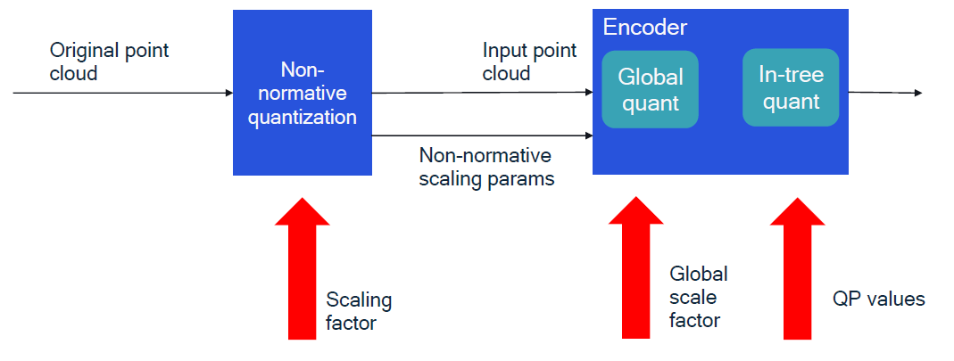

Figure 155: Normative global scaling process in the encoder

The global scaling process in the decoder side is before the conformance output of the point cloud, as shown in Figure 156.

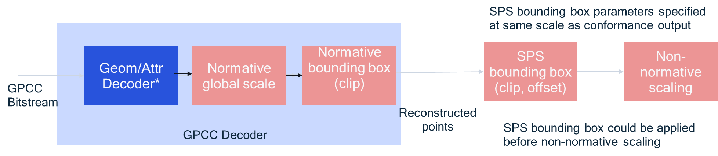

Figure 156: Normative global scaling process in the decoder before the conformance output

### Flexible signalling of attribute parameters [130]

It was introduced that the generalized attribute parameters be allowed to be signalled on a frame level, e.g., using a separate syntax structure generalized_attribute_parameter_inventory(). An example of such a syntax structure would be as follows:

|  |  |
| --- | --- |
| generalized_attribute_parameter_inventory( ) { | **Descriptor** |
| **attr_param_frame_idx** | tbu |
| **attr_param_seq_parameter_set_id** | u(7) |
| **attr_param_sps_attr_idx** | ue(v) |
| **num_attr_parameters** | ue(v) |
| for( i = 0; i < num_attr_parameters; i++ ) |  |
| attribute_parameter() |  |
| } |  |

When present, the above syntax structure may specify one or more attribute parameters (attribute is specified by attr_param_sps_attr_idx) for the point cloud that may be associated with frame index attr_param_frame_idx. For an attribute, if a particular attribute parameter is specified in the SPS as well as in the frame, a system may choose to use the frame-level attribute parameter to be applied.

The advantage of such a signalling is as follows. When multiple frames are combined into one frame, the frame index attribute may only carry the relative frame order. For examples, if frames 100..107 are coded into one frame, the frame index attributes for points belonging to each frame may be in the range 0..7. At the decoder, in order to determine that the decode frames (with frame index attribute values in the range 0..7) correspond to frames 100..107, the value “100” needs to be signalled to the decoder. This may be signalled as an offset parameter in the generalized attribute parameter inventory with the frame.

### Carriage of user data [143]

There is a precedent for the carriage of user data in previous video coding standards. Here, a mechanism was introduced that permits the carriage of registered user data that is in line with the existing mechanisms used in G-PCC for identification of user defined attribute types.

user_data_data_unit() {

user_data_oid = oid(v)

while(more_data_in_byte_stream())

user_data_byte = b(8)

}

The user data data unit contains user data identified by an OID. The semantics of the user data are not specified in this specification. The variable user_data_oid is an international object identifier that identifies the type of user data contained in the data unit. The variable user_data_byte is a byte containing data as specified by the entity controlling the OID.

### Re-ordering for geometry predictive tree coding [145]

CAT3-fused sequences has laser angle which is sweep angle of the laser sensor when the point was captured. The method to use laser angle was introduced to determine origin for re-ordering and re-order points for CAT3-fused sequences.

**Origin determination:**

If laser angles are provided, to determine origin, laser angle is used. The origin satisfied the following conditions are selected.

* the center laser angle point (e.g. 90°)
* the most left point

Figure 156 shows the example of origin positions.

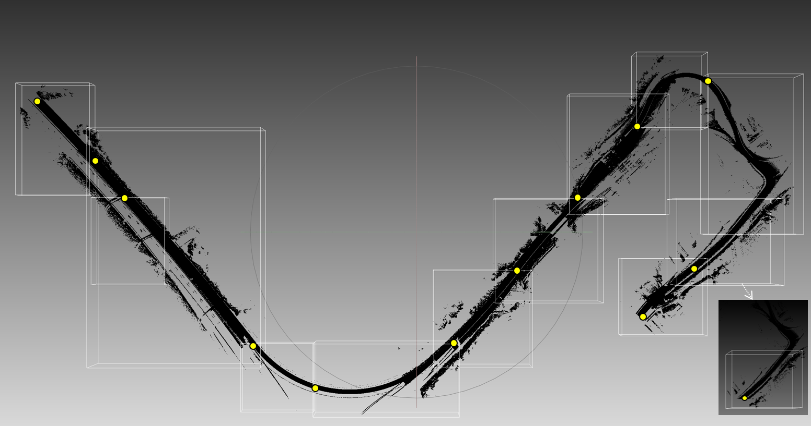

Figure : selected origins of tollbooth C2/R03 (yellow dots)

**re-ordering method based on laser angle:**

The laser angle is used to re-order points instead of calculated azimuth if laser angles are provided. Figure 157 shows the example.

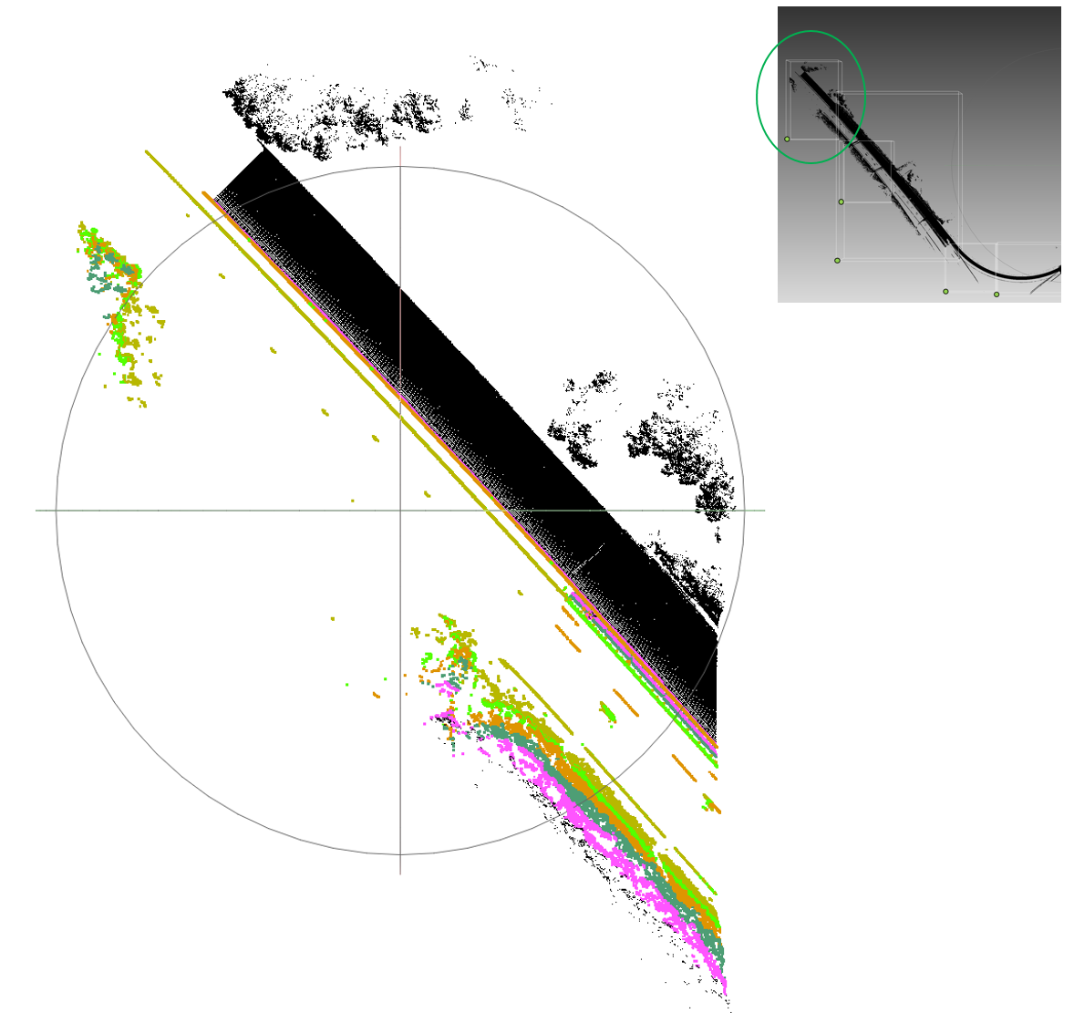

Figure : point re-ordering example based on laser angle  
(yellow→green→orange→dark green→pink … )

# References

1. FastAC fast arithmetic coding algorithm, <http://www.cipr.rpi.edu/research/SPIHT/>
2. Call for Proposals for Point Cloud Compression V2, ISO/IEC JTC1/SC29/WG11 w16736, Hobart, AU, April 2017.
3. https://cmake.org
4. <https://www.threadingbuildingblocks.org>
5. Queiroz and Chou, “Compression of 3D Point Clouds Using a Region-Adaptive Hierarchical Transform,” IEEE Trans. Image Processing, Aug. 2016.
6. Chou and Queiroz, "Transform Coder for Point Cloud Attributes," ISO/IEC JTC1/SC29/WG11 input document m38674, Geneva, May 2016.
7. [PCC] Inference of a mode using point location direct coding in TMC3, ISO/IEC JTC1/SC29/WG11 input document m42239, Gwangju, Korea, January 2018.
8. [PCC] Neighbour-dependent entropy coding of occupancy patterns in TMC3, ISO/IEC JTC1/SC29/WG11 input document m42238, Gwangju, Korea, January 2018.
9. Look ahead cube for efficient neighbours information retrieval in TMC13, ISO/IEC JTC1/SC29/WG11 input document m43591, Ljubjana, Slovenia, July 2018.
10. PCC Simplification of neighbour-dependent entropy coding in CE3.4, ISO/IEC JTC1/SC29/WG11 input document m42689, San Diego, US, April 2018.
11. [PCC] Intra mode for geometry coding in TMC3, ISO/IEC JTC1/SC29/WG11 input document m43600, Ljubljana, Slovenia, July 2018.
12. [PCC] A new binary entropy coder with update for geometry coding in TM3, ISO/IEC JTC1/SC29/WG11 input document m44750, Macau, China, October 2018.
13. Binarization of occupancy information in TMC13, ISO/IEC JTC1/SC29/WG11 input document m43592, Ljubljana, Slovenia, July 2018.
14. PCC TMC13 alternative entropy codecs, ISO/IEC JTC1/SC29/WG11 input document m43649, Ljubljana, Slovenia, July 2018.
15. “Dirac Specification version 2.2.3,” BBC, Sep. 2008.
16. “VC-2 Video Compression,” ST 2042-1, SMPTE, Nov. 2009.
17. PCC Adaptive predictor selection for attributes coding in TMC13 related to CE13.3, ISO/IEC JTC1/SC29/WG11 input document m43665, Ljubljana, Slovenia, July 2018.
18. Binarization of transform coefficients in TMC13, ISO/IEC JTC1/SC29/WG11 input document m43780, Ljubljana, Slovenia, July 2018.
19. Efficient implementation of the Lifting Scheme in TMC13, ISO/IEC JTC1/SC29/WG11 input document m43781, Ljubljana, Slovenia, July 2018.
20. A new neighbour node occupancy decision, ISO/IEC JTC1/SC29/WG11 input document m44752, Macau, China, October 2018
21. Entropy coding an octree node occupancy depending on neighbour’s child nodes, ISO/IEC JTC1/SC29/WG11 input document m44753, Macau, China, October 2018
22. Improved G-PCC lossless and near-lossless coding, ISO/IEC JTC1/SC29/WG11 input document m44899, Macau, China, October 2018
23. Binary-tree based level-of-details generation for attributes coding in G-PCC, ISO/IEC JTC1/SC29/WG11 input document m44940, Macau, China, October 2018
24. TMC13 new proposal on Combine Frame Coding, ISO/IEC JTC1/SC29/WG11 input document m44813, Macau, China, October 2018
25. G-PCC TMC13 CE13.2 report on point cloud tile and slice based coding, ISO/IEC JTC1/SC29/WG11 input document m45867, Marrakech, Morocco, January 2019
26. PCC CE1.3 recolor method, ISO/IEC JTC1/SC29/WG11 input document m42538, San Diego, US, April 2018
27. [PCC] On further reduction of neighbour configurations, ISO/IEC JTC1/SC29/WG11 input document m46148, Marrakech, Morocco, January 2019
28. [PCC] On an improvement of advanced neighbours, ISO/IEC JTC1/SC29/WG11 input document m46149, Marrakech, Morocco, January 2019
29. [PCC] On the reduction of states related to advanced neighbours in OBUF, ISO/IEC JTC1/SC29/WG11 input document m46150, Marrakech, Morocco, January 2019
30. [G-PCC] CE13.2 Report on geometry slice header reduction in slice partition, ISO/IEC JTC1/SC29/WG11 input document m47398, Geneva, CH, March 2019
31. Reference structure modification on attribute predicting transform in TMC13, ISO/IEC JTC1/SC29 WG11 input document m46107, Marrakech, MA, January 2019
32. [G-PCC] [New proposal] Fixed-point implementation of G-PCC, ISO/IEC JTC1/SC29/WG11 input document m44900, Macau, China, October 2018
33. [G-PCC][New Proposal] Efficient Low-Complexity LOD Generation, ISO/IEC JTC1/SC29 WG11 input document m46188, Marrakech, MA, January 2019
34. [G-PCC] CE13.16 Report on Slice-based quantization control, ISO/IEC JTC1/SC29/WG11 input document m47399, Geneva, CH, March 2019
35. [G-PCC] Quantization Parameter table in Attribute Coding, ISO/IEC JTC1/SC29/WG11 input document m47401, Geneva, CH, March 2019
36. [G-PCC] New contribution on quantization parameter definition, ISO/IEC JTC1/SC29/WG11 input document m47507, Geneva, CH, March 2019
37. [G-PCC] Attribute residual coding in TMC13, ISO/IEC JTC1/SC29 WG11 input document m46108, Marrakech, MA, January 2019
38. [G-PCC][New proposal]Non-normative Subband Adaptive, ISO/IEC JTC1/SC29/WG11 input document m45019, Macau, China, October 2018
39. G. Sandri, P. A. Chou, M. Krivokuća, and R. L. De Queiroz, *Integer Alternative for the Region-Adaptive Hierarchical Transform,* submitted for publication in the IEEE Signal Processing Letters. Copyright held by IEEE.
40. Fixed-point version of RAHT with rate-distortion impact tests, ISO/IEC JTC1/SC29/WG11 input document m44486, Macau, China, October 2018
41. G-PCC CE13.14 Report on implementation of fixed-point RAHT in TMC13, ISO/IEC JTC1/SC29 WG11 input document m46209, Marrakech, MA, January 2019
42. [G-PCC] CE13.19 Report on Attribute Layer Quantization Control, ISO/IEC JTC1/SC29/WG11 input document m47834, Gothenburg, Sweden, July 2019.
43. [G-PCC] CE13.2 report on tile and slice based coding, ISO/IEC JTC1/SC29/WG11 input document m48892, Gothenburg, Sweden, July 2019.
44. [G-PCC] [CE13.2-related] An improvement for the uniform-geometry slice partition along the longest edge, ISO/IEC JTC1/SC29/WG11 input document m49121, Gothenburg, Sweden, July 2019.
45. G-PCC Bypass coding of bypass bins, ISO/IEC JTC1/SC29/WG11 input document m47827, Geneva, Switzerland, March 2019.
46. [G-PCC] Spatial scalability support for G-PCC, ISO/IEC JTC1/SC29/WG11 input document m47352, Geneva, Switzerland, March 2019.
47. [G-PCC] (New) Lifting and RAHT harmonization, ISO/IEC JTC1/SC29/WG11 input document m48918, Gothenburg, Sweden, July 2019.
48. [G-PCC][New proposal] Improved color transfer, ISO/IEC JTC1/SC29/WG11 input document m49407, Gothenburg, Sweden, July 2019.
49. On an improvement of RAHT to exploit attribute correlation, ISO/IEC JTC1/SC29/WG11 input document m47378, Geneva, Switzerland, March 2019.
50. [G-PCC] EE13.5 Report on Region-wise Quantization Control, ISO/IEC JTC1/SC29/WG11 input document m51063, Geneva, CH, October 2019
51. [G-PCC][EE13.6 related] Slice-based geometry quantization, ISO/IEC JTC1/SC29/WG11 input document m50927, Geneva, CH, October 2019
52. [G-PCC] EE13.6 report on geometry quantization, ISO/IEC JTC1/SC29/WG11 input document m50924, Geneva, CH, October 2019
53. [G-PCC] Clarification and Modification of CD syntax and semantics, ISO/IEC JTC1/SC29/WG11 input document m51064, Geneva, CH, October 2019
54. [G-PCC] Clarification and Modification of CD syntax and semantics, ISO/IEC JTC1/SC29/WG11 input document m51064, Geneva, CH, October 2019
55. [EE13.7] Report on Inter-Channel Prediction for Attribute Coding, ISO/IEC JTC1/SC29/WG11 input document m51160, Geneva, CH, October 2019
56. [G-PCC] CE13.15 Related on improved spatial scalable lifting, ISO/IEC JTC1/SC29/WG11 input document m49044, Gothenburg, Sweden, July 2019.
57. [G-PCC] CE13.20 report on neighbor’s weight modification on Lifting and Predicting Scheme, ISO/IEC JTC1/SC29/WG11 input document m50773, Geneva, CH, October 2019
58. [GPCC] CE13.23 report on duplicated points in IDCM, ISO/IEC JTC1/SC29/WG11 input document m50009, Geneva, CH, October 2019
59. [G-PCC][New proposal] Improved implementation of the Prediction and Lifting schemes., ISO/IEC JTC1/SC29/WG11 input document m51010, Geneva, CH, October 2019
60. [G-PCC][New Proposal] on possible reduction of attribute coding time for cat3-fused dataset, ISO/IEC JTC1/SC29/WG11 input document m51010, Geneva, CH, October 2019
61. [GPCC] _Planar mode in octree-based geometry coding, ISO/IEC JTC1/SC29/WG11 input document m48906, Gothenburg, Sweden, July 2019.
62. [G-PCC][New proposal] Implicit geometry partition for point cloud coding, ISO/IEC JTC1/SC29/WG11 input document m49231, Gothenburg, Sweden, July 2019.
63. [GPCC] [CE 13.22 related] An improvement of the planar coding mode, ISO/IEC JTC1/SC29/WG11 input document m50642, Geneva, CH, Oct 2019.
64. [G-PCC] CE13.25 report on Triangle soup decoding, ISO/IEC JTC1/SC29/WG11 input document m52279, Brussels, BE, Jan 2020.
65. [G-PCC][New Proposal] on improved spatial scalable lifting, ISO/IEC JTC1/SC29/WG11 input document m51408, Geneva, CH, Oct 2019.
66. [G-PCC][New Proposal] on improvement for adaptive reflectance predictor selection, ISO/IEC JTC1/SC29/WG11 input document m50765, Geneva, CH, Oct 2019.
67. [G-PCC] New proposal CE13.15 Related on improved weight derivation for spatial scalable lifting, ISO/IEC JTC1/SC29/WG11 input document m50743, Geneva, CH, Oct 2019.
68. [G-PCC] [New proposal] On partitioning to support the spatial random access, ISO/IEC JTC1/SC29/WG11 input document m52337, Brussels, BE, Jan 2020.
69. [G-PCC] EE13.5 Report on Region-wise Quantization Control for RAHT, ISO/IEC JTC1/SC29/WG11 input document m52341, Brussels, BE, Jan 2020.
70. [GPCC] CE 13.22 report on harmonization of angular coding mode and implicit QTBT, ISO/IEC JTC1/SC29/WG11 input document m52343, Brussels, BE, Jan 2020.
71. [G-PCC] [new proposal] Early termination for transform domain prediction of RAHT, ISO/IEC JTC1/SC29/WG11 input document m51374, Geneva, CH, Oct 2019.
72. [G-PCC][new proposal] Parallel Octree Coding for Point Cloud Compression, ISO/IEC JTC1/SC29/WG11 input document m50930, Geneva, CH, Oct 2019.
73. [G-PCC][CE13.29 related] Harmonization and Fixing in Geometry Quantization, ISO/IEC JTC1/SC29/WG11 input document m52400, Brussels, BE, Jan 2020.
74. CE13.10 report on chunked entropy streams, ISO/IEC JTC1/SC29/WG11 input document m52514, Brussels, BE, Jan 2020.
75. G-PCC: A method to compute dist2 values for LoD attribute coding, ISO/IEC JTC1/SC29/WG11 input document m52524, Brussels, BE, Jan 2020.
76. [G-PCC] [EE13.7] Improved encoding for inter-channel residual prediction, ISO/IEC JTC1/SC29/WG11 input document m52719, Brussels, BE, Jan 2020.
77. [GPCC] Division-free RAHT coding scheme, ISO/IEC JTC1/SC29/WG11 input document m52951, Alpbach, AT, Apr. 2020
78. [GPCC] [CE13.22 related] On decoupling planar and IDCM in angular mode, ISO/IEC JTC1/SC29/WG11 input document m52956, Alpbach, AT, Apr. 2020
79. [GPCC] [CE 13.22 related] The new azimuthal coding mode, ISO/IEC JTC1/SC29/WG11 input document m51596, Brussels, BE. Jan. 2020
80. [GPCC] Planar mode buffer optimization, ISO/IEC JTC1/SC29/WG11 input document m52345, Brussels, BE. Jan. 2020
81. [GPCC][new] Improving entropy coding of RAHT coefficients, ISO/IEC JTC1/SC29/WG11 input document m52986, Alpbach, AT, Apr. 2020
82. [GPCC][new] Increasing internal precision of inter-depth prediction for RAHT, ISO/IEC JTC1/SC29/WG11 input document m52995, Alpbach, AT, Apr. 2020
83. [GPCC][new] Optimization of RAHT coefficients by the attribute encoder, ISO/IEC JTC1/SC29/WG11 input document m52996, Alpbach, AT, Apr. 2020
84. [G-PCC][New proposal] Using L1 norm for nearest neighbour search in Prediction and Lifting schemes, ISO/IEC JTC1/SC29/WG11 input document m51011, Geneva, CH, Oct. 2019
85. [G-PCC](New Proposal) CE13.15 Related on improved LoD generation for spatial scalability, ISO/IEC JTC1/SC29/WG11 input document m52331, Brussels, BE. Jan. 2020
86. [G-PCC][new proposal] On geometry occupancy intra prediction, ISO/IEC JTC1/SC29/WG11 input document m52327, Brussels, BE. Jan. 2020
87. [G-PCC] Alphabet-partition coding of transform coefficients, ISO/IEC JTC1/SC29/WG11 input document m52720, Brussels, BE. Jan. 2020
88. [G-PCC][New Proposal] on geometry reconstruction for spatial scalability, ISO/IEC JTC1/SC29/WG11 input document m52315, Brussels, BE. Jan. 2020
89. [G-PCC][New Proposal] on nearest neighbour search for spatial scalability, ISO/IEC JTC1/SC29/WG11 input document m52314, Brussels, BE. Jan. 2020
90. [G-PCC][New Proposal] on weight derivation for spatial scalability, ISO/IEC JTC1/SC29/WG11 input document m52823, Brussels, BE. Jan. 2020
91. [GPCC][new] On bypassed bit coding and chunks, ISO/IEC JTC1/SC29/WG11 input document m53385, Alpbach, AT, Apr. 2020
92. G-PCC: Integer step sizes for in-tree geometry quantisation, ISO/IEC JTC1/SC29/WG11 input document m52522, Brussels, BE. Jan. 2020
93. G-PCC: An IDCM specific QP for in-tree geometry quantisation, ISO/IEC JTC1/SC29/WG11 input document m52523, Brussels, BE. Jan. 2020
94. [G-PCC][EE13.35] Report on explicit signaling of OtQtBt, ISO/IEC JTC1/SC29/WG11 input document m53338, Alpbach, AT, Apr. 2020
95. EE13.35 report on OtQtBt partition signalling, ISO/IEC JTC1/SC29/WG11 input document m53390, Alpbach, AT, Apr. 2020
96. [G-PCC][New proposal] Predictive Geometry Coding, ISO/IEC JTC1/SC29/WG11 input document m51012, Geneva, CH, Oct 2019.
97. EE13.8 report on low-latency coding for automotive/mapping applications, ISO/IEC JTC1/SC29/WG11 input document m53391, Online, Apr. 2020
98. [GPCC][New proposal] Integration of refining slices on existing partitioning methods, ISO/IEC JTC1/SC29/WG11 input document m53392, Online, Apr. 2020
99. [G-PCC][New Proposal] Fixing neighbor context accessing in QTBT, ISO/IEC JTC1/SC29/WG11 input document m53421, Online, Apr. 2020
100. [G-PCC][New_proposal] Rate-distortion optimization for prediction mode selection, ISO/IEC JTC1/SC29/WG11 input document m53442, Online, Apr. 2020
101. [G-PCC] [EE13.8 Related] Predictive tree encoding modifications, ISO/IEC JTC1/SC29/WG11 input document m53538, Online, Apr. 2020
102. [G-PCC] High Level Syntax and Specification Modification, ISO/IEC JTC1/SC29/WG11 input document m53541, Online, Apr. 2020
103. [G-PCC] Entropy Continuation flag for Low Latency Coding, ISO/IEC JTC1/SC29/WG11 input document m53542, Online, Apr. 2020
104. [G-PCC] [new proposal] High Level Syntax modification and skip sorting process based on Morton code for low delay attribute coding, ISO/IEC JTC1/SC29/WG11 input document m52392, Brussels, BE. Jan. 2020
105. [G-PCC][New proposal] Division-free Implementation of the Lifting/Prediction scheme, ISO/IEC JTC1/SC29/WG11 input document m53619, Alpbach, AT. Apr. 2020
106. [G-PCC][software] Encoder improvements for inter-component residual prediction, ISO/IEC JTC1/SC29/WG11 input document m53633, Alpbach, AT. Apr. 2020
107. [G-PCC][New proposal] Global scaling for point clouds, ISO/IEC JTC1/SC29/WG11 input document m53650, Alpbach, AT. Apr. 2020
108. G-PCC: A raw attribute coder, ISO/IEC JTC1/SC29/WG11 input document m53679, Alpbach, AT. Apr. 2020
109. [GPCC][New Proposal] Angular mode simplifications and HLS refinements, ISO/IEC JTC1/SC29/WG11 input document m53693, Alpbach, AT. Apr. 2020
110. [G-PCC] CE13.26 Report On RAHT transform order, ISO/IEC JTC1/SC29/WG11 input document m53332, Alpbach, AT. Apr. 2020
111. [GPCC] [CE13.41] Report on modifying IDCM implicit conditions and introducing non-ordered two-point IDCM, ISO/IEC JTC1/SC29/WG11 input document m54264, Online, July 2020
112. [GPCC] [CE13.33] Report on modifying entropy coding of attributes coefficients with dictionary removal and Run-Length coding, ISO/IEC JTC1/SC29/WG11 input document m54265, Online, July 2020
113. [GPCC] [CE13.41] Report on dyadic RAHT, ISO/IEC JTC1/SC29/WG11 input document m54266, Online, July 2020
114. [G-PCC] CE13.31 report on nearest neighbour search for spatial scalability, ISO/IEC JTC1/SC29/WG11 input document m54590, Online, July 2020
115. [G-PCC][CE13.38 related] Modification on the azimuthal sorting for predictive geometry tree coder, ISO/IEC JTC1/SC29/WG11 input document m54592, Online, July 2020
116. [G-PCC] [New] On spatial scalability with predicting Transform, ISO/IEC JTC1/SC29/WG11 input document m54599, Online, July 2020
117. [G-PCC] [New proposal] RAHT upsampled prediction improvement, ISO/IEC JTC1/SC29/WG11 input document m54607, Online, July 2020
118. [G-PCC][New Proposal] Signaling of the number of points at each depth for spatial scalability, ISO/IEC JTC1/SC29/WG11 input document m54616, Online, July 2020
119. [G-PCC] [EE13.43] Report on coordinate conversion, ISO/IEC JTC1/SC29/WG11 input document m54622, Online, July 2020
120. [G-PCC][New] Software refinement to achieve to the tile partitioning, ISO/IEC JTC1/SC29/WG11 input document m54651, Online, July, 2020.
121. [G-PCC][New] High Level Syntax and Specification Modification, ISO/IEC JTC1/SC29/WG11 input document m54652, Online, July, 2020.
122. [G-PCC][New] Implementation of Entropy Continuation for Attribute, ISO/IEC JTC1/SC29/WG11 input document m54659, Online, July, 2020.
123. [G-PCC] CE13.39 report on Bit count coding for predictive coding, ISO/IEC JTC1/SC29/WG11 input document m54628, Online, July, 2020.
124. [G-PCC][New] The modification on intra LoD prediction for attribute predicting transform coding, ISO/IEC JTC1/SC29/WG11 input document m54633, Online, July, 2020.
125. [GPCC] EE 13.44 Report on Chroma Residual Coding for Lifting Transform, ISO/IEC JTC1/SC29/WG11 input document m54655, Online, July, 2020.
126. CE13.6 report on attribute LoD construction and neighbour search, ISO/IEC JTC1/SC29/WG11 input document m54668, Online, July, 2020.
127. CE13.38 report on angular coding for the predictive geometry coder, ISO/IEC JTC1/SC29/WG11 input document m54671, Online, July, 2020.
128. [G-PCC][CE13.29-related] Additional results of CE13.29 and step-size derivation methods, ISO/IEC JTC1/SC29/WG11 input document m54697, Online, July, 2020.
129. [G-PCC][New proposal] On attribute QP derivation, ISO/IEC JTC1/SC29/WG11 input document m54698, Online, July, 2020.
130. [G-PCC][New proposal] On frame index coding, ISO/IEC JTC1/SC29/WG11 input document m54699, Online, July, 2020.
131. [G-PCC] [new] Attribute residual coding fix, ISO/IEC JTC1/SC29/WG11 input document m54703, Online, July, 2020.
132. [G-PCC][New proposal] Fast laser search method, ISO/IEC JTC1/SC29/WG11 input document m54707, Online, July, 2020.
133. CE13.34 report on filter based attribute prediction scheme, ISO/IEC JTC1/SC29/WG7 input document m54951, Online, October, 2020.
134. A Progressive Quantization for LoD-based 3D PCCs, ISO/IEC JTC1/SC29/WG7 input document m55035, Online, October, 2020.
135. [G-PCC] CE13.37 report on planar coding improvement, ISO/IEC JTC1/SC29/WG7 input document m55314, Online, October, 2020.
136. [G-PCC][New] Integration of Decimation-based and Scalable LOD Generation, ISO/IEC JTC1/SC29/WG7 input document m55344, Online, October, 2020.
137. [G-PCC] [EE report] Report on EE 13.42: Decoupling predIndex and attribute reconstruction in predicting transform, ISO/IEC JTC1/SC29/WG7 input document m55364, Online, October, 2020.
138. [G-PCC] [new] Regarding last component prediction coding, ISO/IEC JTC1/SC29/WG7 input document m55365, Online, October, 2020.
139. [G-PCC] [new] On inter-component residual prediction, ISO/IEC JTC1/SC29/WG7 input document m55373, Online, October, 2020.
140. [G-PCC] [new] On predictive geometry coding, ISO/IEC JTC1/SC29/WG7 input document m55376, Online, October, 2020.
141. [G-PCC][New proposal] On in-tree quantization and angular mode, ISO/IEC JTC1/SC29/WG7 input document m55387, Online, October, 2020.
142. G-PCC: Tweaks related to octree geometry coding, ISO/IEC JTC1/SC29/WG7 input document m55491, Online, October, 2020.
143. G-PCC: Carriage of user data, ISO/IEC JTC1/SC29/WG7 input document m55495, Online, October, 2020.
144. [G-PCC][New] A Progressive Quantization for LoD-based attribute Predicting Transform coding, ISO/IEC JTC1/SC29/WG7 input document m55859, Online, January, 2021.
145. [G-PCC][New Proposal] on re-ordering for geometry predictive tree coding, ISO/IEC JTC1/SC29/WG7 input document m56740, Online, April, 2021.
146. [G-PCC][new]Reflectance scaling using attribute parameters for CTC, ISO/IEC JTC1/SC29/WG7 input document m56810, Online, April, 2021.
147. [G-PCC][New] Latency Reduction between Geometry and Attribute Coding in G-PCC, ISO/IEC JTC1/SC29/WG7 input document m57355, Online, July, 2021.

Appendix A: Mathematical Functions

the greatest integer less than or equal to x.

the least integer greater than or equal to x.

.

the base-2 logarithm of x.

= the maximum of x1, …, xN.

the trigonometric inverse tangent function, operating on an argument x, with  
an output value in the range of −π÷2 to π÷2, inclusive, in units of radians.

Appendix B: RAHT

This Appendix provides details of how to transform a list of attributes , into a list of transform coefficients , , given a list of associated voxel locations , as side information, and how to invert the transform.

RAHT and its inverse are performed with respect to a hierarchy defined by the Morton codes of the voxel locations. The Morton code of -bit non-negative integer coordinates , , and is a -bit non-negative integer obtained by interleaving the bits of , , and . To be specific, the Morton code of non-negative -bit integers coordinates

where are the bits of , , and from (high order) to (low order), is the non-negative -bit integer

where are the bits of from (high order) to (low order).

Let denote the -bit prefix of . Let be such a prefix. Define the block at level with prefix to be the set of all points for which . Two blocks at level are sibling blocks if they have the same -bit prefix. The union of two sibling blocks at level is a block at level called their parent block.

The Region Adaptive Haar Transform of the sequence , and its inverse, can now be defined recursively as follows.

**Base case:**

Let be the attribute of a point and let be its transform. Then .

**Recursion:**

Consider two sibling blocks and their parent block. Let and be the attributes of the points in the sibling blocks, listed in increasing Morton order, and let and be their respective transforms. Similarly, let be the attributes of all points in their parent block, listed in increasing Morton order, and let be its transform. Then

where and .

In other words, the transform of the parent block is the concatenation of the two sibling blocks, with the exception that the first (DC) components of the transforms of the two sibling blocks are replaced by their weighted sum and difference, and inversely the transforms of the two sibling blocks are copied from the first and last parts of the transform of the parent block, with the exception that the DC components of the transforms of the two sibling blocks are replaced by their weighted difference and sum, namely

and

It is not difficult to show that these are inverses of each other. These are known as Givens rotations.